Melbourne Sewerage Strategy

Michael Wandmaker
Melbourne Water
Pat McCafferty
Yarra Valley Water
David Ryan
City West Water
Terri Benson
South East Water
Robert Murphy
Western Water
ISBN 978-1-925541-12-0 (Print)
ISBN 978-1-925541-13-7 (Web)
© Copyright December 2018 Melbourne Water Corporations. All rights reserved. No part of the document may be reproduced, stored in a retrieval system, photocopied or otherwise dealt with without prior written permission of Melbourne Water Corporation.
Disclaimer: This publication may be of assistance to you but Melbourne Water and its employees do not guarantee that the publication is without flaw of any kind or is wholly appropriate for your particular purposes and therefore disclaims all liability for any error, loss or other consequence which may arise from you relying on any information in this publication.
All actions in this strategy will be delivered subject to funding.

Preface
For over 100 years, Melbourne’s sewerage system has protected public health and the environment and contributed to making Melbourne one of the world’s most liveable cities.
Challenges like our growing population, the changing urban environment and climate change require an evolution of the sewerage system to ensure that Melbourne remains a liveable and sustainable city for generations to come.
This strategy represents an innovative, new approach to facilitate transformational change of the sewerage system in the face of complex challenges and opportunities.
It includes ambitious goals to support our 50 year Vision for a liveable, thriving Melbourne, and outlines an agile, adaptive approach that takes into consideration the rapidly changing environment in which we live.
Importantly, it explains how our sewerage system can further evolve from a waste disposal system to one which plays a critical role in meeting urban water demands, sustainably managing waste and enhancing resource recovery.
This bold, new approach is the result of a collaboration between Melbourne Water, City West Water, South East Water, Western Water and Yarra Valley Water. These strong and effective partnerships will underpin ongoing collaboration throughout the strategy implementation.
In implementing the strategy, we will continue to work with our customers and the community, adapting our approach to ensure it remains aligned with community needs and expectations.
The decisions we make with the community will ensure affordable services for current and future generations.
Working together, we can ensure our sewerage system is well positioned to face the challenges and opportunities of the future, remains a valued community asset, and supports a prosperous, liveable Melbourne for many years to come.

Aboriginal acknowledgment
Melbourne Water, City West Water, South East Water, Western Water and Yarra Valley Water proudly acknowledge Aboriginal people as Australia’s First Peoples and the local Traditional Owners as the original custodians of the land and water on which we rely and operate. We pay our deepest respects to their Elders past, present and future.
We acknowledge the continued cultural, social and spiritual connections Aboriginal people have with the lands and waters, and recognise and value that the Traditional Owner groups have cared for and protected them for thousands of generations.
In the spirit of reconciliation, we remain committed to working in partnership with local Traditional Owners to ensure their ongoing contribution to the future of the water management landscape, while maintaining their cultural and spiritual connections.

Contents
Executive Summary 7
1. Introduction 21
1.1 About this strategy 21
1.2 Approach 21
1.3 Water Industry Strategies 22
1.4 Victoria’s Regulatory Context 23
1.5 Our Customers and Stakeholders 26
1.6 About Our Sewerage System 31
2. Why do we need a sewerage strategy? 38
2.1 Supporting Broader Water Industry Outcomes 38
2.2 Our Changing Environment 47
3. A New Sewerage Strategy 66
3.1 Our Vision 66
3.2 Our Goals 66
4. The features of a future resource recovery system 71
4.1 Functions of Melbourne’s Future Resource Recovery System 73
5. Delivering the strategy - Adaptive Pathways 79
5.1 Why Adaptive Pathways? 79
5.2 The Adaptive Pathway Approach 79
5.3 Knowledge, Values and Rules 80
5.4 How Will We Deliver the Adaptive Pathways? 82
5.5 System Limits 82
5.6 Sewerage Network and Treatment Plant Limits 86
5.7 Environmental Discharge Limits 103
5.8 Greater Melbourne Waste Limits 115
5.9 Availability of Fit For Purpose Water 129
6. Implementing the Strategy 139
6.1 Decision Making Framework 141
6.2 Collaborative Implementation 144
6.3 Governance for Strategy Implementation 144
6.4 Actions for Implementation 148
Appendix 1. Melbourne’s journey towards a water sensitive city 159
Appendix 2. Melbourne sewerage system overview 162
Appendix 3. Adaptive Pathways Case Studies 171
Appendix 4. Decision Making Framework 177
Glossary 181
References 195
ENDNOTES 196

Executive Summary
Melbourne is one of the world’s most liveable cities. Our sewerage system plays a vital role in supporting that liveability and ensuring that our city remains healthy and prosperous.

Why do we need a Sewerage Strategy?
The pace of change around us is increasing. Technology is rapidly advancing, the population is growing and the climate is changing. The greatest certainty we have for the future is that it will not be the same as the past. We can no longer plan for the future based on what has happened previously.
Melbourne’s population is expected to more than double in the next 50 years. This increase in population is driving change to the urban form. We no longer live in the suburbs with large backyards, instead we have a mix of high density, medium density and sprawling suburbs on the fringe of the city. The areas to the north and west of Melbourne, are some of the most rapidly growing areas in Australia.
The increasing population has also created challenges for managing other waste materials, particularly organic material such as food waste. This material has historically been sent to landfill or composting facilities. With changing government policies around organic waste to landfill, along with limited landfill capacity and the ability for organic wastes to be used to generate renewable energy, there may be benefits of treating some of this waste in the sewerage system.
Our industry and employment base has changed with the decline of manufacturing and the rise of service based industries, including an increase in cafés and other options for indulging in the famous Melbourne lifestyle. These changes have impacted on the composition of sewage that now enters our treatment plants.
Climate change projections indicate Melbourne will become a hotter, drier city. Sea level rise is likely to see impacts on infrastructure such as the Western Treatment Plant. Other climate change impacts on the sewerage system include increased rates of odour and corrosion of our assets due to warmer sewage temperatures and more intense storms that may require infrastructure upgrades to ensure we are meeting our environmental discharge requirements. A drying climate also increases the need for alternative water sources to help Melbourne meet its water needs.
Customer expectations are changing, driving us to find different ways of delivering and funding our services and providing services that are valued by the community.
Given the challenges posed by population growth and climate change, Melbourne can no longer continue with a mindset of using our resources once, treating them to make them safe, and then disposing of them to the environment.
In Melbourne our water cycle is essentially a linear process; where we use water and then dispose of it, and any contaminants, via the sewerage system to be treated before it re-enters the environment.
Organic and inorganic material that enters our sewerage system forms the basis of the resources that can then be extracted to support Melbourne as a sustainable city.
Although previous Sewerage Strategies have identified the potential for using the resources within the system, and there have been government policies to encourage a greater reuse of resources such as recycled water, we have had limited success in realising their full value.
This strategy represents an innovative new approach to facilitate transformational change of the sewerage system in the face of complex challenges and opportunities. We have developed bold and ambitious goals and embraced adaptive pathways planning to ensure we have a robust, resilient and affordable sewerage system that is valued by our customers and community for the long term.
This strategy is not an infrastructure plan but a framework that provides direction for the future.

Our Vision and Goals

Our Vision
Melbourne’s sewerage system has the potential to not only continue to protect public health and the environment, but to deliver enhanced value through contributing to our city’s liveability. To do this, our Vision for Melbourne’s sewerage system is:
A resilient and adaptable system that supports thriving, healthy communities and a liveable, flourishing environment.

Our Goals
To achieve our Vision, we need to take measurable steps to reposition our sewerage system from being viewed as a waste disposal system to one that is a true resource recovery system and a key contributor to Melbourne’s future as a water sensitive city. We need to think about future generations of Melburnians and ensure that we are leaving a legacy that holds them in good stead for the challenges that they are likely to face, whilst maintaining the equity that our sewerage system provides to our customers and community.
The Goals are aspirational and are a stretch beyond what the industry currently delivers.
They are reflective of a future where sewage is valued as a resource and industry, government and the community are united in striving for bold change.
The affordability of essential services is an issue currently facing our community and this strategy is mindful of this.
These goals, although aspirational, are underpinned by the fundamental principle of ensuring affordability for our customers and community.
By 2070, Melbourne’s metropolitan water industry will see the key features of our sewerage system helping to achieve the following Goals:

Melbourne Sewerage Strategy goals figure – text version
The image shows the five sewerage strategy goals listed, each with a pictorial icon.

Human health and wellbeing (Leaf and water droplet icon)
The evolution of Melbourne’s sewerage system enhances human health and wellbeing, now and in the future.

Enhancing the environment (Large seahorse and small seahorse icon)
Melbourne’s sewerage system leads the world in protecting and enhancing natural assets including waterways, green spaces, biodiversity and marine environments.

Leveraging resources (Arrow cycle icon)
Melbourne will be recognised as a world leader in advancing the circular economy through our commitment to beneficially using 100% of our water and resources while ensuring affordability for current and future generations of Melburnians.

Community stewardship (Adult and child holding hands icon)
Our customers and community understand and care about the role the sewerage system plays in Melbourne’s liveability. This fosters shared stewardship and informs the services we provide.

An enabling policy and regulatory environment (Pipe icon)
Our collaborative policy, pricing, and regulatory environment fosters an adaptive, scalable, agile and innovative system that enables us to equitably meet Melbourne’s needs for the next 50 years and beyond.
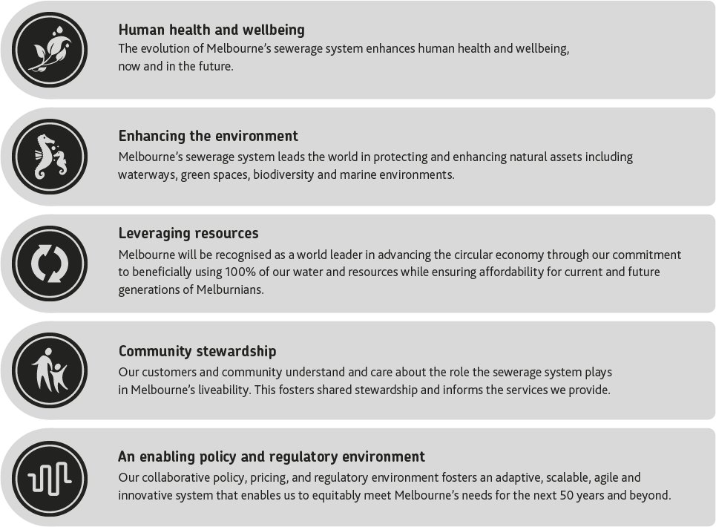

The functions and features of our future system
To achieve our Goals and Vision, we must transform our system from a largely linear ‘treat and discharge’ system to a ‘resource recovery’ system that exemplifies the circular economy. Transformational changes will be required to realise the functions and features required in our future resource recovery system.
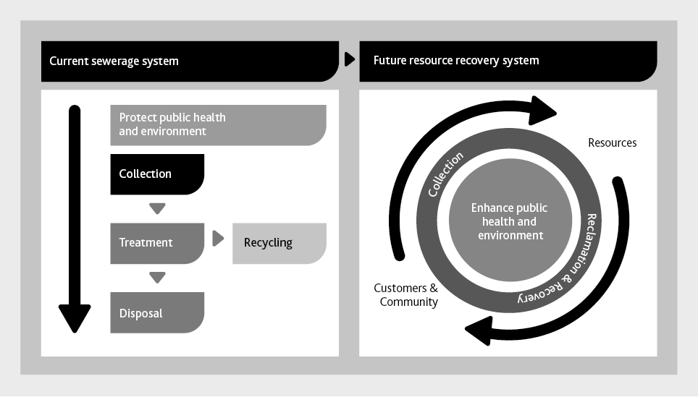

Figure: Transitioning from a linear treatment system to a circular economy - text version
The figure shows the linear processes of the current sewerage system side by side with the cyclical processes of the future resource recovery system.
It shows that the current sewerage system protects public health and the environment by collection of sewage which is then treated. After treatment some goes to recycling and the remainder is disposed to the environment.
In the future, the sewerage system will become a resource recovery system. The figure shows the cyclical process of sewage collection from customers and community, and the reclamation and recovery of resources, which are then returned to customers and community. At the centre of the diagram is ‘Enhance public health and environment’, showing that this remains a core feature of the resource recovery system in the future.
Becoming a resource recovery system requires an enabling policy environment, a supportive and engaged community, an improvement in resource recovery technology and improved infrastructure to support resource reuse.
The process of transforming the sewerage system into a resource recovery system will need action, from changing rules and limits within our processes, through to changing paradigms both within the water industry and in the minds of our policy makers, regulators, customers and community.
The resource recovery system of the future will still be required to collect sewage from homes, businesses and industry, but it may also include collection of additional materials, such as high strength organic food waste, that could present resource recovery opportunities. Treatment for safe discharge will transform to valued product generation that can support economic development and enhance public health and the environment.

The functions of the resource recovery system of the future include:
Improves public health and wellbeing: The system continues to protect human health and also proactively manages new risks, such as emerging contaminants. It supports improvements to community health and wellbeing, through the use of resources to support the provision of green open space to encourage recreation and urban cooling.
Improves environmental health: The system continues to protect environmental health by receiving and treating liquid wastes before they reach the environment. It plays a key role in enhancing our natural assets including improving waterway health and increasing the biodiversity values of our land, waterways and marine environments.
Collects and recovers resources: The system will continue to perform the job of collecting residential, commercial and industrial sewage, including its embedded recoverable resources- water, organics, inorganics, nutrients, carbon and energy.
Supports economic development: The resource recovery system becomes a vital part of Melbourne’s economy that supports industry.
Improves the built environment and liveability: The system improves the built environment by supplying valuable waste collection services in new and better ways.
Promotes an engaged, water sensitive community: The system plays a key role in building water cycle understanding and engagement with the community, utilising landholdings, education programs and customer interactions to progress towards these outcomes.

The features of the system of the future include:
Affordable and Equitable: The decisions we make do not place an unacceptable economic burden on current or future generations, and products and services of the system are provided equitably to our customers.
Safe: The system and its products are safe for our customers, the community and our employees and contractors.
Net Zero Carbon Emissions: Emissions generated through the sewage transfer and treatment processes are minimised and offset.
Smart: The system has the ability to self-monitor and diagnose faults and operational anomalies through the use of smart technologies, artificial intelligence, machine learning and data analytics.
Resilient: The system includes capability to respond to climate change and other external shocks. Waterways and beaches are protected through reducing sewage spills. The system is able to cope with accidental, unauthorised and malicious inputs without creating debilitating process or infrastructure failures.
Robust: The system is protected against corrosion and premature failure that may arise due to increased sewage temperatures and changing sewage composition (such as from the acceptance of additional resources).
Bespoke: The system is bespoke, to meet the needs of the immediate community that it serves, rather than adopting a ‘one size fits all’ approach.
Integrated: The resource recovery system, stormwater management, drinking water quality and supply, recycled water quality and supply and desalinated seawater form an integrated urban water system.
Beneficial: The resource recovery system is planned in conjunction with broader land use planning that is smart and makes the optimal use of land for community benefits. It engages customers by becoming an integrated part of an aesthetically pleasing, highly vibrant, liveable urban environment.

How will we Deliver this Transformation?

Adaptive Pathways Planning
Historically, the water industry has used a predictive planning approach that considers past conditions and decisions to anticipate our future infrastructure needs. In a rapidly changing world, it is no longer possible to make plans based on what has happened in the past. Nor can we prepare infrastructure blueprints that are difficult to adapt in response to change, or that do not consider the holistic implications of decisions.
We acknowledge that technical solutions alone are no longer sufficient to solve the challenges Melbourne is facing. We need a plan that is flexible and adaptable to change, that addresses the challenges that we face, works with the regulators and the community and ensures that our technical solutions are innovative and effective.
Adaptive Pathways is an approach to help achieve transformational change, to take the sewerage system from a waste disposal system to a resource recovery system that is valued by the community for its role in protecting public health and the environment, and supporting Melbourne as a liveable, water sensitive city. A key concept of Adaptive Pathways Planning is that greatest choice in responding to system limits and challenges occurs where there is alignment between our technical understanding (Knowledge), our social norms (Values) and our regulatory settings (Rules). The more options we have through alignment of these three elements, the more chance we have of delivering on our Vision and Goals while maintaining an affordable and equitable sewerage service.

Sewerage System Limits
We know there are key limits that the sewerage system and other interconnected systems will reach in the next 50 years that will necessitate significant decisions. The decisions made when key limits are reached will ensure the sewerage system’s relevance for future generations. The scale of these decisions will range from the micro, such as a choice around the material for a sewer replacement, through to the macro, such as how to manage treated water from our sewage treatment plants once an environmental outlet reaches capacity.
A range of external factors including population growth, climate change, ageing infrastructure and choice around organic waste management will impact sewerage system limits and drive significant decisions that have the ability to create transformational change. These factors influence the detailed infrastructure plans.
A challenge with system limits is that they are interrelated and influence each other. Avoiding one limit may put increased pressure on another. This tension and quest for balance between all the system limits is critical when considering options to avoid unintended consequences. Community values and expectations will also inform our choices.
There are many system limits that could impact on Melbourne’s sewerage system. Some of these limits will only impact a localised area of the network, while others will impact the whole of the sewerage system. Some will occur in the near future, 10 to 20 years, while others are likely to be realised in the long term.
For the development of the Sewerage Strategy we focused on the highest level system limits to demonstrate the diversity of limits that the sewerage system will face during the life of the strategy.
Four system limits requiring significant decisions that are likely to occur in the next 20 years have been identified. These include:
- Network and sewerage system limits (infrastructure focus). This includes our sewerage network and treatment plant limits and those that affect our sewerage system assets such as pipes and pumps and treatment plants. Addressing these limits will assist in informing future infrastructure plans.
- Environmental discharge limits. Our current approach to managing sewage involves largely a linear system that comprises collection, treatment and disposal. If we continue this approach, receiving environments are going to reach their assimilation limit, which is the amount of treated water that they can accept before the discharges begin to have detrimental impacts, ultimately affecting our communities and ecosystems.
- Greater Melbourne waste limits. As Melbourne’s population grows, so does the volume of waste we produce. The growing pressure on landfill and the existing capacity of the sewerage system to treat organic components in sewage means that the sewerage system can play a role in addressing the limits of the waste system. With a growing population, pressure on landfill capacity, the need to achieve net zero carbon emissions and a goal of beneficially using all our resources, the sewerage system could potentially take on a greater role in managing some components of Melbourne’s waste.
- Availability of fit for purpose water. The sewerage system has a key role to play in the supply of alternative water to meet the future needs of the Melbourne region. A water sensitive city makes efficient use of diversified water sources to build resilience and protect the environment. To increase the use of recycled water beyond what currently occurs, we need to undertake further work to understand gaps in the Knowledge, Values and Rules that are currently constraining further uptake of recycled water.
Significant work has been identified that needs to be completed to enable us to have sufficient information to be able to make informed decisions with regard to each of these limits.

Strategy Implementation
Successful implementation of the strategy is key to being able to deliver on our Vision and Goals. To achieve this we need a governance framework, a collaborative approach to making decisions along with a series of actions to deliver the strategy.
To support decision making we have developed a Decision Making Framework. It is used as part of the Adaptive Pathways Planning to make a choice between different options, and uses the Future Functions and Features and the Sewerage Strategy Goals as criteria for making decisions. Most importantly, the Decision Making Framework provides a process for making decisions collaboratively, in conjunction with the Sewerage Strategy Governance.

Collaborative Strategy Delivery
The significant uncertainty associated with a 50 year planning horizon means that definitive decisions on infrastructure development cannot all be made today. We need to keep our options open for as long as possible to ensure that we meet community needs.
By developing this strategy collaboratively we have agreed what we are striving to achieve and how we go about doing it. Collaboration also offers the best opportunity for delivering best for community outcomes as needs and expectations change, rather than preparing an infrastructure plan based on current knowledge that each business then implements in isolation.
We will work together as an industry to ensure that system limits are better understood, appropriate options are developed and decisions are made in a manner which provides the best possible outcomes for the community, while upholding the principles of the water industry and our regulators.

Actions arising from the strategy
The following table is a summary of the actions required to implement the strategy.
Strategic Action | Outcomes
Facilitate delivery of the strategy | - Melbourne’s five water businesses and key regulators (EPA,DHHS and DELWP) collaborate effectively to successfully transform the sewerage system to meet future needs.
Adopt adaptive pathways concept to address the four identified system limits | - Multiple pathways and options for addressing the limits have been developed, and the Knowledge, Values and Rules around each decision identified .  - Adaptive Pathways inform the development of future infrastructure plans.
Listen, involve and engage with our customers and community to develop a shared understanding for the future of our sewerage system | - Customers understand and value the role of the sewerage system in the water cycle, environmental protection and resource recovery and have a greater role in sewerage system planning.  - Traditional Owner cultural values are embedded into planning processes.  - Customer values and expectations are aligned with our existing service levels and any proposed future services to provide greater value to our communities.
Develop a plan to ensure the resilience of the system is capable to meet Melbourne’s future needs | - Resilient system for current and future generations providing a safe, reliable, affordable and effective service.  - Risk management and risk appetite of water businesses support delivery of a resilient system.  - Water businesses leverage external expertise in resilience management.  - The resource recovery system is safe for the community and those that work with and around it.
Drive transformational approaches to the role that the sewerage system plays in maximising the use of our resources and providing the best environmental outcomes | - A greater use of ‘fit-for-purpose’ recycled water for the environment to support flow stressed rivers.  - Land use planning is integrated with sewerage planning as part of addressing limits identified in the Adaptive Pathways.
Engage with customers and stakeholders on an ongoing basis to develop a greater appreciation of their environmental values | - Water businesses understand the environmental values of our customers which are used to inform adaptive pathways decisions.  - Customers understand the role of the sewerage system in the water cycle and the opportunities available for providing sustainable and affordable resource management services.
Drive transformational approaches to the role of the sewerage system in organic waste management and resource recovery | - A resource recovery system valued by the community for protecting public health and the environment while being equitable and affordable.  - Customers and stakeholders understand the wide range of benefits from resource recovery.  - The role the water businesses have in managing Melbourne’s organic waste is clearly understood and agreed by all.  - Policy and regulation enables and encourages the use of resources through pricing frameworks and risk-based approaches to integrated water and waste management.
Ensure that emerging contaminants and chemicals of concern that might be present in sewage, treatment plant discharges and recovered resources do not cause harm to the environment or public health, through whole of system management | - There is strong policy and industry leadership regarding chemicals of concern that facilitates safe resource recovery and encompasses the management of chemicals of concern at both source and at the ‘end of pipe’.  - Robust self-reporting and tracking of off specification product events to increase learning.
Develop and implement resource recovery opportunities | - Diverse markets are established for resource recovery products that could include biosolids, nutrients, methane, heat, energy, and recycled water to add resilience to the sewerage system.  - Public health and the environment outcomes are protected and enhanced.
Drive transformational approaches to the role of the sewerage system in Integrated Water Management | - Pricing and regulatory structures for recycled water include appropriate allocation of costs and benefits to the community and environment, as part of Integrated Water Management investment evaluation framework.  - An additional 50 GL/year of water from the sewerage system is beneficially reused in an economically viable way by 2040 to support MWSS goals.
Strategic, consistent and effective engagement with government stakeholders | - Regulation supports integrated water management solutions.  - Consideration is given to the full economic benefits of making alternative water available through the use of safe, reliable and affordable recycled water.  - All water sources are regulated under a consistent framework.  - Water pricing to be reflective of value and considers all benefits.  - Holistic pricing of all water sources taking into account the total environmental benefits.  - There is strong policy around chemicals of concern that enables safe reuse of resources.

Section 1

Introduction
Melbourne is one of the world’s most liveable cities and our sewerage system plays a vital role in ensuring a healthy, prosperous and liveable city.

1.1 About this strategy
Our sewerage system has evolved over the past 120 years as Melbourne has grown and changed. Past sewerage strategies have supported the city’s evolution and growth to give Melbourne the sewerage system we have today, which is currently valued at over $10 billion.
The 1985 Sewerage Strategy focused on building assets to support our growing city while the 1999 Strategy focused on optimising the use of our sewerage infrastructure to deliver value for money services for our customers. The most recent strategy in 2009, recognised the need to move from sewage being seen as a waste to being used as a resource. It also considered the need to plan using scenarios to cater for an uncertain future. Each sewerage strategy has built on the previous strategies and has helped to deliver a sewerage system that continues to serve Melbourne well.
The 2018 Sewerage Strategy explores the sewerage system’s role in a water sensitive city and in Melbourne’s waste management, and outlines where policy and regulation can enable us to achieve our Vision for 2070. It sets the direction for Melbourne’s sewerage system that will provide value to future generations, providing a framework to facilitate timely decision making that progressively moves us towards achieving our Vision and Goals.
The strategy focuses on Melbourne’s sewerage system, wholesale and retail, which includes the built and natural infrastructure used to collect, transfer and treat sewage, the resources that can be recovered from the system and the receiving environments such as waterways, bays and the ocean. This holistic approach means the strategy looks beyond assets, focusing on the community value it offers and driving this further for the future.

1.2 Approach
This strategy has been collaboratively produced by Melbourne’s water industry, which consists of Melbourne Water, City West Water, South East Water, Yarra Valley Water and Western Water. The need for a collaborative approach with joint governance structure was agreed to facilitate transparency and holistic consideration of Melbourne’s sewerage system, which are essential if we are to drive best for community outcomes.
The strategy directions are based on evidence gathered through a series of foundational work packages. These work packages considered the full context of the sewerage system including infrastructure, the regulatory environment, our customers, and external factors that will influence the future. This evidence has been used to support development of our Vision, Goals, Adaptive Pathways and Implementation Plan.

1.3 Water Industry Strategies

Figure 1. Current strategies and processes and how they relate to the Melbourne Sewerage Strategy – text version
Melbourne’s water industry works closely with regulators and policy makers to develop and implement strategies that outline the future outcomes for various aspects of our services.
The Sewerage Strategy is one of a linked set of strategies prepared by the Melbourne water industry, which work together to deliver the objectives of Water for Victoria. It was developed in accordance with the associated Guidelines for the Development of a Long-Term Bulk Sewerage Strategy for Melbourne prepared by the Department of Environment, Land, Water and Planning (DELWP).
The series of linked strategies include:
- Central Region Sustainable Water Strategy
- Retail & regional water corporations’ Urban water strategies
- Collaboration between Melbourne Water and urban water corporations
- Water For a Future-Thriving Melbourne
- Melbourne Sewerage Strategy (this strategy)
- Melbourne Water
- Melbourne Water Strategic Direction
- Melbourne Water service strategies
  - Flood Management Strategy – Port Phillip and Westernport
  - Melbourne Water System Strategy
  - Healthy Waterways Strategy
  - Yarra Strategic Plan
  - Environmental Stewardship Strategy
  - Drinking Water Quality Strategy 2017
These key strategies support initiatives from Water for Victoria and are used to inform integrated Water Management Forums and Plans.
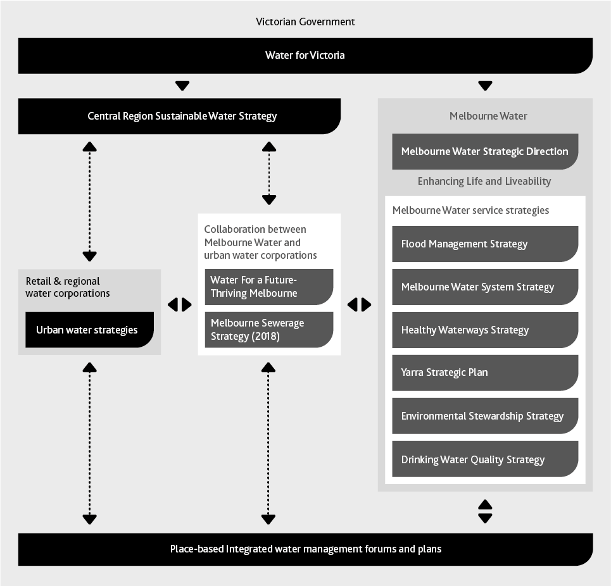

1.4 Victoria’s Regulatory Context
The water industry works within the policy context set by the Victorian Government and is committed to delivering policy outcomes, which are underpinned by a wide range of local, state and national policies and global goals focusing on improving community wellbeing, enhancing the environment and ensuring equity and affordability for all.
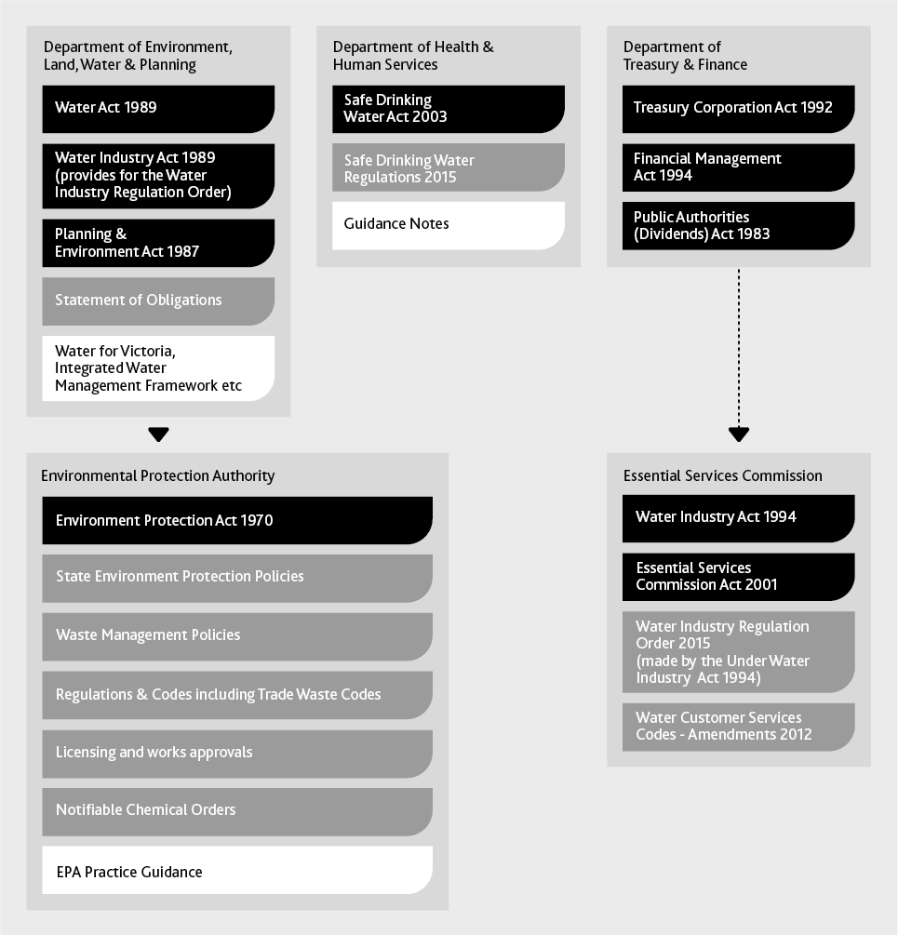

Figure 2. An overview of the existing regulatory framework for planning of water supply and sewerage services – text version
To ensure sewerage services deliver on their important benefits and responsibilities, a comprehensive legislative and regulatory framework exists. The Victorian framework has several regulatory bodies, each with different objectives, roles and responsibilities. Aspects such as environmental impacts, customer service, public health, and economic and financial performance are well regulated.
This regulatory oversight ensures accountability to our customers and community.
The Victorian regulatory agencies and their roles include:
Department of Environment, Land, Water and Planning (DELWP) sets the regulatory framework for the water industry. It provides the overarching policy framework that the industry works within, as well as administering statutory acts.
- Water Act 1989
- Water Industry Act 1989 (provides for the Water Industry Regulation Order)
- Planning and Environment Act 1987
- Statement of Obligations
- Water for Victoria, Integrated Water Management Framework etc.
Environment Protection Authority Victoria (EPA) is responsible for environmental protection and administers the Environment Protection Act 1970 (Vic) and the State Environment Protection Policies (SEPPs). Given the potential for negative environmental impacts from the sewerage system, treatment plants are licenced by the EPA. Compliance with each licence is assessed annually. The EPA also publish guidance for large-scale water recycling schemes. Recycled water management plans must be approved by the EPA. The responsibilities of the EPA are listed below.
- Environmental Protection Act 1970
- State Environment Protection Policies (SEPPs)
- Waste Management Policies
- Regulations and Codes including Trade Waste Codes
- Licensing and works approvals
- Notifiable Chemical Orders
- EPA Practice Guidance
Department of Health and Human Services (DHHS) is responsible for managing public health associated with safe drinking water. They deliver policies, programs and services that support and enhance the health and wellbeing of all Victorians (listed below). Recycled water management plans must be approved by the EPA and endorsed by DHHS.
- Safe Drinking Water Act 2003
- Safe Drinking Water Regulations 2015
- Guidance Notes
Department of Treasury and Finance (DTF) ensures that investment business cases offer value for money for the shareholder and are a prudent and efficient use of money. DTF are responsible for the following policies.
- Treasury Corporation Act 1992
- Financial Management Act 1994
- Public Authorities (Dividends) Act 1983
The Essential Services Commission (ESC) is the independent economic regulator for water in Victoria, who monitor water corporation performance through annual reporting, assess and approve price submissions, and develop water codes that specify services standards for water corporations in accordance with the Water Industry Regulatory Order.
- Water Industry Act 1994
- Essential Services Commission Act 2001
- Water Industry Regulation Order 2015 (made by the Under Water Industry Act 1994)
- Water Customer Services Codes - Amendments 2012
Working within a tightly regulated industry, with multiple regulators for each aspect of the operating environment, means that change takes time. While many external factors are changing rapidly, the policy and regulatory environment evolves at a slower pace.

1.5 Our Customers and Stakeholders
Melbourne’s five water corporations have a wide range of customers and stakeholders. Our customers include approximately 5 million people that currently call Melbourne home as well as the commercial and industrial customers whose sewage is transferred and treated to ensure it does not negatively impact on public health or the environment.
A summary of our stakeholders is included in Table 1.
Melbourne Water’s major sewerage customers are the retail water corporations, who have the direct interface with each sewerage customer.
The industry has many stakeholders, whose needs and interests in the sewerage system will continue to change and evolve. Each of these customers and stakeholders has different requirements of the sewerage system and the water industry must work closely with all these groups to ensure that decisions are best for the overall customers and community. Setting a clear direction for the future helps our stakeholders understand what our objectives are when it comes to making decisions.

1.5.1 Engagement Approach
Customer and stakeholder engagement is an ongoing activity for each the five water corporations involved in the development of this strategy. We have used existing information where the community has told us about sewerage issues for the development of this strategy.
The review of existing information included a customer insights audit of 23 documents, which included over 12,000 participants through 40 research and engagement activities.
In addition to making use of existing information, the water industry undertook series of engagement activities specific to the sewerage strategy, gathering insights from the community, local government, state government and Victorian industry representatives.
The strategy specific engagement included:
- Research into customer attitudes and the future of Melbourne’s infrastructure. This included 20 interviews, 2 focus group meetings, and engagement with local government and community groups.
- Engagement with Traditional Owner groups.
- A discussion paper and interactive survey through the ‘YourSay’ website, which returned 55 surveys.
- A social media campaign that received over 900 responses.
Findings from this engagement demonstrated that stakeholder knowledge and engagement with Melbourne’s sewerage system varies widely from being uninformed and largely uninterested to being highly engaged and knowledgeable about the system.

1.5.2 Government Stakeholders
Government stakeholders include local councils, government departments and government agencies. These stakeholders are generally well-informed and have had a high level of engagement throughout the development of the Sewerage Strategy. They understand the future challenges including the impact of rapid population growth, climate change and emerging contaminants and note the importance of integrating the strategy into broader government policy.
Government stakeholders are particularly interested in sustainability, resource recovery, the broader role of the sewerage system in waste management and in encouraging the community to act sustainably.

Table 1: Our stakeholders
Government and regulators | - Commonwealth Department of Environment and Energy.  - Victorian Government Ministers – such as The Minister for Water and The Minister for Energy, Environment and Climate Change.  - Department of Environment Land, Water and Planning.  - Department of Treasury and Finance.  - Department of Health and Human Services.  - Environment Protection Authority Victoria.  - Essential Services Commission.  - Department of Economic Development, Jobs, Transport and Resources.
Government agencies and advisories | - Metropolitan Waste and Resource Recovery Group.  - Sustainability Victoria.  - Councils.  - Infrastructure Victoria.
Traditional Owner Groups | - Bunurong Land Council Aboriginal Corporation.  - Boon Wurrung Foundation.  - Wathaurung Aboriginal Corporation (trading as Wadawurrung).  - Wurundjeri Land and Compensation Cultural Heritage Council Aboriginal Corporation.
Customers | - Industrial and commercial customers.  - Households.  - Businesses and schools.  - Horticultural businesses.  - Agriculture.  - Community Groups.  - Australian Industry Group.

Local government stakeholders are generally less informed about the sewerage system than other government stakeholders. They do show a growing interest in alternative water sources being able to maintain green open spaces. They have raised concerns about the need to protect public health where recycled water is being used in agriculture and industry.

1.5.3 End Use Customers
Our customers have told us of the need for a reliable, future thinking sewerage system that meets current needs, protects human and environmental health, responds to future stresses and looks to benefit capture.
Sewage management is not front of mind for most people. The community is generally unclear about how the sewerage system works, and are unaware that there may be challenges in the future. They do not think or talk about sewerage on a day to day basis. They have also told us that they are unclear on the roles and responsibilities of the different agencies responsible for regulating and delivering sewerage services. There is, however, some understanding that the sewerage system is fundamental to achieving good public and environmental health.
This suggests that there is a great opportunity to make information about the sewerage system more accessible and available. This will build awareness of sewerage system services and water industry roles and responsibilities, equipping our customers to play a greater role in co-designing a sewerage system that provides them services suited to their needs.
There is strong support among our customers for developing alternative water sources that include the use of stormwater and recycled water in order to preserve drinking water supply, as long as the uses are fit-for-purpose and cost effective. Affordability is a key focus for our customers, who have a wide variety of views on increased costs for alternative solutions, with willingness to pay varying widely between different groups.
In order to influence future sewerage system decisions we need to continue to improve our understanding of customer values through the use of innovative engagement and communication methodologies across multiple channels. This will enhance broader water cycle literacy and gain greater insight into community values and preferences around sustainable sewerage management.

1.5.4 Traditional Owners
A number of key Traditional Owner groups were consulted which included groups of the Kulin Nation. These included Bunurong Land Council Aboriginal Corporation, Boon Wurrung Foundation, Wadawurrung Aboriginal Corporation and Wurundjeri Tribe Land and Compensation Cultural Heritage Council.
Traditional Owners are in agreement that the overarching challenge for Melbourne is rapid population growth which accentuates other challenges, such as protection of environmental and public health. They indicated that the Sewerage Strategy Goals are generally aligned with the values of the Traditional Owner community.
As a priority they would like to see:
- Protection and promotion of Traditional Owner culture and history.
- Protection of environmental values – land, water and associated wildlife.
- Continuing involvement and partnerships with Traditional Owners in land and water management.

1.5.5 Engagement Actions
Action 1 supports us working with our customers and stakeholders to ensure we can deliver a sewerage system for the future that is valued by our community.

ACTION 1
LISTEN, INVOLVE AND ENGAGE WITH OUR CUSTOMERS AND COMMUNITY TO DEVELOP A SHARED UNDERSTANDING FOR THE FUTURE OF OUR SEWERAGE SYSTEM.
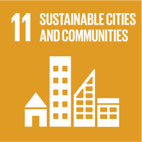

Outcomes
Customers understand and value the role of the sewerage system in the water cycle, environmental protection and resource recovery and have a greater role in sewerage system planning.
Traditional Owner cultural values are embedded into planning processes.
Customer values and expectations are aligned with our existing service levels and any proposed future services to provide greater value to our communities.

Next Steps
Understand where there are gaps in alignment between service provision and what customers value.
Develop an innovative, targeted and strategic communication and engagement plan that is integrated with other engagement activities, to support limits identified in the Adaptive Pathways.

1.6 About Our Sewerage System
Today, some 120 years since Melbourne’s sewerage system was first established, its primary function of protecting public health and the environment remains. The system has evolved to become a valuable community asset, underpinning liveability, as well as providing resource recovery opportunities that contribute to Melbourne’s long term sustainability.
Sewage is the water that has been used within our homes from our laundry, kitchen, bathroom and toilet. Businesses and industries also discharge water that has been used for a variety of industrial processes that may contain different contaminants to those found in sewage from our homes.
Many of the contaminants within sewage pose a risk to human health and the environment, hence it requires treatment before the water can be discharged to the environment. Figure 3 provides examples of the different components of sewage.

Figure 3. Composition of Sewage – text version
The figure shows several different materials entering a sewer pipe. The materials are labelled:
- Water
- Organic Waste (e.g. human excreta, food scraps)
- Inorganic waste (e.g. sand, soil, egg shells)
- Nutrients (e.g. nitrogen, phosphorus)
- Other contaminants (e.g. metals, cleaning compounds, pharmaceutical residues)
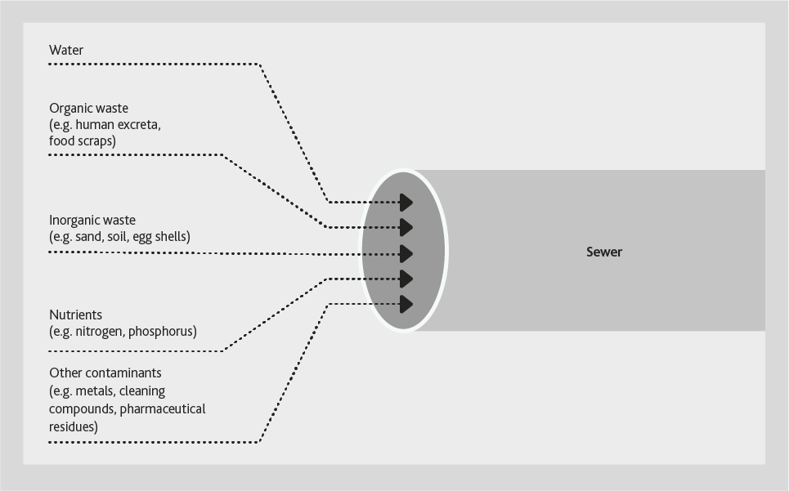

Sewage and Sewerage
Sewage is the used water within the sewer pipes and treatment plants before it has been treated. Sewage is generated in the Greater Melbourne catchment from a number of sources:
- Residential – generally all flows from kitchen, bathroom and laundry drains.
- Commercial – businesses including offices, restaurants and hotels.
- Industrial – include manufacturing processes for example chemical production, abattoirs and food production.
Commercial and industrial discharges of waste to the sewer are regulated as trade waste under the Water Industry Regulations (1995).
Sewerage is the term used to describe the pipes, pumps, treatment plants and all of the other components that make up our system.

Figure 4. Map of Melbourne’s Existing Sewerage System – text version
This figure shows the:
- Boundaries of each urban water corporation
- 26 local treatment plants and Western and Eastern treatment plants
- Melbourne Water and Urban water corporation sewers
Figure 4 provides an overview of the sewerage system which comprises:
- Melbourne Water sewers
- Urban water corporation sewers
- A network of over twenty five thousand kilometers of pipes and pumps that transfer sewage to our Western and Eastern treatment plants.
- 26 local treatment plants that treat sewage. Once treated, the water can be supplied as recycled water or safely released to the receiving environment, in accordance with EPA licence requirements.
- Water corporation boundaries of Western Water, City West Water, Yarra Valley Water and South East Water. The map shows Western Water to the North-West, City West Water in the South-West, Yarra Valley Water in the North-East and South East Water in the South-East and the Mornington Peninsula.
- Resources recovered from sewage, which include recycled water, biogas and biosolids.
- The land on which sewerage assets are located or which act as buffer zones.
- Receiving environments for treated water that include Port Phillip Bay, Bass Strait and many inland waterways, such as the Yarra River, Jacksons Creek and Merri Creek.
Appendix 2: Melbourne sewerage system overview provides further detail of Melbourne’s sewerage system.
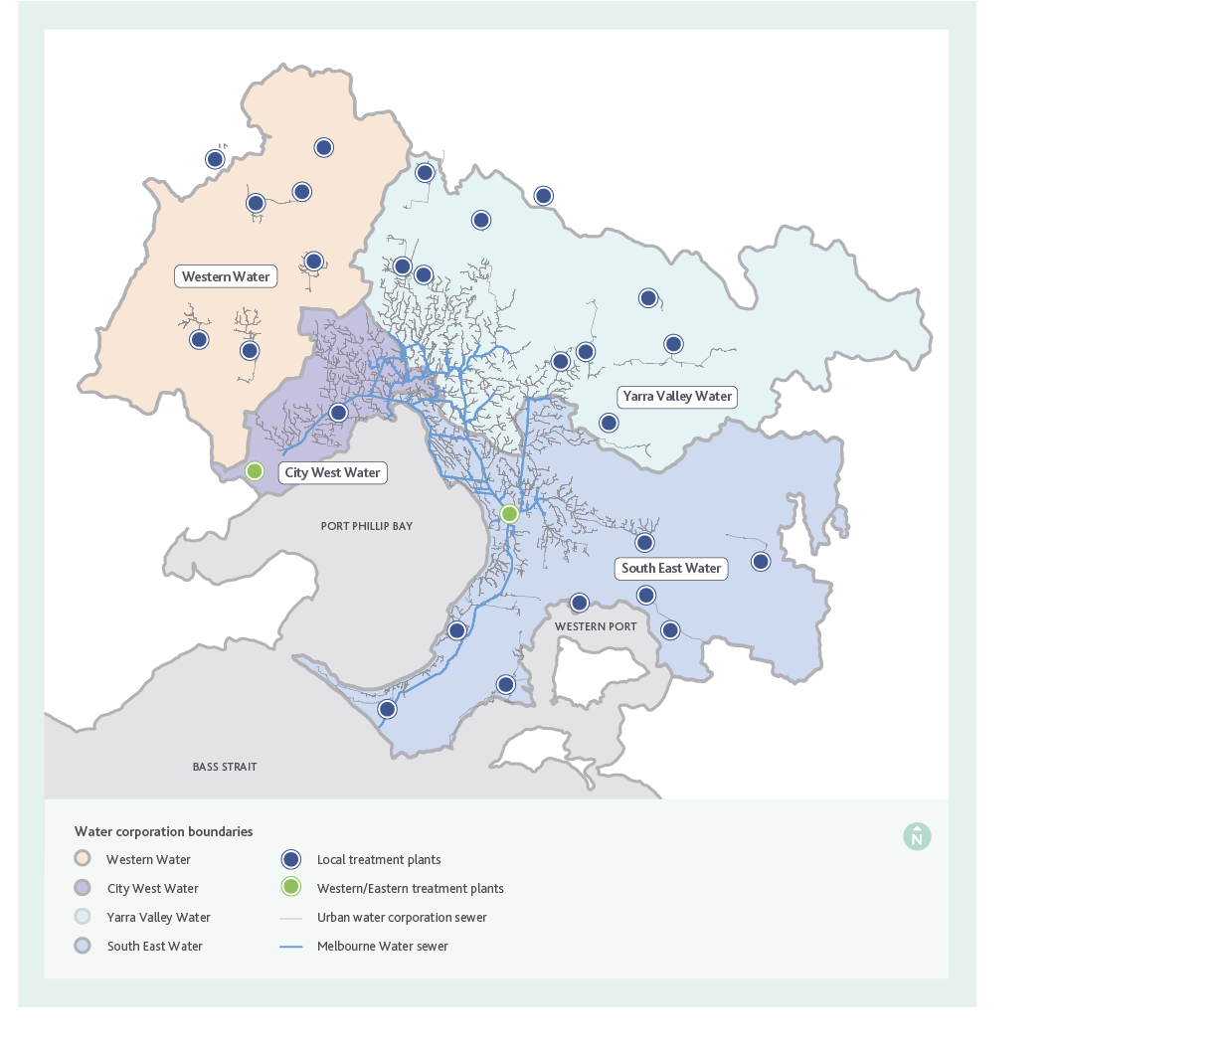

1.6.1 Our sewage treatment plants
Most of the sewage generated in Melbourne is currently transferred to one of Melbourne Water’s two large sewage treatment plants: the Eastern Treatment Plant in Bangholme or the Western Treatment Plant in Werribee. These two treatment plants process approximately 90 per cent of the total sewage generated, while the remaining 10 per cent is treated at one of 26 smaller local treatment plants located mainly around the fringes of Melbourne and operated by the urban water corporations.
Once treated, the water can be supplied as recycled water or safely released to its receiving environment. Eastern Treatment Plant, Mt Martha, Somers and Boneo treatment plants discharge under EPA licence to Bass Strait, while Western Treatment Plant and Altona Treatment Plant discharge under licence to Port Phillip Bay. Of the 26 local treatment plants, a number release treated water to inland waterways, including the Yarra River, while a number practice 100 per cent reuse with no routine discharge.
Each treatment plant uses different treatment technology, depending on the needs of the receiving environment that they discharge to, available land and the resources they recover from sewage. The main method for treating sewage across Melbourne involves physical and biological processes.
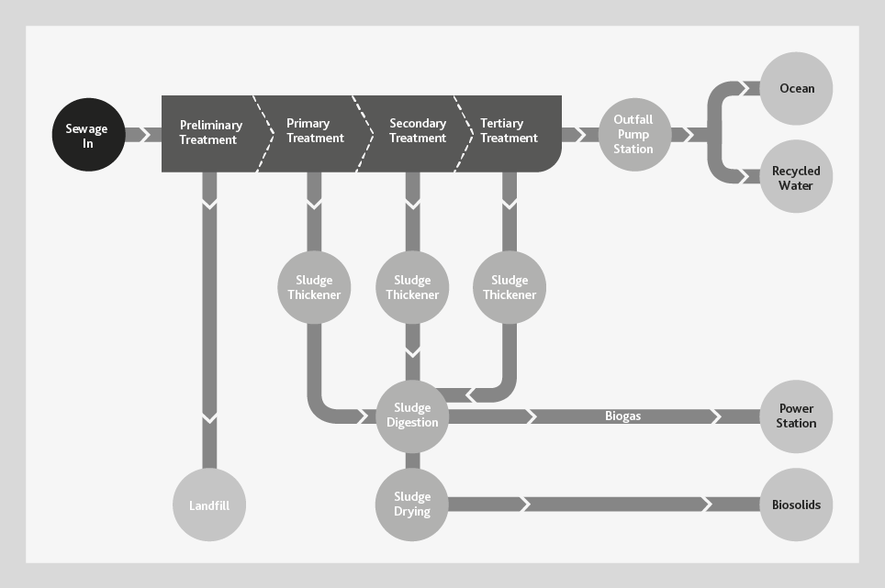

Figure 5. Eastern Treatment Plant sewage treatment process – text version
Figure 5 shows an example of how a sewage treatment process, such as at Eastern Treatment Plant, works. The Eastern Treatment Plant employs advanced tertiary treatment to protect the receiving marine environment at Boags Rocks on the southern Mornington Peninsula.
As sewage enters a treatment plant, it goes through the preliminary treatment process where materials such as rubbish, rocks and sticks are removed. These materials are generally washed and sent to landfill.
Organic solids that will settle are often removed next, followed by treatment for nutrients that are dissolved in the water such as carbon, nitrogen and phosphorus. The secondary treatment processes generally require the addition of air to support the biological treatment process.
At some plants, energy is generated through biological processes that operate without the use of air, converting carbon removed from the sewage flow as sludge, into methane rich biogas which can generate electricity and heat to power the treatment processes.
Treated residual solids that are removed from the process and dried (sludge drying) are known as biosolids, and can be safely used as soil enhancers or to generate more energy.
Treated water is disinfected to remove harmful pathogens before being reused or discharged to the environment.
The biological processes used in our sewage treatment plants are very efficient but can generate fugitive greenhouse gas emissions including nitrous oxide and methane. Melbourne’s water corporations have made carbon reduction pledges to assist the Victorian Government’s long-term target of net zero greenhouse gas emissions by 2050. The metropolitan water corporations are pursuing a target of net zero greenhouse gas emissions by 2030, consistent with Water for Victoria.

1.6.2 Resources from sewage
The three main resources currently produced from Melbourne’s sewerage system are recycled water, biosolids and biogas.
- 31 billion litres of recycled water is currently used annually for beneficial uses, which equates to approximately 10 per cent of sewage treated at Melbourne’s treatment plants, with Class A recycled water produced at 11 of Melbourne’s 28 treatment plants.
- Beneficial use of biosolids occurs from both the Western and Eastern Treatment Plants and a number of the smaller local treatment plants. For the remainder of the local treatment plants liquid sludge is discharged to Melbourne’s centralised sewerage system, where it is transferred to either the Western or Eastern Treatment Plants for treatment and reuse. The Western and Eastern Treatment Plants currently produce approximately 40,000 and 30,000 dry tonnes of biosolids per year, respectively.
- Biogas can only be generated at treatment plants that use anaerobic (without oxygen) processes to treat sewage. At both Western and Eastern Treatment Plants biogas is captured and transferred to onsite power stations where it is combusted into renewable energy (electricity). This renewable electricity is used to power the treatment plant processes at both plants. The Western Treatment Plant produces essentially 100 per cent of the plant’s power requirements. At times, electricity generation exceeds consumption and excess electricity can be fed back into the Victorian electricity grid.
The Eastern Treatment Plant generates 30 per cent of its power requirements. Other examples of energy recovery practices employed include:
- Mt Martha Treatment Plant – Biogas produced from the sludge digestion process is captured and used to heat the digestion process.
- Aurora Treatment Plant – Has a waste to energy facility next to the plant, which processes commercial food waste into clean, renewable energy. The facility uses anaerobic digestion to produce biogas which is combusted into renewable electricity. The facility produces enough energy to power the facility and the Aurora Treatment Plant. Any excess energy is fed back into Melbourne’s electricity grid.
A variety of other additional resources are available from our sewerage system including the potential to recover heat from sewage in the sewerage system for urban heating, and to generate products such as biofuels from the carbon in sewage, and alternative products from nutrients, such as nitrogen and phosphorous fertilisers. These resource recovery technologies are at various stages of technical development and commercial viability.

Section 2

Why do we need a sewerage strategy?
Melbourne is facing a number of challenges over the next 50 years as our population grows, the climate changes and the pace of change increases. We can no longer plan and do things the way we did in the past. In an uncertain future we need to be resilient and adaptable to ensure we can continue to provide valued, affordable services that protect public health and the environment, and support a prosperous, liveable city.

2.1 Supporting Broader Water Industry Outcomes
Melbourne’s water industry supports broader state, federal and international goals and concepts that drive equitable, affordable water and sewerage services and environmental sustainability. We need to meet these commitments and understand the opportunities these provide for change.

2.1.1 Sustainable Development Goals
The Melbourne water industry has made a commitment to support and promote the United Nations Sustainable Development Goals (SDGs). The SDGs (Figure 6) provide a common set of goals to put the world on a sustainable path by 2030 and have been adopted by 193 countries worldwide.
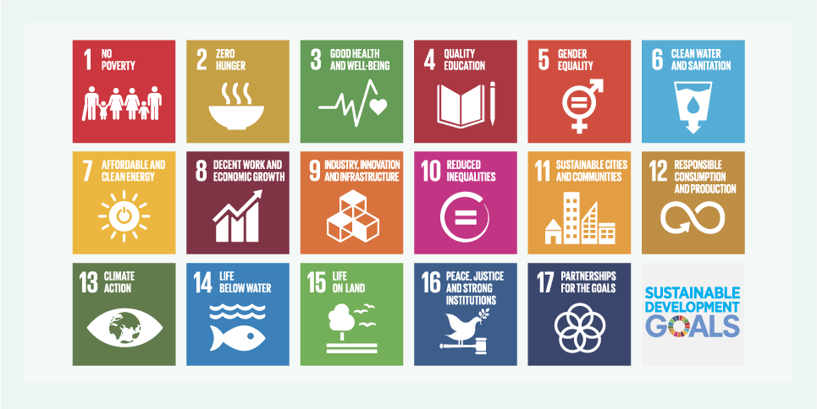

Figure 6. The United Nations Sustainable Development Goals – text version
The figure shows the icons for the 17 United Nations Sustainable Development goals, arranged in a 3 x 6 grid. The titles of the goals are:
- No Poverty. Icon shows four adults and two children holding hands
- Zero Hunger. Icon shows a hot bowl of food.
- Good Health and Well-being. Icon shows a heart and ECG line.
- Quality Education. Icon shows a book and a pencil.
- Gender Equality. Icon shows a combination of the male and female symbols with an equals sign inside the circle.
- Clean Water and Sanitation. Icon shows a cup full of water with an arrow coming out of bottom of it.
- Affordable and Clean Energy. Icon shows a sun with a power button in the middle of it.
- Decent Work and Economic Growth. Icon shows a growing trend with stylized buildings underneath.
- Industry, Innovation and Infrastructure. Icon shows four cubes stacked in a corner.
- Reduced Inequality. Icon shows an equals sign in a partially closed circle.
- Sustainable Cities and Communities. Icon shows two high rise buildings, on medium density building and a house.
- Responsible Consumption and Production. Icon shows an infinity loop with an arrow.
- Climate Action. Icon shows the earth as the pupil of a stylized eye.
- Life Below Water. Icon shows a fish under water.
- Life on Land. Icon shows the ground, a tree and two birds flying.
- Peace and Justice Strong Institutions. Icon shows a dove with an olive branch standing on top of a Judge’s gavel.
- Partnerships to achieve the Goal. Icon shows five interconnected rings in a circle.
The goals universally apply to all, aiming to mobilise efforts to end all forms of poverty, fight inequality and tackle climate change, while ensuring no one is left behind.
The Sustainable Development Goals provide us, our stakeholders, and our customers with a common framework to deliver improved community wellbeing and a better natural environment.
The vital role of clean water and sanitation in creating and delivering sustainable communities puts the Melbourne water industry in a key position to contribute to achieving the SDGs. Melbourne Water, Yarra Valley Water, South East Water and City West Water have made a formal commitment by becoming signatories of the United Nations Global Compact.
Water and sanitation are fundamental to achieving many of the SDGs and this Sewerage Strategy therefore has potential to contribute significantly to the Sustainable Development Goals including 2, 3, 6, 7, 8, 9, 10, 11, 12, 13, 14, 15 and 17. Relevant SDGs are linked to actions throughout the Strategy.

2.1.2 Integrated water management and water sensitive cities
Melbourne’s water industry is committed to integrated water management and driving towards becoming a water sensitive city. Both approaches are integral to achieving the desired outcomes of current water industry strategies.
As a provider of recycled water, the sewerage system plays an important role in integrated water management and water sensitive cities.

Integrated water management
Integrated water management brings together consideration of all facets of the water cycle to maximise social, environmental and economic benefits.
By considering the whole water cycle when planning and delivering services, as well as key interfaces with urban development and land and resource management processes, we can take advantage of links and develop solutions that have broader benefits over a long period of time. In doing so, we are reducing the number of decisions made based on the short-term, which are often influenced or restricted by the political, operating and economic environment of the day. This would not be possible if we planned and managed the water supply system, sewerage system, drainage system and waterways in isolation of each other.
Integrated water management is enabled by collaboration between community leaders, Traditional Owners, and planners from water corporations, councils, state government, catchment management authorities, end-use customers and businesses and other relevant organisations.
The benefits of integrated water management often extend beyond the solution to the initial problem. Water for Victoria outlines five key elements of resilient and liveable cities and towns that can be delivered through an integrated water management approach. These elements are presented in Figure 7.
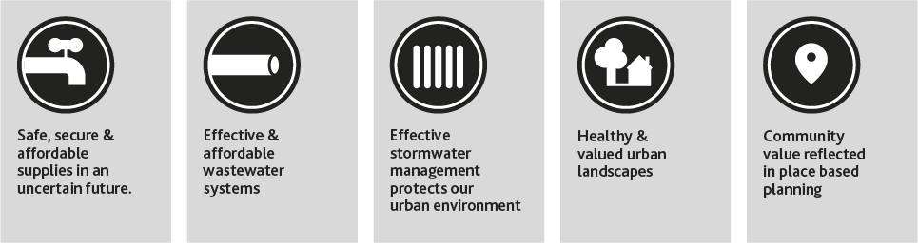

Figure 7. Water’s Role in Liveable and Resilient Cities and Towns – text version
The figure shows five icons in a row, each representing an element of resilient and liveable cities that can be delivered through integrated water management.
- Tap icon representing safe, secure and affordable supplies in an uncertain future.
- Pipe icon representing effective and affordable wastewater systems
- Five vertical lines icon representing effective stormwater management protects our urban environment
- Tree and house icon representing healthy and valued urban landscapes
- Map pin icon representing community value reflected in place based planning
The Integrated Water Management Framework for Victoria that has been produced by DELWP supports Integrated Water Management by helping the government, water sector and the community to work together to better plan, manage and deliver water in Victoria’s towns and cities.

Water sensitive cities
A water sensitive city is liveable, sustainable, productive and resilient through efficient and effective management of water resources enabled by holistic and collaborative planning. Integrated water management is one aspect required to become a water sensitive city.
It manages water in a transparent and equitable way that protects the health of receiving waters, provides water security for economic prosperity through efficient use of diverse water sources, mitigates flood risk and creates public spaces that mitigate urban heat and promote liveability. This is achieved by using a diverse portfolio of water sources, of which the sewerage system is a key component.
A water sensitive city is an aspirational goal that no city in the world has yet achieved. It is the result of a series of transitions that move cities through predictable pathways, from focusing solely on providing drinking water and removing sewage, to an interconnected and resilient network of built and natural assets supported and owned by the community.
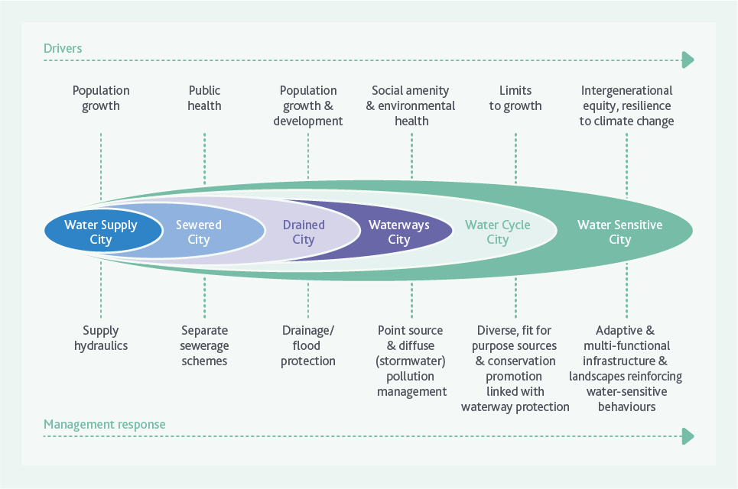

Figure 8. Transition phases to a water sensitive city¹ – text version
The figure shows each transition phase of a water sensitive city as an ellipse nested within the next transition phase, with the Water Supply City forming the basis and then expanding out through the other phases in the order below, finally reaching the Water Sensitive City, which encompasses all other transition phases. The drivers are shown above the nested ellipses and the management responses are shown below. These are outlined in the table below.

Driver | Transition phase | Management response
Population growth | Water Supply City | Supply hydraulics
Public health | Sewered City | Separate sewerage schemes
Population growth and development | Drained City | Drainage/flood protection
Social amenity and environmental health | Waterways City | Point source and diffuse (stormwater) pollution management
Limits to growth | Water Cycle City | Diverse, fit for purpose sources and conservation promotion linked with waterway protection
Intergenerational equity, resilience to climate change | Water Sensitive City | Adaptive and multi-functional infrastructure and landscapes reinforcing water-sensitive behaviours

2.1.3 Greenhouse gas emissions reduction
The Victorian Government has committed to a long-term target for Victoria of net zero greenhouse gas emissions by 2050.
The policy includes organisations, for example government agencies, ‘pledging’ to government to reduce their emissions.
Water for Victoria includes an action reflecting this wider process that states “Our water sector will be a leader in the state’s climate change mitigation and adaption actions.” This action commits Victoria’s water corporations to pledging a pathway to net zero emissions by 2050, with the metropolitan water corporations to also examine an option of accelerated progress to reach net zero emissions by 2030. Note that this accelerated target is not applicable to Western Water.
To achieve this, the Victorian Government’s Statement of Obligations (Emission Reduction) outlines the 2025 emission reduction levels to be achieved collectively and individually by each water corporation.
There are two different types of emissions considered. Scope 1 emissions, which are created during the treatment of sewage and are emitted directly from a site, and Scope 2 emissions, which relate to the use of electricity from the grid and are created when generating the electricity from non-renewable sources such as coal.
The water industry is currently the largest government emitter of greenhouse gases in Victoria, of which about 80 per cent of emissions are attributed to the sewerage system. In order to meet the carbon emission reduction pledge, significant changes will be required to the way we treat and manage sewage, including increasing capture of greenhouse gases, reducing energy use through demand management and efficiency, implementing new treatment technologies that reduce emissions and increasing the generation and use of renewable energy to power our treatment plants and pumping stations.

Integrated water management and water sensitive cities
Integrated water management and water sensitive cities are key concepts embraced by this strategy. For many years, the water cycle has been thought of as consisting of separate drinking water, stormwater, groundwater and sewerage systems. Significant inroads have been made in recent times through mechanisms such as government policy, precinct planning and sustainable water strategies. These take a more holistic approach that considers many diverse water sources. This Sewerage Strategy creates an opportunity to further integrate the sewerage system as a valued part of the urban water cycle.
The environment in which the water industry operates is well regulated to ensure public health and the environment is protected from any potential impacts of the sewerage system. The policy and regulatory frameworks have evolved over time and have achieved their objectives of protecting public health and the environment.
In more recent times, the operating environment has changed. As we look to deliver integrated water management outcomes, it has become clear that while our policy and regulatory frameworks are well suited to delivering outcomes for single areas of the water cycle, they do not work well when we look to deliver multiple outcomes, or when looking to use resources in ways that have not been done previously.
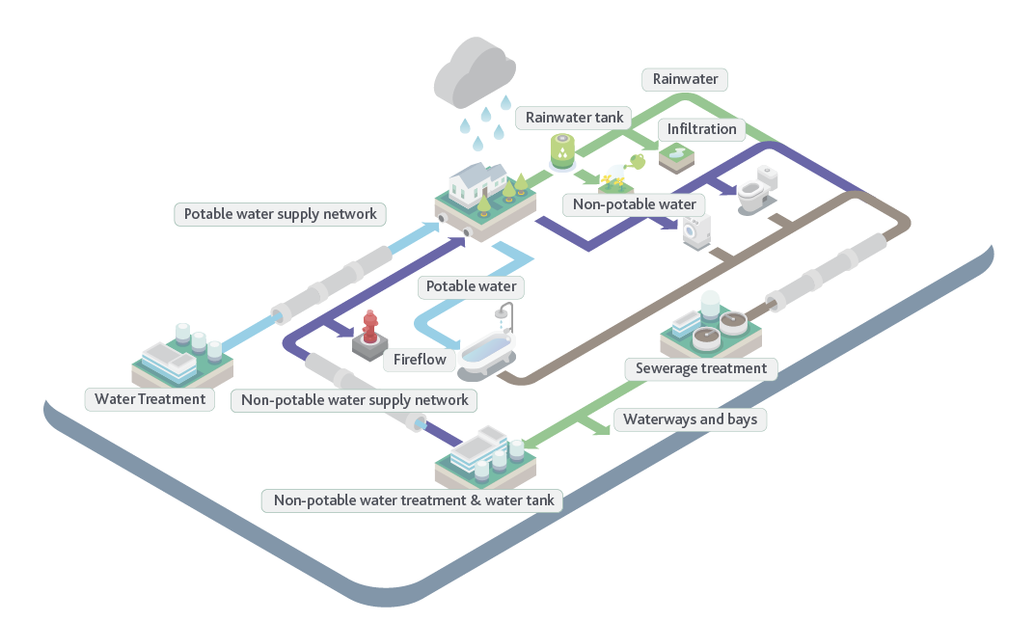

Figure 9. Melbourne’s Urban Water Cycle – text version
The figure shows icons of the different components of the urban water cycle, linked by the pathways that the water takes.
Water treatment: water is treated and joins the potable water supply network. This is supplied to residences as drinking water. Uses of this water include drinking, washing and food preparation.
Non-potable water treatment and water tank: recycled water is supplied via the non-potable water supply network. This water can be used for firefighting and is supplied to residences for other non-drinking purposes such as washing machines and toilets.
Rainwater: rainwater can be collected from residences via rainwater tanks. This water can be used for non-drinking purposes.
Sewerage Treatment: after water has been used it joins the sewer network which conveys it to the sewage treatment plant. Once treated the water is either discharged to the environment or reused for non-drinking purposes.

2.1.4 Sustainable waste management
In metropolitan Melbourne, food and garden waste make up approximately 28 per cent (around 805,000 tonnes every year) of everything we send to landfill. Our waste volume is expected to grow as our population grows. If we continue to manage waste as we have been, an estimated one million tonnes per year of extra waste will need to be disposed of to landfill by 2042.
Organics, and food organics in particular, have the lowest recovery rates of all waste types across the waste sector, with 1 per cent of food waste recovered annually, compared to an average of 73 per cent resource recovery across the industry.
Organic waste in landfills causes odour and vermin issues and contributes to leachate that can have significant impacts on local communities and the environment. This is driving a desire to increase the diversion of this recoverable waste stream. Sending organic waste to landfill also means there is a lost opportunity to produce energy from this material.
To address the challenges associated with organic waste management, the Victorian Organics Resource Recovery Strategy sets out a path to reduce greenhouse gas emissions from organic waste decomposition and to recover resources, which can be recycled by the agricultural industry or used to make energy.
The Statewide Resource Recovery Infrastructure Plan drew on this work and is enacted through Regional Implementation Plans.
The Metropolitan Waste and Resource Recovery Implementation Plan sets the following objectives for managing waste across Melbourne:
Reduce waste sent to landfill to increase the supply of viable resource recovery infrastructure, reduce pressure on existing landfills and reduce the need for new facilities.
Increase organic waste recovered to reduce the environmental and community impact of organics in landfill by minimising food waste and recovering more food and garden waste.
Deliver community, environmental and economic benefits to support a liveable and productive Melbourne with a resource recovery and waste network that provides jobs and economic opportunities, while reducing environmental and community impact.
Plan for Melbourne’s growing population to ensure Melbourne has the right resource recovery and waste infrastructure it needs in the right place, at the right time.
Considering that Melbourne’s sewerage system manages an estimated 1.6 million tonnes every year of solids associated with sewage flows from households, cafés and restaurants, as well as from food manufacturing and other industrial activities. This is mostly organic waste, equating to approximately 15% of the total solid waste generation in Melbourne. There is significant potential to divert more organic waste to the sewerage system, facilitating Victoria’s waste management objectives. Melbourne’s water corporations are already helping to address this organic waste challenge, through waste to energy plants like Yarra Valley Water’s ReWaste plant, and could play a broader role in the future of organic waste for Melbourne.

2.2 Our Changing Environment
In addition to role that the sewerage system has in supporting broader water industry goals and integrated water management objectives, our external environment is changing faster than ever.
Change is inevitable, and our city has changed significantly since the first homes and industries were connected to the sewerage system in the late 1890s to address public health and environmental issues.
Now that the pace of change is increasing, we can no longer plan for the future based on what happened in the past. The greatest certainty we have is that the future will be very different to the past.
We need to be prepared for change. Our plans need to be adaptable and flexible and take into account innovative new technologies that will enable us to meet the needs of future generations.
We need to work with regulators to manage these future challenges and changes, to ensure we continue to protect public health and the environment and deliver outcomes that are valued by our customers.

2.2.1 External factors
Our external environment is changing rapidly and there are numerous factors and trends that have the potential to influence the sewerage system and our ability to continue to provide an affordable sewerage service.
Figure 10 shows some of the external factors we may experience including changes to the urban form, climate change, changing sewage composition, the internet of things and cyber-attack.
The figure also indicates some interactions between factors that may either exacerbate or attenuate impact.

Figure 10. External factors that could disrupt the Melbourne sewerage system – text version
External factor | Risk | Linkage | Impact
Changes to the urban form | Increased urban growth and densification will place increased demand on sewerage systems. Future drivers of the urban form are unclear as new transport systems will revolutionise mobility in cities. | N/A | Physical
Cascading systemic risk | A disruption event in a major external infrastructure system triggers a series of cascading disruptions across the wastewater system. | N/A | Physical
Internet of things | Digital connection and automation of the sewerage system drives innovation and efficiency | N/A | Physical
Cyber attack | Digital customer data and automated and remotely operated infrastructure, are at risk through cyber-hacking. | The risk of cyberattack puts big data and the internet of things at higher risk of failure | Physical, Institutional, Customer
Changes in sewage composition | Changes to water & food consumption patterns and the introduction of novel chemicals, will modify sewage characteristics. | Encourages new microbial diseases | Physical, Customer
New microbial diseases | Anti-bacterial resistant and new pathogens emerge, creating public health risks from ‘superbugs’ and pandemics. | N/A | Customer
Climate change | Increases in the frequency and severity of extreme shock events could disrupt sewerage services, leading to environment and public health risks. Sea level rise, increased salinity in groundwater, and drought impact on tree root intrusion into pipes could disrupt sewerage services. | Extreme events disrupt external services causing cascading sewerage system failure (Cascading systemic risk). Changes in climatic conditions support new microbial diseases. | Physical, Customer
Rise of individualism | The rise of individualism could undermine the cross subsidised nature of the centralised system. | Exacerbates sudden disruptions caused by climate change impacts. | Institutional
Circular economy | Circular resource management models see wastewater and biosolids as a resource to be recovered and reused, improving quality of biosolids and managing risks from contaminants. | New sewer and treatment technologies drive changes in sewage composition downstream. | Institutional, Customer
New sewer and treatment technologies | Technological (hardware) advances change the way sewers are planned, where treatment facilities are located and how wastewater is reused. | Influences downstream sewage composition by enabling the circular economy and changed ownership models (Changed industry interaction). | Physical
Changed industry interaction | There is potential for change in the way that water corporations interact with each other and private industry in the future. | N/A | Institutional
Power shift to communities and customers | Citizens demand that decision-making shifts towards civic and local models of governance, taking greater control over the sewerage services they require. | Customers opt out of the centralized system, reducing equity in service provided (Rise of individualism). | Physical, Institutional, Customer
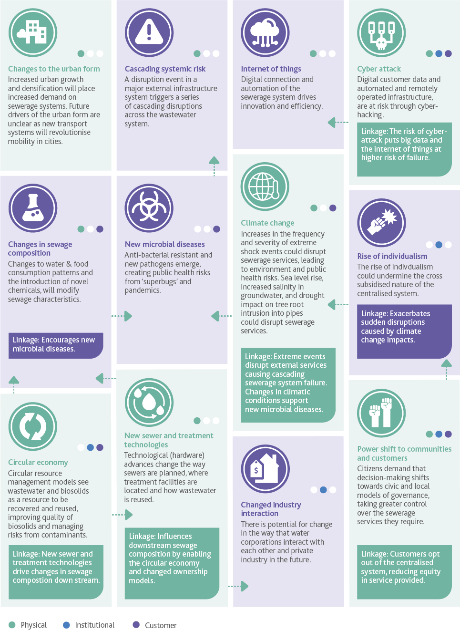

Climate change
Climate change means Melbourne is becoming a hotter, drier city. Sea level rise is likely to impact infrastructure such as the Western Treatment Plant. Other climate change impacts on the sewerage system include increased rates of odour and corrosion of our ageing network due to warmer sewage temperatures, and more intense storms that may see a need to upgrade infrastructure to ensure we remain compliant with environmental discharge requirements.
With climate change it is possible that more environmental water will need to be delivered to manage both water quality and water quantity.

Our growing population
Victoria in Future 2016 (VIF) official state government projections of population and households, show Victoria’s population is likely to continue to grow over the coming decades, and Melbourne’s population is expected to grow faster than the rest of the state.
Victoria is currently the fastest growing state in Australia, with Melbourne being Australia’s fastest growing capital city.
Victoria’s current population growth (of which Greater Melbourne forms the vast majority) is approximately 146,000 people per year. This is almost double historical records from the Gold Rush (70,000 per year in 1862) and the post-war ‘Baby Boom’ and migration period (76,000 in 1956). Melbourne’s growth has surpassed these historical highs for a decade, and projections indicate this will not slow down any time soon. However, we also know that, similar to previous booms, it will come to an end and could be disrupted by a range of events.
The latest projections from Victoria in Future suggest from a base of about 4.5 million people in mid-2015, Melbourne’s population could grow to 8 million people by 20502. According to the water industry’s extrapolation of this projection, the city may be as large as 10 million by 2070 (Figure 11).
Continuing to provide affordable sewerage services to a rapidly growing population and support broader goals, including integrated water management, is a significant challenge for the water industry.

Figure 11. Greater Melbourne population growth graph – text version
Figure 11. Greater Melbourne population growth based on Victoria in Future 2016 (VIF) and high and low uncertainties from ABS population projections.

Year | VIF | VIF - high | VIF - low | Historical
1980 |  |  |  | 2,472,000
1981 |  |  |  | 2,475,000
1982 |  |  |  | 2,486,000
1983 |  |  |  | 2,505,000
1984 |  |  |  | 2,524,000
1985 |  |  |  | 2,775,370
1986 |  |  |  | 2,808,880
1987 |  |  |  | 2,842,390
1988 |  |  |  | 2,875,900
1989 |  |  |  | 2,909,410
1990 |  |  |  | 2,942,920
1991 |  |  |  | 2,976,430
1992 |  |  |  | 3,009,940
1993 |  |  |  | 3,141,999
1994 |  |  |  | 3,154,438
1995 |  |  |  | 3,171,555
1996 |  |  |  | 3,199,810
1997 |  |  |  | 3,231,728
1998 |  |  |  | 3,264,872
1999 |  |  |  | 3,302,691
2000 |  |  |  | 3,344,758
2001 |  |  |  | 3,389,918
2002 |  |  |  | 3,437,820
2003 |  |  |  | 3,486,585
2004 |  |  |  | 3,530,341
2005 |  |  |  | 3,570,050
2006 |  |  |  | 3,608,931
2007 |  |  |  | 3,696,930
2008 |  |  |  | 3,796,069
2009 |  |  |  | 3,892,289
2010 |  |  |  | 4,004,687
2011 |  |  |  | 4,091,638
2012 |  |  |  | 4,241,062
2013 |  |  |  | 4,288,868
2014 |  |  |  | 4,344,533
2015 |  |  |  | 4,423,062
2016 |  |  |  | 4,526,445
2017 | 4,598,610 | 4,631,145 | 4,572,364
2018 | 4,703,067 | 4,779,568 | 4,642,656
2019 | 4,807,525 | 4,927,991 | 4,712,948
2020 | 4,911,982 | 5,076,415 | 4,783,240
2021 | 5,016,440 | 5,224,838 | 4,853,531
2022 | 5,120,897 | 5,373,261 | 4,923,823
2023 | 5,225,355 | 5,521,684 | 4,994,115
2024 | 5,329,812 | 5,670,108 | 5,064,407
2025 | 5,434,270 | 5,818,531 | 5,134,699
2026 | 5,538,727 | 5,966,954 | 5,204,990
2027 | 5,643,185 | 6,115,377 | 5,275,282
2028 | 5,747,642 | 6,263,801 | 5,345,574
2029 | 5,852,100 | 6,412,224 | 5,415,866
2030 | 5,956,557 | 6,560,647 | 5,486,158
2031 | 6,061,015 | 6,709,071 | 5,556,450
2032 | 6,165,472 | 6,857,494 | 5,626,741
2033 | 6,269,930 | 7,005,917 | 5,697,033
2034 | 6,374,387 | 7,154,340 | 5,767,325
2035 | 6,478,845 | 7,302,764 | 5,837,617
2036 | 6,583,302 | 7,451,187 | 5,907,909
2037 | 6,687,760 | 7,599,610 | 5,978,200
2038 | 6,792,217 | 7,748,033 | 6,048,492
2039 | 6,896,675 | 7,896,457 | 6,118,784
2040 | 7,001,132 | 8,044,880 | 6,189,076
2041 | 7,105,590 | 8,193,303 | 6,259,368
2042 | 7,210,047 | 8,341,726 | 6,329,660
2043 | 7,314,505 | 8,490,150 | 6,399,951
2044 | 7,418,962 | 8,638,573 | 6,470,243
2045 | 7,523,420 | 8,786,996 | 6,540,535
2046 | 7,627,877 | 8,935,420 | 6,610,827
2047 | 7,732,335 | 9,083,843 | 6,681,119
2048 | 7,836,792 | 9,232,266 | 6,751,410
2049 | 7,941,250 | 9,380,689 | 6,821,702
2050 | 8,045,707 | 9,529,113 | 6,891,994
2051 | 8,150,165 | 9,677,536 | 6,962,286
2052 | 8,254,622 | 9,825,959 | 7,032,578
2053 | 8,359,080 | 9,974,382 | 7,102,870
2054 | 8,463,537 | 10,122,806 | 7,173,161
2055 | 8,567,994 | 10,271,229 | 7,243,453
2056 | 8,672,452 | 10,419,652 | 7,313,745
2057 | 8,776,909 | 10,568,075 | 7,384,037
2058 | 8,881,367 | 10,716,499 | 7,454,329
2059 | 8,985,824 | 10,864,922 | 7,524,620
2060 | 9,090,282 | 11,013,345 | 7,594,912
2061 | 9,194,739 | 11,161,769 | 7,665,204
2062 | 9,299,197 | 11,310,192 | 7,735,496
2063 | 9,403,654 | 11,458,615 | 7,805,788
2064 | 9,508,112 | 11,607,038 | 7,876,080
2065 | 9,612,569 | 11,755,462 | 7,946,371
2066 | 9,717,027 | 11,903,885 | 8,016,663
2067 | 9,821,484 | 12,052,308 | 8,086,955
2068 | 9,925,942 | 12,200,731 | 8,157,247
2069 | 10,030,399 | 12,349,155 | 8,227,539
2070 | 10,134,857 | 12,497,578 | 8,297,830

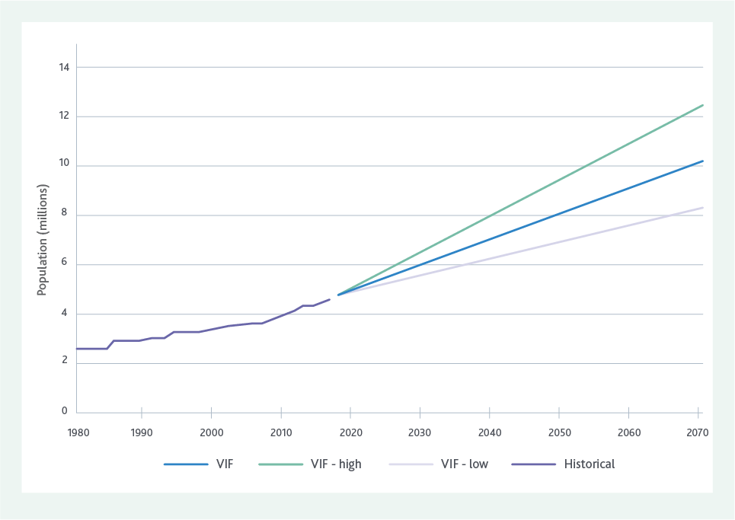

A changing urban environment
Population growth is driving change to the urban form. We no longer live in suburbs with large backyards, instead we have a mix of high and medium density along with sprawling suburbs on the fringe of the city.
The areas to the north and west of Melbourne are some of the most rapidly growing areas in Australia.
All of these different housing choices need sewerage services, and this means we can no longer have a ‘one size fits all’ approach to our infrastructure plans.
Increased housing density and population means we will need to provide more community green open space to support maintenance of Melbourne’s most liveable city status. Green open space requires water, and in a hotter, drier climate with a larger population, we will need to consider how we provide water for all of our community’s needs, including the enormous potential for the sewerage system to provide recycled water for greening open spaces across Melbourne.
A changing urban environment creates challenges for renewing our ageing assets, which are located around the central areas of Melbourne. A growing number of residents in central Melbourne means undertaking noisy renewal works at night can be disruptive to sleep.
Working during the day can be disruptive to traffic, people moving about the city, and for local business activity.
There is an opportunity to change the way we think about our sewerage assets, including the land on which they are situated. Many of our assets already provide multiple benefits to the community, such as supporting biodiversity and green open spaces. Existing examples include habitat for rare and threatened birds at Western Treatment Plant and the underground sewer mining facility at the MCG, which ensures the park receives sufficient water regardless of climate conditions and was built underground so as not to impact on surrounding parklands.

Meeting urban water demands
Residential water use makes up the largest proportion of Melbourne’s urban water demand, with industrial, commercial, agricultural and environmental water requirements all exerting a demand on regional water resources.
The Melbourne Water System Strategy identified a wide range of potential futures for Melbourne’s water resources, from a future with no shortfall, to a shortfall of up to 450 billion litres each year by 2065 if we experience high population growth and high levels of climate change. Water shortages will be exacerbated by high population growth occurring in the north and west, which will be increasingly difficult to service from existing water supplies and storages in the east.

Case Study
Fit-for-purpose water

Overview
In operation since the 1960s, City West Water’s Altona Treatment Plant was built to service an area now containing some 20,000 homes and numerous businesses.
Profound changes in operations over recent years now sees approximately 40 per cent of the average daily wastewater inflow of the 14 million litres per day (dry weather conditions) entering the now transformed plant supply approximately 2.5 billion litres per year of fit-for-purpose Class A recycled water.
More recently, the commissioning of three energy recovery devices to power reverse osmosis treatment has translated into significant energy savings, critical, given site usage represents close to 60 per cent of City West Water’s total energy consumption. Based on the most recent energy readings, City West Water can expect to save some 550,000 kWh per annum.
The plant provides its high-quality recycled water to nearby customers including Qenos (whose adjacent Altona manufacturing plant uses the recycled water for heat exchangers, boilers and for fire-fighting purposes) a range of local golf courses and Hobsons Bay City Council, where open spaces are turned green by the high-quality treated water leaving the plant.

Drivers for change
Customers and environmental stewardship are the key drivers for change at the plant. Two types of water, each one the perfect fit for the needs of the customers in question are produced.
In addition, there are the positive environmental benefits that, literally, flow from here – benefits meeting the increasing environmental stewardship expectations of customers and the community.

Outcome
The Altona Treatment Plant now stands as a symbol of contemporary change, driven by a customer-focused philosophy.
The changes have provided a safe, alternative water source, reduced the amount of treated sewage discharged to Port Phillip Bay and in turn the demand on our water catchments and drinking water.
Once a traditional sewerage treatment plant, it has evolved to be a fit-for-purpose recycled water plant saving significant amounts of drinking water – an outcome reflecting profound change in our customer-focus and environmental landscapes.
End Case Study
The Melbourne Water System Strategy proposes that every year, 80 billion litres of the water resource deficit could come from diverse sources of water in the future. There is potential for the sewerage system to play a key role in achieving this target.
Sewage is 98 per cent water with Melbourne currently producing approximately 320 billion litres of sewage per year. Approximately 10 per cent (31 billion litres) of this is currently recycled every year for a range of non-drinking purposes, however there is a significant opportunity to increase the amount of water used from our sewerage system to support the potential water resource shortfall of the future.
If we take an integrated water management approach and consider all sources of water available in the Melbourne area, including stormwater or that contained in the sewerage system, then a potential 450 billion litres deficit could be addressed by ensuring all our urban water is beneficially used. Utilising all our water sources provides the opportunity to potentially defer augmenting our water supply and will help drive Melbourne towards becoming a water sensitive city.

A drive toward a circular economy
A circular economy is an alternative to a traditional linear economy (make, use, dispose) in which we keep resources in use for as long as possible, extract the maximum value from them while they are in use, then recover and create new products and materials when they reach their end of life. It is also a fundamental principle of Industrial Ecology where resources are conserved and materials used again and again.
In Melbourne, our water cycle is largely a linear process where we use water and then dispose of it (and any contaminants) via the sewerage system for treatment prior to it returning to the environment.
With population growth, resource limitations and climate change, continuing with a linear process will increasingly present constraints on sewerage system operations.
Melbourne can no longer continue with a mindset of using our resources once, treating them to make them safe, and then disposing of them to the environment.
Increased resource recovery with a circular economy model is expected to deliver multiple benefits, including protection of the environment and human health, and enhanced economic resilience in a resource constrained future.
Enhanced resource recovery offers the opportunity to provide greater benefits for the liveability of Melbourne, supporting green open spaces meeting future waste management challenges, and reducing our carbon footprint.
Although previous sewerage strategies have identified the potential for using the resources within the system, and there have been government policies to encourage more reuse of resources such as recycled water, we have had limited success in realising their full potential. In the case of recycled water, uptake has been limited due to the challenges and costs associated with delivering it from where it is produced to where it can be used.

New technology
Technology is rapidly advancing and will drive change and facilitate realisation of opportunities. The increasing application of smart technology, increasing affordability of safe, micro-scale alternatives for water supply and sewage treatment, and the step-change underway in the availability and usefulness of big data will influence how we build, monitor and maintain the sewerage system.
By leveraging the data available, the water industry will be able to gain increased understanding of usage patterns and the nature of wastes in real time, which will enable us to optimise the operation of the sewerage system and provide a more integrated service to our customers.
The technologies to transfer and treat our sewage, and design, renew and maintain our assets is constantly evolving. We need to ensure we are able to make the best use of these innovations as they present themselves, to deliver greatest value for our customers.

Sewage composition and our changing industries

Impact of changing industries
Our industry and employment base has changed, with the decline of Melbourne’s manufacturing industry and the rise of service-based industries. The general change in Melbourne’s economy from manufacturing to services-based and the observed flat-lining of growth from some trade waste sectors in recent years, means we are expecting limited or no growth in sewage produced by major manufacturing industries.
The commercial sector, however, is projected to grow in line with employment forecasts, while food processing and retail, hospitality, cleaning and toiletry product manufacturing are projected to grow in line with population.
As an example, the reduction in major manufacturing discharges over time will lower its impact on sewage quality, resulting in proportionally higher nitrogen levels, as residential sewage is the main contributor of nitrogen in sewage.
This is likely to influence future decisions on sewage treatment plant processes and the cost of treatment.

Sewage quality management
Melbourne’s water industry manages sewage quality with the following key objectives:
- Safety of people, including maintenance workers and the community.
- Protection of assets, such as pipes and pump stations.
- Protection of treatment plant processes.
- Facilitation of regulatory and EPA licence compliance, including protection of receiving environments (water, land, air).
- Facilitation of resource recovery activities, such as production of recycled water and reuse of biosolids.
Each water corporation operates its own Sewage Quality Management System and trade waste departments which are supported by the Integrated Sewage Quality Management System (ISQMS) and are individually certified to ISO22000. ISO 22000 combines HACCP principles and a risk-based approach to Quality Management to understand, monitor, assess and control the risks to sewage quality and the various receiving environments for treated water.
Sewage quality management in Melbourne is a unique situation due to the structure of the water industry. The certification of the management system allows all water corporations to work together to achieve agreed objectives with respect to protecting sewage quality.
As required under the Bulk Sewage Agreement between each water corporation and Melbourne Water, the ISQMS has been developed and implemented to assist in both the day to day operation of sewage quality management and to inform longer term strategic planning.

Trade waste management
Trade waste management is a key element of sewage quality management. Discharge of liquid wastes from manufacturing and commercial industries to the sewerage system is regulated under trade waste regulations. Victorian Water law provides a framework of legislation, codes and guidelines that enable trade waste discharges to the sewerage system to be managed through trade waste agreements issued by the relevant water corporation.
In addition, the Essential Services Commission (the regulator of trade waste in Victoria) sets out the obligations of water corporations specific to trade waste services. It provides water corporations with a consistent transparent and timely decision making approach to trade waste management throughout metropolitan Melbourne.
Trade waste agreements set by water corporations aim to control which wastes can enter the sewerage system. The discharge of trade waste to the sewerage system means the system closely interacts with the commercial and industrial sectors and is integral to supporting economic development.
Recovery of resources for reuse, such as recycled water, can be impacted by levels of contaminants (such as salt) present in sewage. There is an opportunity to work with our industrial and commercial customers and regulators to better manage the risk of contaminants, while still supporting economic development.

Emerging contaminants
Emerging contaminants are contaminants with potential impacts on public health and the environment that are not yet well understood and are therefore are not yet well regulated. They include flame retardants, microplastics, anti-microbial resistant organisms and pharmaceuticals and have been the focus of public interest and scientific attention in recent years.
Through the ISQMS, Melbourne’s water industry is collaboratively working together to identify, assess and control both existing and emerging substances that may adversely impact sewage quality. Improving the understanding and management of new contaminants presents an opportunity to support the transition toward resource recovery by improving confidence in our products.

2.2.2 Other Factors

Industry structure
Melbourne’s metropolitan water industry is structured with Melbourne Water as the wholesale provider of water and sewerage services and Yarra Valley Water, South East Water and City West Water as the retail providers. With rapid population growth in the west, interactions between Western Water and the metropolitan water authorities are increasing.
Together, all five water corporations provide Melbourne’s sewerage service and this presents challenges in managing risks associated with factors such as sewage quality, emerging contaminants and population growth.
In order to manage these risks and take advantage of opportunities there is a need to be aligned in our vision and goals for the future. Further there will be a growing need for collaborative, transparent decision making across Melbourne’s water industry in order to provide an affordable, equitable sewerage service.
Increasing resource recovery represents an opportunity to derive greater customer and community benefits from the sewerage system.

Sewage as a resource
Increasing resource recovery represents an opportunity to derive greater customer and community benefits from the sewerage system. Resources may represent value not only to the water industry but to private businesses.
For example, sewage is a good source of carbon that can be used to generate renewable electricity. Melbourne’s water industry is already taking advantage of the carbon available in sewage to generate renewable energy on site to power treatment plants. As the need for businesses to become more sustainable grows, the value of carbon may rise driving private businesses to recover carbon to meet their own energy needs rather than discharging it to sewer.
Alternatively there may be interest from third parties in extracting resources from the sewerage system through activities such as sewer mining. In these cases valuable constituents are extracted from the sewage and the remaining lower value constituents are returned to sewer for treatment via the centralised system.
This practice could be seen as ‘cherry picking’ and results in harder to treat, lower value sewage that is currently not charged appropriately for through standard trade waste charges.
In both of these cases, there would be an impact on sewage quality and the ability of the water industry to not only recover valuable resources (including generation of renewable energy), but also potentially drive more costly treatment processes.
Cost and benefit reflective pricing for trade waste customers to discharge to sewer and the ability for the water industry to appropriately charge third parties to extract resources from the sewerage system, plays a critical role in managing sewage quality and resources for the benefit of all customers and community.
Third party access to sewerage system resources is not currently well regulated and there is risk that the broader customer and community group will bear the cost.

Why does this matter?
The rapidity and breadth of change in today’s world represents significant challenge but also great opportunity. Climate change, population growth and the changing urban environment especially are challenges that will significantly influence our future sewerage system, its features and the functions it needs to deliver. The drive towards integrated water management, water sensitive cities, emissions reduction and sustainable waste management will also be highly influential notably by opening opportunities for the sewerage system to deliver community value beyond that of protecting public health and the environment.
For example, as climate change moves us towards a drier climate, the sewerage system can provide an alternative source of water to contribute to urban water demands such as environmental flows and irrigation of green open spaces and food crops.
As our population grows and the urban environment spreads, a move towards expanding our centralised sewerage system and/or supplementing this with more decentralised solutions could support integrated water management and a greater role in the recovery of resources in organic wastes.
This strategy acknowledges the critical role Melbourne’s sewerage system has to play in maintaining a prosperous, liveable Melbourne through meeting urban water demands, sustainably managing waste and enhancing resource recovery. Adoption of new technologies and an enabling regulatory environment will be essential in supporting the agile, flexible and innovative approaches that will be required to fulfil this critical role.

Section 3

A New Sewerage Strategy
The policy and regulatory environment, the expectations and values of our customers and the ever present threats and opportunities presented by change requires Melbourne’s sewerage system to be flexible and resilient. We need to be well-positioned to realise opportunities and face our challenges to enable the system to remain affordable and equitable, and support broader liveability outcomes.

3.1 Our Vision
Melbourne’s sewerage system has the potential to not only continue to protect public health and the environment, but to deliver enhanced value through contributing to our city’s liveability. To do this, our Vision for Melbourne’s sewerage system is:
A resilient and adaptable system that supports thriving, healthy communities and a liveable, flourishing environment.

3.2 Our Goals
To achieve our Vision, we need to take measurable steps to reposition our sewerage system from being viewed as a waste disposal system to one that is a true resource recovery system and a key contributor to Melbourne’s future as a water sensitive city. We need to think about future generations of Melburnians and ensure that we are leaving a legacy that holds them in good stead for the challenges that they are likely to face, while maintaining the equity that our sewerage system provides to our customers and community.
The Goals are aspirational and are a stretch beyond what the industry currently delivers. They are reflective of a future where sewage is valued as a resource and industry, government and the community are united in striving for bold change.
These goals, although aspirational, are underpinned by the fundamental principle of ensuring safety and affordability for our customers and community.

3.2.1 Affordability
Ensuring affordability is fundamental to our regulatory principles and frameworks. The Essential Services Commission (ESC) undertakes price determinations for a prescribed regulatory period to specify the prices water corporations can charge their customers and how these are calculated for each water corporation.
The ESC has introduced a new pricing approach with financial, reputational and procedural incentives to create a better alignment between the interests of water corporations and the customers they serve. The main changes to the pricing approach are:
- A greater emphasis on the role of customer engagement to inform and influence the price submissions of water businesses.
- An incentive mechanism called PREMO (Performance, Risk, Engagement, Management Outcomes), which links the return on equity earned by a water business to the level of ambition in its price.
- New flexibility mechanisms to help ensure the pricing approach accounts for the diversity of the water businesses and their customers, and to allow for streamlined price review processes.
The PREMO model is designed to ensure our proposed actions in the short term maintain affordability for our customers.
By 2070, Melbourne’s metropolitan water industry will see the key features of our sewerage system helping to achieve the following Goals:

Melbourne Sewerage Strategy goals figure – text version
Human health and wellbeing (leaf and water drop icon)
The evolution of Melbourne’s sewerage system enhances human health and wellbeing, now and in the future.
Enhancing the environment (Large seahorse and small seahorse icon)
Melbourne’s sewerage system leads the world in protecting and enhancing natural assets including waterways, green spaces, biodiversity and marine environments.
Leveraging resources (Arrow cycle icon)
Melbourne will be recognised as a world leader in advancing the circular economy through our commitment to beneficially using 100% of our water and resources while ensuring affordability for current and future generations of Melburnians.
Community stewardship (Adult and child holding hands icon)
Our customers and community understand and care about the role the sewerage system plays in Melbourne’s liveability. This fosters shared stewardship and informs the services we provide.

An enabling policy and regulatory environment (Pipe icon)
Our collaborative policy, pricing, and regulatory environment fosters an adaptive, scalable, agile and innovative system that enables us to equitably meet Melbourne’s needs for the next 50 years and beyond.
Realising our Vision and Goals in the face of significant change and challenges will require making transformational change. Our current approach sees us focusing on using research and science to demonstrate how we can continue our operations as we reach system limits, then change our processes. For example, as we reach a point where we are approaching our licensed discharge limits, we might look to change our treatment processes and upgrade our plants in order to ensure that we continue to meet our regulatory requirements.
This largely relies on engineering solutions to address our challenges and continues to drive us to maintain the status quo regarding our approach to managing the sewerage system.
While this approach has served us well in meeting the challenges that Melbourne has faced in the past, if we are going to be prepared to tackle the challenges of the future and take advantages of opportunities as they arise, we need to change our approach. This does not mean that technology, research and science will not contribute to resolving our challenges, it only means that we cannot continue to rely solely on this approach in the future.
Figure 12 provides an example of how we need to work at the upper end of the spectrum for enacting change. Working to change world views and beliefs, is challenging, takes time to implement and is a different approach to the one usually taken when it comes to implementing solutions to our challenges.
Successfully changing our world views and beliefs offers the greatest opportunity for lasting and effective change that will support us in achieving delivery of our Vision and Goals.
To achieve our vision, we need to take measurable steps to reposition our sewerage system from being viewed as a waste disposal system to one that is a true resource recovery system and a key contributor to Melbourne’s future as a water sensitive city.

Figure 12. Spectrum of change – text version
The figure shows five different ways to change systems set on a chart. The X-axis represents the potential for system change, starting with weaker on the left moving to stronger on the right. The Y-axis represents the ease of implementation, starting with easier at the bottom and moving up towards harder, as well as speed of change with faster at the bottom and slower at the top.
The measurable steps are arranged in diagonally, with implementation becoming more difficult as the potential for change becomes stronger, it generally shows that the speed of change will be slower.
Measurable step | What is achieved | Ease of implementation | Increasing potential for system change | Speed of change
Changing rates and flows | Changing limits on existing processes | Easy | Weak | Fast
Changing feedbacks | Changing the process to counter undesirable effects | Easy | Weak | Fast
Changing networks | Targeting relationships and connectivity between systems (ie. IWM) | Moderate | Moderate | Moderate
Changing contexts | Targeting rules, governance | Hard | Strong | Slow
Changing world views | Targeting paradigms, values, beliefs and visions | Harder | Stronger | Slower

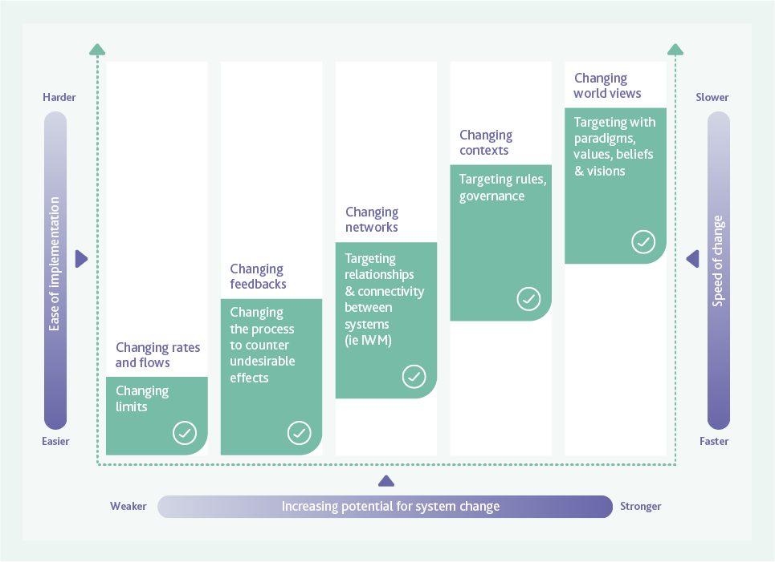

Section 4

The features of a future resource recovery system
To achieve our Goals and Vision, we must transform our system from a largely linear ‘treat and discharge’ system to a ‘resource recovery’ system that exemplifies the circular economy. Transformational changes will be required to realise the functions and features required in our future resource recovery system.
Melbourne’s existing sewerage system is based on a linear design, where we collect sewage, treat it to protect public health and the environment and then discharge treated water to the environment.
Only a small portion of the resources available from the sewerage system are currently reused. Recycled water distribution networks service some residential and industrial areas, while customers with a high water demand that are located close to recycled water sources also take advantage of this resource (for example; golf courses and agricultural activities). Nutrients and carbon are being recycled by applying biosolids to land in some areas and carbon is used to generate renewable energy where this is feasible.
In order for Melbourne’s resource recovery system to respond to the changing conditions described in Section 2.2, it must transform from a largely linear system to a system based on the principles of a circular economy. Figure 13 shows conceptually what this might look like.

Figure 13: Transitioning from a linear treatment system to a circular economy - text version
The figure shows the linear processes of the current sewerage system side by side with the cyclical processes of the future resource recovery system.
It shows that the current sewerage system protects public health and the environment by collection of sewage which is then treated. After treatment some goes to recycling and the remainder is is disposed to the environment.
In the future, the sewerage system will become a resource recovery system. The figure shows the cyclical process of sewage collection from customers and community, and the reclamation and recovery of resources, which are then returned to customers and community. At the centre of the diagram is Enhance public health and environment, showing that this remains a core feature of the resource recovery system in the future.
Becoming a resource recovery system requires an enabling policy environment, a supportive and engaged community, an improvement in resource recovery technology and improved infrastructure to support resource reuse.
The process of transforming the sewerage system into a resource recovery system will need action across the spectrum of change, from changing rules and limits within our processes, through to changing paradigms both within the water industry and in the minds of our policy makers, regulators, customers and community.
The resource recovery system of the future will still be required to collect sewage from homes, businesses and industry, but it may also include collection of additional materials, such as high strength organic food waste, that could present resource recovery opportunities. Treatment for safe discharge will transform to valued product generation that can support economic development and enhance public health and the environment.

Figure 14. Functions and attributes of our future system – text version
The functions and features of a future resource recovery system, (illustrated in Figure 14) will meet the needs and Melbourne’s industry, community and environment and drive realisation of the Strategy’s Goals and Vision.
The figure shows three layers of icons, representing that the top layer (goals) is supported by the middle layer (functions), which is supported by the bottom layer (features).
The top layer shows the five circular goal icons: The leaf and water drop icon (human health and wellbeing), the large seahorse and small seahorse icon (enhancing the environment), the arrow cycle icon (leveraging resources), the adult and child holding hands icon (community stewardship), and the pipe icon (enabling policy and regulatory environment).
The functions of the resource recovery system of the future are represented by rectangular icons and include:
Collects and recovers resources: Arrow cycle filled with water icon
Improves public health and wellbeing: Hand, palm facing upwards, with a heart resting on top icon.
Improves environmental health: Three different sized leaves icon.
Supports economic development: Four square columns increasing in size with a dollar symbol icon.
Improves the built environment and liveability: Two high rise buildings behind trees, a park bench and a hill icon.
Promotes an engaged, water sensitive community: Two adults and two children holding hands under a cycle arrow with water drops inside icon.
The features of the system of the future are represented in multi-coloured circles and include:
Affordable and Equitable
Safe
Net Zero Carbon Emissions
Smart
Resilient
Robust
Bespoke
Integrated
Beneficial
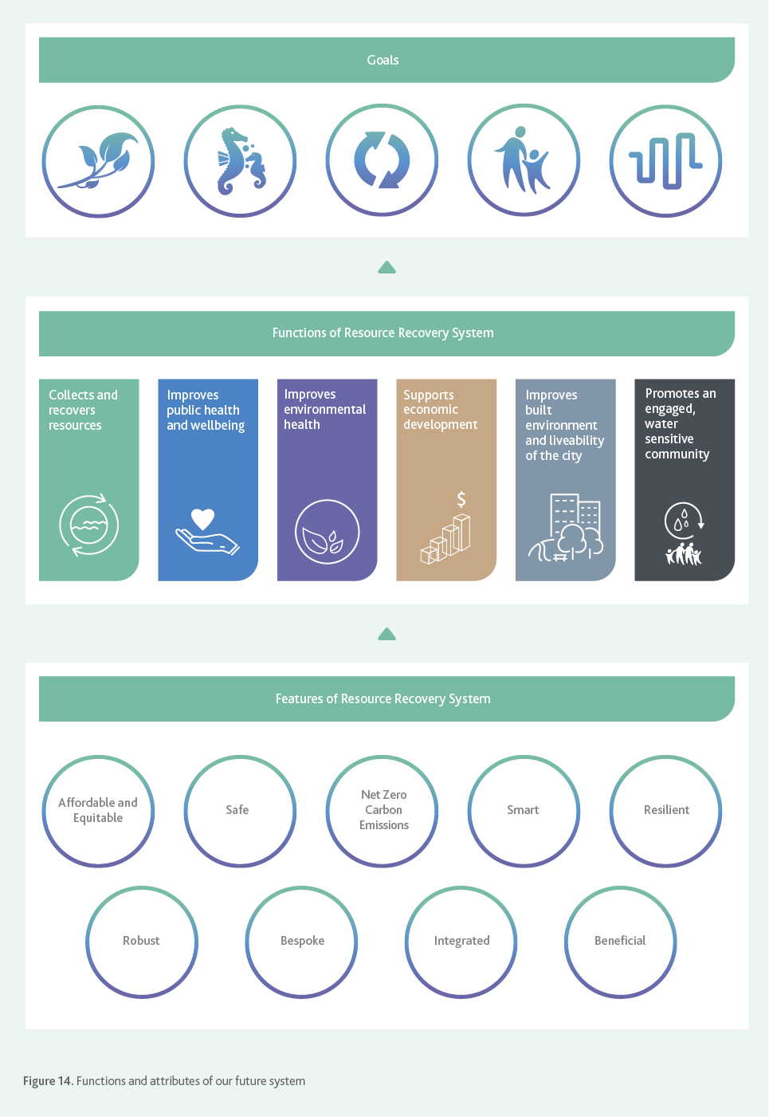

4.1 Functions of Melbourne’s Future Resource Recovery System
The functions define what the system must do to both fulfil its obligations and achieve the Goals set out in this strategy. The functions performed by the system will evolve as described below.
Improves public health and wellbeing. The system continues to protect human health and also proactively manages new risks, such as emerging contaminants. It supports improvements to community health and wellbeing, through the use of resources to support the provision of green open space to encourage recreation and urban cooling.
The system helps reconnect the community to nature and biodiversity within an urban setting by enhancing and connecting blue infrastructure (drainage and waterways) and green infrastructure (parks, open spaces and river and creek banks) to create a more vibrant, liveable city.
Improves environmental health. The system continues to protect environmental health by receiving and treating liquid wastes before they reach the environment. It plays a key role in enhancing our natural assets including improving waterway health and increasing the biodiversity values of our land, waterways and marine environments. Any discharges to the environment provide environmental benefits, while products of the resource recovery system are used to enhance environmental values or displace the use of resources that have a greater environmental footprint, (for example renewable energy displacing non-renewables).
Collects and recovers resources. The system will continue to perform the job of collecting residential, commercial and industrial sewage, including its embedded recoverable resources – water, organics, inorganics, nutrients, carbon and energy. The system collects and recovers other resources, such as energy and nutrients from food waste or water from contaminated sources, where this is the best community outcome.
The treatment systems will be designed not solely for making the products safe to discharge but for generating products that are valued as inputs to other industries, for use by customers or as beneficial to the environment.
Contaminants that are detrimental to resource recovery are collaboratively managed by the water industry, regulators, customers and suppliers to ensure the best outcome for both customers and the environment.
Supports economic development. The resource recovery system becomes a vital part of Melbourne’s economy that supports industry.
Our system is used to retain industries and attract new industries of the future through the use of our resources such as reliable, affordable, high-quality recycled water and providing secure, reliable and affordable energy sources for advanced manufacturing and water intensive industries.
The system supports and enables population growth and density where this is planned to occur. Economic development is further promoted by liveable and healthy environments supported by the resource recovery.
Becoming a resource recovery system requires an enabling policy environment, a supportive and engaged community, an improvement in resource recovery technology and improved infrastructure to support resource reuse.
Improves the built environment and liveability. The system improves the built environment by supplying valuable waste collection services in new and better ways. This includes products such as recycled water or heating and cooling to enable a better built environment. The system is flexible and adaptable and has the capability to support new and evolving built environment infrastructure.
Promotes an engaged, water sensitive community. The system plays a key role in building water cycle understanding and engagement with the community, utilising landholdings, education programs and customer interactions to progress towards these outcomes. Pricing, industry and regulatory structures encourage behaviour that is consistent with a water sensitive city.

4.2 Features of Our Future Resource Recovery System
The following features will enable the system to perform its intended functions. The system may not achieve all of these features equally in every part of the system, at the same time, or in the same way. For example, it may be more important to concentrate on resilience and robustness in some parts while other areas will have a strong need to be smart and realise multiple benefits. However the closer we get to achieving these features across the whole system, the more likely we will be to achieve the strategy’s Goals and Vision.
Affordable and Equitable. The decisions we make do not place an unacceptable economic burden on current or future generations, and products and services of the system are provided equitably to our customers.
Safe. The system and its products are safe for our customers, the community and our employees and contractors. Maintenance and improvement activities are able to be carried out without putting employees, contractors or the public at risk.
Net Zero Carbon Emissions. Emissions generated through the sewage transfer and treatment processes are minimised and offset. The system recovers renewable energy to displace emissions intensive electricity supply and any excess energy generated is exported to the grid. The system becomes an important supplier of distributed renewable energy generation and generates carbon offsets. This protects the system against energy price increases and mitigates climate change.
Smart. The system has the ability to self-monitor and diagnose faults and operational anomalies through the use of smart technologies, artificial intelligence, machine learning and data analytics. It contains real-time data and performance monitoring. Operations and maintenance are autonomous, or largely assisted by smart technologies and automation to minimise human intervention and error.
The system is ready to adapt to and integrate innovative new technologies and ideas. This will make our system safer and more affordable, while improving product quality for our recovered resources.
Resilient. The system includes capability to respond to climate change and other external shocks. Waterways and beaches are protected through reducing sewage spills. The system is able to cope with accidental, unauthorised and malicious inputs without creating debilitating process or infrastructure failures. We ensure that our planning processes are timely to maintain system resilience.
A resilient system will improve the quality and reliability of service and the production of recovered resources.
Robust. The system is protected against corrosion and premature failure that may arise due to increased sewage temperatures and changing sewage composition (such as from the acceptance of additional resources). Operational intervention and renewals are minimised, leading to a safer, more reliable system that causes less community disruption.
Bespoke. The system ensures that it meets evolving community expectations, changing regulatory and compliance frameworks and integrates with new technologies. It is able to respond with agility to changing needs to ensure it remains fit for purpose as new opportunities emerge, such as the recovery of more resources. The system is bespoke, to meet the needs of the immediate community that it serves, rather than adopting a ‘one size fits all’ approach.
Integrated. The resource recovery system, stormwater management, drinking water quality and supply, recycled water quality and supply and desalinated seawater form an integrated urban water system.
Beneficial. The resource recovery system is planned in conjunction with broader land use planning that is smart and makes the optimal use of land for community benefits. It engages customers by becoming an integrated part of an aesthetically pleasing, highly vibrant, liveable urban environment. Visitor centres and educational facilities are incorporated into the planning and design of resource recovery infrastructure. The community are engaged using language free from technical jargon and are an integral part of planning processes.
In describing the resource recovery system of the future, we have avoided specific technologies and options. There are many different ways in which we could deliver the Functions and the Features described in this section, including implementing new technology, changing the way we operate the system and changing our own and others’ perceptions of the value the system can provide to our community and customers. As technology progresses and our knowledge improves, new opportunities will appear and our approach to planning and decision making must be flexible enough to take advantage of these changes.

Section 5

Delivering the strategy - Adaptive Pathways
We are proposing a new approach to planning for our sewerage system that will ensure we are well informed and positioned to make key decisions for the future. The ‘Adaptive Pathways Planning’ approach embraces a deeply uncertain future and enables the water industry to proactively adapt and respond to changing circumstances and needs.

5.1 Why Adaptive Pathways?
Historically, the water industry has used a predictive planning approach that considers past conditions and decisions to anticipate our future infrastructure needs. In a rapidly changing world, it is no longer possible to make plans based on what has happened in the past. Nor can we prepare infrastructure blueprints that are difficult to adapt in response to change, or that do not consider the holistic implications of decisions.
We acknowledge that technical solutions alone are no longer sufficient to solve the challenges Melbourne is facing. We need a plan that is flexible and adaptable to change, that addresses the challenges that we face, works with the regulators and community and ensures that our technical solutions are innovative and effective.
Adaptive Pathways is an approach to help achieve transformational change, to take the sewerage system from a waste disposal system to a resource recovery system that is valued by the community for its role in protecting public health and the environment, and supporting Melbourne as a liveable, water sensitive city. It helps to ensure a whole of industry approach to decision making, which is a key factor in maintaining an equitable and affordable system. It also increases transparency regarding the consequences of making certain decisions in the short, medium and long term.

5.2 The Adaptive Pathway Approach
Adaptive Pathway planning identifies the key decisions that need to be made in the next 10 to 20 years, along with the information required to inform the decisions, taking into consideration a longer term view of the overarching Goals and Vision. The key decision points are determined when a system limit is reached that requires adaptation of the system, so it can continue to meet the needs of the community. Some decisions will enable future choices to be broad, others will close out options for the long term.
Once made, a decision will set the Melbourne water industry on a trajectory or ‘pathway’ toward our Vision and Goals. Since multiple decisions are made over the lifetime of the strategy, together they demonstrate how the system can be adapted over the long term, depending on the choices that are made. Adaptive Pathways ensures that decisions made are cognisant of the longer term context and take future decisions into consideration.
If the decisions we make for adaptation are made too early, there is a risk of adopting changes that are not consistent with reaching our Vision and Goals. If we make decisions too late, we risk not being able to achieve the transformation that is needed, and the system becoming outdated and no longer meeting the needs of the community.
The approach is not a ‘set and forget’ plan that documents our pathways, but a living, dynamic plan that is intended to be regularly reviewed and updated to reflect outcomes of previous decisions and new information on limits and options. This approach enables us to become more aware of the interrelationship between the system limits.
Below we describe the key elements of Adaptive Pathway planning and how they lead to improved decision making.

5.3 Knowledge, Values and Rules
A key concept of Adaptive Pathways Planning is that the greatest choice in responding to system limits and challenges occurs where there is alignment between our technical understanding (Knowledge), our social norms (Values) and our regulatory settings (Rules). The more options we have through alignment of these three elements, the more chance we have of delivering on our Vision and Goals while maintaining an affordable and equitable sewerage service.
In the context of Adaptive Pathways, Knowledge, Values and Rules are defined as shown in Figure 15.
Aligning each of these important pieces of information to inform decision making and maximise available options takes time. Community values can take upwards of 10 years to change, depending on the external circumstances, and knowledge takes time to generate.
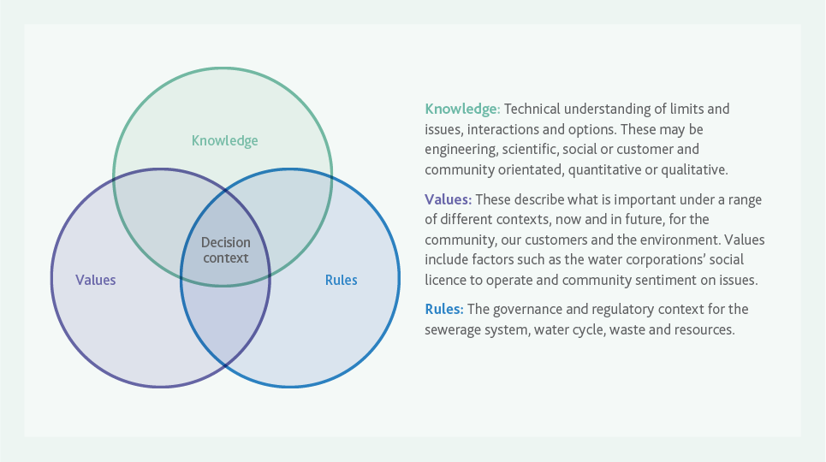

Figure 15. Intersection of Knowledge, Values and Rules identifies acceptable decisions – text version
The figure shows a venn diagram of three evenly overlapping circles. The top circle is labelled Knowledge, the bottom left circle is labelled Values and the bottom right circle is labelled Rules. The section in the centre where all three circles overlap is labelled Decision Context.
The text on the figure to the right of the overlapping circles states:
Knowledge: Technical understanding of limits and issues, interactions and options. These may be engineering, scientific, social or customer and community orientated, quantitative of qualitative.
Values: These describe what is important under a range of different contexts, now and in future, for the community, our customers and the environment. Values include factors such as the water corporations’ social license to operate and community sentiment on issues.
Rules: The governance and regulatory context for the sewerage system, water cycle, waste and resources.
Policy and regulatory changes also take time to instigate, implement and embed. Alignment of the Knowledge, Values and Rules helps to define which pathways we want to pursue and ensures that we are fully prepared to make decisions when they are needed.
Additional time to gather relevant information and approvals also needs to be factored in if there is a need for large scale infrastructure to be constructed as part of implementing a decision.
Shock events and crises can also lead to sudden changes in community attitudes that may be aligned, or otherwise, with our current direction.
This suggests making transformational change that comes from significant decisions requires significant planning and time to gather information in the lead up to making decisions.
Historically there have been times when we have not had our Knowledge, Values and Rules fully aligned when the time comes to make big complex decisions. This limits us in being able to deliver innovative solutions and leads us to doing more of what we know to resolve an issue for the short term. The adaptive pathways approach forces early planning work that addresses complex issues so that we are able to keep a broader range of solutions ‘on the table’ and make decisions that respond to our changing environment in a timely manner.

5.4 How Will We Deliver the Adaptive Pathways?
Adaptive Pathways requires an iterative and collaborative approach that includes:
- Identification and agreement on the system limits.
- Research to better understand agreed limits and their interactions, qualitatively and quantitatively.
- Engaging with our customers to understand their values and needs.
- Focused activities that fill gaps and bring together the Knowledge, Values, and Rules to position us to make timely, informed decisions that deliver best for community outcomes. These activities are identified for each key decision as part of the actions that will be undertaken to deliver the strategy.
Adaptive Pathways should be monitored, reviewed and updated regularly. This will facilitate incorporation of best available information and ensure we retain flexibility for future decisions.

5.5 System Limits
A system limit is the point where the environment has changed so much that the system is no longer able to perform its functions. Decisions need to be made that will adapt the system to the new environment, setting the pathway towards the desired future.
We know there are key limits that the sewerage system and other interconnected systems will reach in the next 50 years that will necessitate significant decisions. The decisions made when these limits are reached will either ensure the sewerage system’s relevance for future generations, or see it fail to adapt, creating greater challenges for future generations.
The scale of these decisions will range from the micro, such as a choice around the material for a sewer replacement, through to the macro, such as how to manage treated water from our sewage treatment plants once an environmental outlet reaches capacity.
A range of external factors including population growth, climate change, ageing infrastructure and choice around organic waste management will impact sewerage system limits and drive significant decisions that have the ability to create transformational change. These factors also influence the detailed infrastructure plans.
The interrelated nature of system limits creates a challenge for their management. Avoiding one limit may put increased pressure on another. This tension and quest for balance between all the system limits is critical when considering options to avoid unintended consequences on other key factors. Community values and expectations will also inform our choices.
There are many system limits that could impact on Melbourne’s sewerage system. Some of these limits will only impact a localised area of the network, while others will impact the whole of Melbourne’s sewerage system. Some will occur in the near future, while others are within a 10-20 year time frame. These are in addition to the long term system limits.
For the development of the Sewerage Strategy we focused on the highest level system limits to demonstrate the diversity of limits that the sewerage system will face during the life of the strategy.
In order to identify system limits, a series of workshops were held with representatives from each of Melbourne’s water corporations. Four system limits that will require significant decisions in the next 20 years were identified.
- Network and sewerage system limits (infrastructure focus)
- Environmental discharge limits
- Greater Melbourne waste limits
- Availability of fit for purpose water
Understanding these limits and the knowledge required to address them allows us to prepare to make decisions that support transforming our sewerage system and deliver our Vision and Goals.
As an industry we will adopt the adaptive pathways concept to address the four identified system limits.
Case studies demonstrating Adaptive Pathways in action are included in Appendix 3.

Figure 16. Adaptive Pathways planning overview – text version
The figure is conceptual drawing showing that there are many paths that we can take to reach our Vision and Goals.
The figure shows a diverse group of people, representing the community, at the bottom right. The people standing in front of three hills covered with multiple, divergent pathways, and are about to begin walking along the pathways. The paths are different colours, representing different adaptation choices that could be made.
Some paths become blocked, representing that they will only enable adaptation to certain point. Some parts of the paths are not visible to us in the picture, representing the uncertainties of the future.
Some paths are shown with dashed borders, indicating that they are not available to us presently because we haven’t aligned the Knowledge, Values and Rules associated with those potential options.
In the distance, at the end of all of the pathways is a vision of the city of Melbourne in the future. The picture shows the Eureka tower and multiple other buildings of a similar size. The picture also shows trees and water to represent liveable environment, that is supported by the sewerage system.
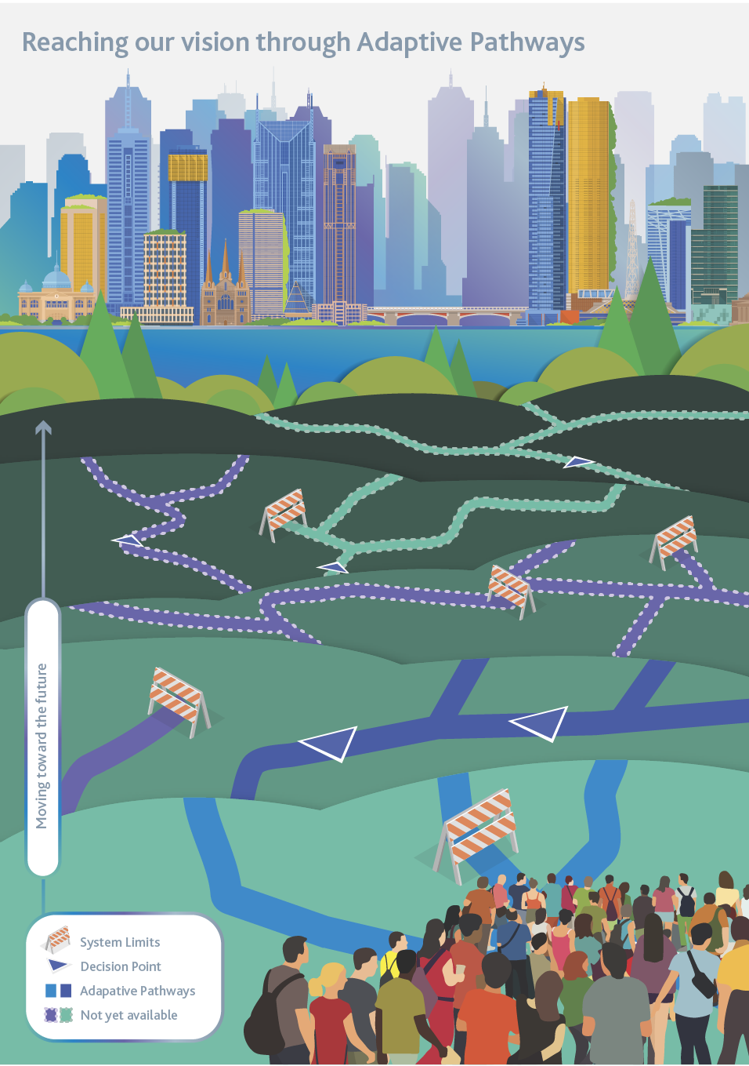

ACTION 2
ADOPT THE ADAPTIVE PATHWAYS CONCEPT TO ADDRESS THE FOUR IDENTIFIED SYSTEM LIMITS

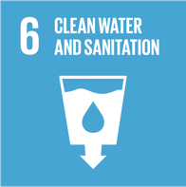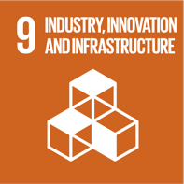

Outcomes
- Multiple pathways and options for addressing the limits have been developed, and the Knowledge, Values and Rules around each decision identified.
- Adaptive Pathways inform the development of future infrastructure plans.

Next Steps
- Confirmation, quantification and alignment of system limits identified by the Adaptive Pathways process by all five water businesses.
- An understanding of the indicators for trigger points that will initiate the requirement for a decision. This will include the requirement to understand and implement appropriate lead times to allow for planning to occur.
- Establish a monitoring program to identify when trigger points have been reached, similar to the ‘Annual water outlook’.
- A means of testing pathways against plausible futures and vulnerabilities has been implemented.
- Develop infrastructure plans to inform future Price Submissions for Melbourne.

5.6 Sewerage Network and Treatment Plant Limits
Sewerage network and treatment plant limits relate to the points where we need to make decisions about renewing or augmenting our assets to ensure they are safe to operate and maintain, and they can continue to provide a service to our customers.
We need to ensure that our future decisions enable a resilient system for current and future generations. Our drive toward efficiency in recent years has reduced the inherent resiliency of the sewerage system. For example, we are now facing challenges with asset renewals due to population growth. Increasing sewage flows has reduced the ability to divert large volumes of sewage for long durations to enable works to occur, either due to limitations on the sewerage network or the receiving treatment plant capacity.
To increase the resiliency of the system we need to ensure the industry is aligned and working to deliver a level of service that is fit for purpose and able to meet our customer and stakeholder needs for both the short and long term.
Our sewerage network and treatment plant limits are those that affect our sewerage system assets such as pipes and pumps and treatment plants. While there are a number of system limits we are facing in the coming years, which are included in this document, the list is by no means complete and requires further work to fully scope as part of developing the Adaptive Pathways and system limits.
This work will inform detailed infrastructure plans to manage our system for the future.
Melbourne’s sewerage system currently consists of:
- A network of over 3,000 km of large diameter pipes (300 mm or greater) (over 25,000 km including the reticulation system) and pumps that transfer sewage from homes and businesses to our treatment plants. We also have odour control facilities to prevent odour release from the sewerage network.
- Two large treatment plants, Eastern Treatment Plant (ETP) and Western Treatment Plant (WTP), and 26 smaller scale local treatment plants that process sewage, which can then be supplied as recycled water or safely released to a receiving environment. Biosolids are managed in various ways at each site and include stockpiling, beneficial reuse or transfer to alternative sites for management.
- Pipes to distribute recycled water to our customers and discharge treated water to a receiving environment.
Our planners are regularly making decisions around timing for treatment plant augmentation, sewer augmentation, asset renewals, odour control and land use planning. While some of these decisions are at the micro scale, each micro decision ultimately has a cumulative impact and can change the direction of the system for the future in terms of either enabling or limiting further transformation.
Diverting stormwater flows to the sewerage system, is an example of a micro decision that can impact on other system limits and the direction of the system for the long term. In some instances, stormwater could be diverted to the sewerage system in order to protect a local waterway.
While this could provide a good environmental outcome for waterway health, consideration needs to be given to the impact this will have on sewerage system’s network capacity, treatment plants, receiving environments and recoverable resources.
The timing of when the network and treatment plant limits will be reached also depends on factors such as population growth, the nature of the built form and the rate of climate change. The benefit of the Adaptive Pathways approach is to have completed work prior to reaching a system limit so we have sufficient information at the time a decision is made to enable a flexible and resilient outcome.
There are many decisions that need to be made to enable our existing assets to meet the needs of the future. These include decisions around managing ageing infrastructure, the best approach to asset renewals, augmentation timing and approach for our treatment plants, managing peak wet weather flows in the face of population growth and climate change, and septic tank management.
Figure 17 shows a forecast of sewage flows for the next 50 years, along with recorded sewage flows dating back to 1980. The forecast flows are based on average climate conditions and do not show the variations due to wet weather that are apparent in the historical flows.

5.6.1 Ageing infrastructure
Of the approximately 3,000km of large sewers that collect and transport Melbourne’s sewage, some are over 100 years old and were built when Melbourne’s sewerage system was first established.
Figure 18 shows that most of the old sewers are in Melbourne’s Central Business District (CBD), which are the areas that were first connected to the sewerage system in the 1890s. Older sewers in Melbourne’s CBD are mostly made of brick or concrete. Brick sewers have a higher potential to collapse due to displacement of bricks.
Concrete is more susceptible to structural failure from reduced pipe strength caused by corrosion. New sewers are built mostly at the fringe of Melbourne’s sewerage system to service the city as it grows.
Technology has allowed us to learn more about the behaviour of different materials, so over time, the materials have changed. For example, we know that gases, such as hydrogen sulphide,
released when sewage interacts with bacteria living in wet sewer walls, causes sewers to corrode.

Figure 17. Graph Showing Predicted Sewage flows – text version
Predicted sewage flows for Melbourne compared with historical flows
Year | Historical Flow Data  (Gigalitres per year) | Forecast Base  (Gigalitres per year) | Forecast Low  (Gigalitres per year) | Forecast High  (Gigalitres per year) | Forecast Very High  (Gigalitres per year)
1980 | 231
1985 | 251
1990 | 299
1995 | 290
2000 | 321
2005 | 316
2010 | 270
2015 | 299
2020 |  | 299 | 295 | 303 | 304
2025 |  | 304 | 296 | 313 | 315
2030 |  | 319 | 305 | 337 | 339
2035 |  | 338 | 317 | 364 | 366
2040 |  | 354 | 326 | 389 | 393
2045 |  | 372 | 337 | 415 | 419
2050 |  | 392 | 350 | 443 | 446
2055 |  | 409 | 361 | 468 | 474
2060 |  | 428 | 374 | 495 | 501
2065 |  | 446 | 386 | 522 | 528
2070 |  | 462 | 396 | 547 | 554

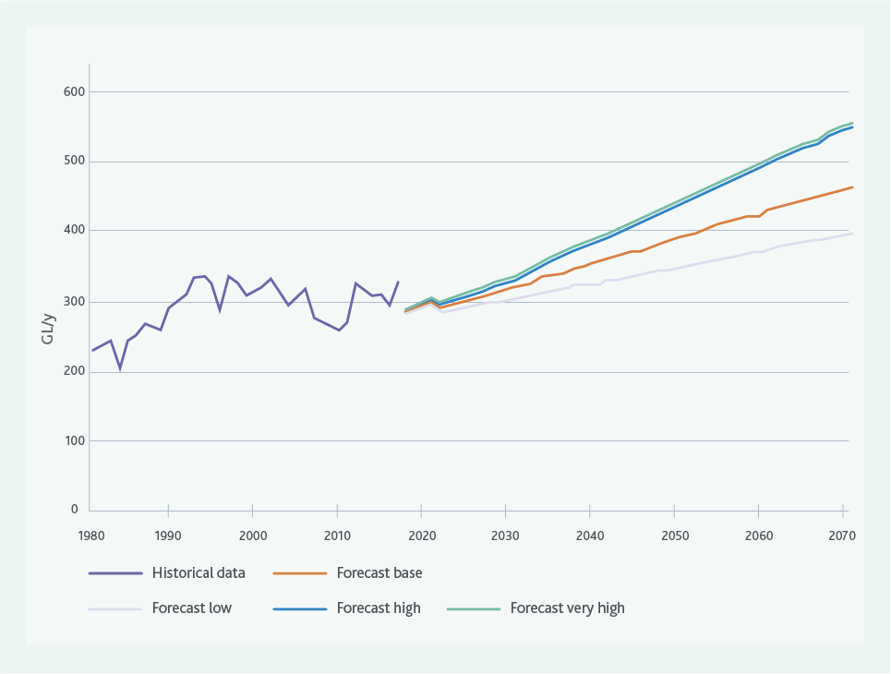

Figure 18. Map showing Melbourne’s existing sewerage system showing construction date by decade – text version
Melbourne’s sewerage system has been constructed progressively since the 1890’s to meet the needs of a growing population. Central Melbourne and the inner suburbs were the first areas sewered in the 1890’s. With the middle areas constructed between 1950 to 1970’s with the outer areas sewered since the 1970’s through to 2010’s.
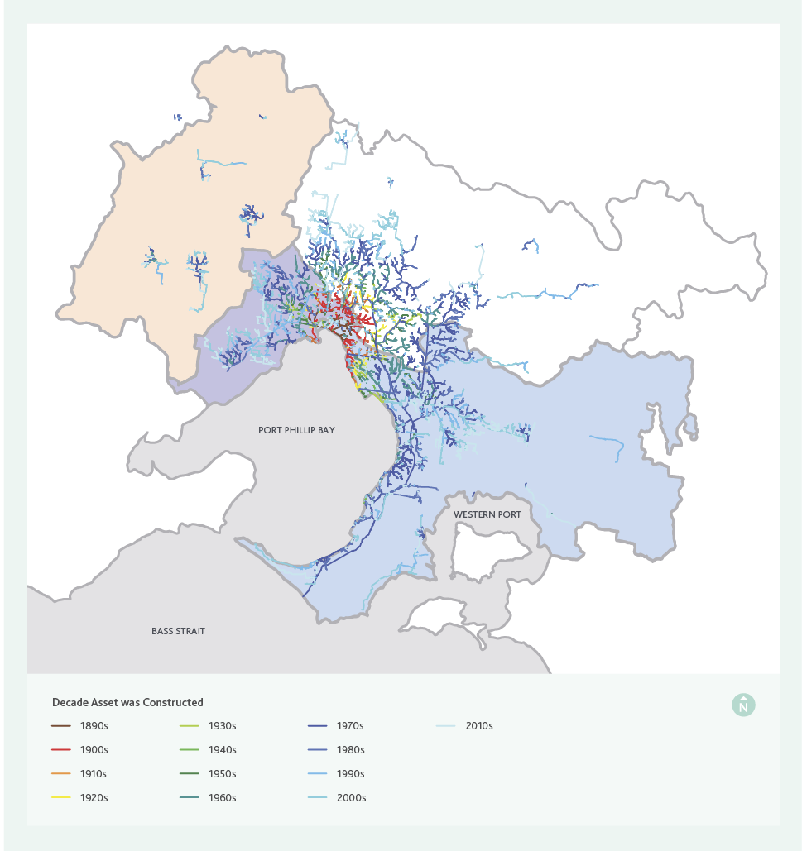

Hydrogen sulphide is also responsible for some of the odour that is released from our sewerage network. Sewage age, composition and the time it spends within the system also contribute to corrosion and odour. This means, where possible, we now use non-corrosive materials to build new sewers. However, there is still a challenge for maintaining and renewing existing brick and concrete sewers.
If the sewerage system’s role in waste is expanded (refer section 5.8) to include acceptance of high strength organic waste, this is likely to shorten the time before critical network and system limits are reached.
Increasing the organic waste content in sewage is one of the causal factors influencing corrosion rates in concrete sewers, as it increases the rate of hydrogen sulphide production in sewage.
When hydrogen sulphide is released from liquid to gas phase, bacteria living on the wet sewer walls and roof converts the hydrogen sulphide to sulphuric acid. Over time, the pipe strength is reduced, and structural failure can occur.
Decisions made about the materials used for sewer renewals is one example where multiple micro decisions can have a macro impact. The choice of sewer material for renewals is impacted by cost, but choosing on cost alone can have an impact on other limits such as how the sewerage system manages organic waste in the future.

5.6.2 Managing asset risk
To ensure our sewerage system continues to safely collect and transfer Melbourne’s sewage, we use technology, such as CCTV footage of our sewers to understand where pipe failure may occur. A range of information is used to give a risk score to each sewer in Melbourne’s sewerage system, from low to extreme risk of failure.
We prioritise investments in our system to ensure our sewers continue to operate at least cost to the customer.
Each water corporation also has an annual program to assess and replace high risk sewers. Less than 1 per cent (by length) of sewers have an extreme risk score and only 15 per cent have a high risk.
Since older sewers that are more likely to become an extreme risk are mostly located in and around Melbourne’s CBD, replacing or renewing these aging assets in the future is likely to be a challenge. This will require collaboration between utilities to minimise the impact on our community.

5.6.3 Treatment plant capacity
Most of the sewage generated in Melbourne is transferred to one of Melbourne Water’s two sewage treatment plants; Eastern Treatment Plant in Bangholme or Western Treatment Plant in Werribee.
26 smaller treatment plants service local areas across Melbourne. These plants are mainly located around the fringe of the metropolitan area.
To minimise customer bills Western Treatment Plant and Eastern Treatment Plant are planned and managed to closely match their treatment capacity to customer demand, which typically grows in line with the population growth rate (currently around 2 per cent per year).
Augmentation of the plant capacity generally does not involve large scale ‘end to end’ process augmentation as this would be inefficient, leading to times where assets are under utilised immediately after augmentation. Instead there is selective targeted investment in individual process units to unlock smaller incremental capacity gains closely matching the growth in sewage flows and loads from our customers. This typically means that, at any given time, there is an upgrade underway at one of the two treatment plants.
A number of local treatment plants are also nearing capacity, with a number of major upgrades currently underway, such as at Sunbury Treatment Plant, or planned for the near future, such as at Boneo Treatment Plant.
Approximately 10 per cent of Melbourne’s centralised sewerage system can be diverted to either Western Treatment Plant or Eastern Treatment Plant. This allows Melbourne Water some limited ability to manage the balance of flows and associated treatment costs at each treatment plant and to manage wet weather flows in aging assets near the CBD. As we plan for transfer asset renewals and treatment plant upgrades in future, a holistic approach is needed to ensure the timing and location of system upgrades are optimised to drive efficiency and affordability for the community.
This includes continuing our current approach that considers centralised and decentralised options on a case by case basis. All these decisions need to consider the likely impacts on the network limits, the receiving environment limits and waste limits.

5.6.4 Peak and wet weather flows
As Melbourne’s population grows, more sewage is generated. Sewers must be large enough to collect and transfer this sewage to a treatment plant. On a dry day, most of Melbourne’s sewers are half full during peak flows, indicating they have spare capacity for more sewage flows during dry weather. There are diurnal peaks in dry weather flows that occur due to water usage patterns by households and industry, with a peak generally occurring in the morning and again in the evening.
Increasing dry weather flows reduces our window of opportunity to undertake routine inspections and maintenance activities.
When it rains, stormwater enters the sewerage system through cracks in pipes or improper connections at the household level. Flooding over manholes and access points also contributes more water to the sewers during very wet weather. Our sewers must be large enough to collect and transfer this water along with any sewage that is already in them. This is known as wet weather capacity. Groundwater can infiltrate through cracks in pipes contributing to flows in our sewerage system in both dry and wet weather. Comparison of dry and wet weather flows in the sewerage system show a significant increase in flow during and after wet weather events.
EPA set the wet weather capacity standards that the sewerage system must meet in order to comply with the State Environment Protection Policy (Waters of Victoria). This standard states that sewers must contain flows associated with a 1 in 5 Average Recurrence Interval (ARI) rainfall event, which is roughly an event that happens once every five years. This is a stringent standard by world standards and is highly protective of the environment.
Sewer spills can exert physical, chemical and biological impacts on the receiving environment, resulting in risks to human health, environment and aesthetic values, which can be both cumulative and acute. The purpose of the containment standard is to minimise these risks by ensuring that the spills only occur in extreme wet weather.
Depending on the sewerage catchment characteristics, short and long duration rainfall events can be used to assess reticulation and trunk sewer wet weather flow capacity, respectively. We use hydraulic models to simulate these rainfall events and their predicted impact on the sewerage system. These tools help us plan and prioritise system upgrades.
Detailed planning work is ongoing to understand areas where sewers may spill and the options to address these are undertaken as part of our current planning approaches.
The sewerage system contains assets called Emergency Relief Structures. An Emergency Relief Structure allows for a controlled release of flows to a waterway from the sewerage system during large wet weather events only (greater than 1 in 5 ARI).
These structures are not used on a day to day basis and allow for emergency release of sewage, rather than spills occurring in domestic residences and heavily populated areas. The sewage released during wet weather events is highly diluted from stormwater intrusion and the increased flows in the receiving waterway, however it can still impact on human and environmental health. To prioritise and manage the impact of these discharges, we will incorporate the recommendations and priorities identified in the Healthy Waterways Strategy.
One challenge we face is the uncertainty about the impact climate change may have on the frequency and intensity of rainfall and subsequently, whether this will lead to increased activation of our Emergency Relief Structures. The impact this has on waterways will need to be managed into the future to ensure the environment is not affected.
When addressing capacity limits across the distribution network, this has a flow on effect for treatment plant upgrades. There needs to be a coordinated, risk-based, planning approach across the entire network to ensure there is sufficient treatment capacity prior to the start of the upgrades or maintenance work across the distribution network.

5.6.5 Biosolids
Biosolids are the solid organic material remaining after sewage treatment. Once dry, this material has similar properties to soil and contains varying degrees of carbon, nitrogen, and phosphorous. Metals such as copper, nickel and zinc and other emerging contaminants often end up in biosolids and these can limit end uses.
EPA regulates biosolids storage and how it can be safely reused, while protecting the environment and public health.
Challenges arise due to limited understanding and alignment between technical knowledge, social and community values and the policy and regulatory environment overseeing the beneficial reuse of biosolids.
Biosolids have been reused in land application for agricultural purposes, or as construction material, such as landfill geotechnical capping, on an intermittent basis. Disposal via landfill is cost prohibitive, wasteful of the resource potential, and would not be aligned with the Environment Protection Act, EPA guidelines, or government waste policies.
Technological advancements, as well as market development to provide more financially sustainable alternatives, are required to enable us to leverage greater reuse opportunities from biosolids. By broadening the understanding of the role our sewerage system plays from one of waste disposal to one of resource recovery, we will open opportunities for further reuse of biosolids.
Regulation also has a role to play in the wider use of biosolids in future. This is not only related to managing the storage and reuse of biosolids, but also in helping to address the contaminants that enter the sewerage system in the first place.
At Western Treatment Plant, Melbourne Water are developing a specific biosolids Environmental Improvement Plan, which will propose a suitable timeframe for 100 per cent sustainable reuse of annual average biosolids production.

Case Study

Melbourne Sewerage Strategy – Enhancing Our Dandenong Creek program

Overview
The Enhancing Our Dandenong Creek program was a five-year pilot of best practice sewerage management, developed in partnership between the community, local businesses, Councils, EPA and Melbourne Water. The project has taken a risk-based, waterway health outcomes-focused approach to management of wet weather sewage overflows to Dandenong Creek.

Drivers for change
Melbourne Water has been progressively investing in larger sewers to meet sewage containment requirements since 1992. The Ringwood South Branch Sewer remains one of the last few sites which do not meet the 1 in 5 year ARI containment target in the State Environment Protection Policy (Waters of Victoria).
Independent ecological research has shown that wet weather sewer spills are not the dominant threat to ecological values in Dandenong Creek. Pollutants such as heavy metals and pesticides that enter Dandenong Creek in dry weather have been found to present significant stressors on the ecosystem in and around the waterway.
The relatively low risk posed by infrequent highly diluted sewer spills, combined with the relatively high risk posed by other sources of pollution warranted a broader assessment of pollution management as an alternative to conventional sewer augmentation.

Outcome
Together with the community, local business, local Councils and EPA, a pilot project was implemented for the Ringwood Branch Sewer. The project explored best practice sewerage management by combining best science, an outcomes-focus and community-led decision making to define a suite of alternative measures to achieve improvements in waterway values in a more cost-effective approach. The works focused on improving habitat to increase biodiversity, education programs to tackle stormwater quality, while at the same time continuing to monitor infrequent sewer overflows to ensure they are having no adverse impact on the waterway.
The program demonstrated that participatory-decision making builds trust, engagement, and capacity among stakeholders and the community. A key learning was that for effective collaborative governance, stakeholders should be involved early in the project, and roles and responsibilities should be clearly outlined and documented.
End Case Study

5.6.6 Odour management
Current regulation as stated in the State Environment Protection Policy (Air Quality Management) requires offensive odours be minimised and controlled to protect the local environmental values, including amenity. As Melbourne grows and densifies, urban encroachment on sewerage assets means odour management will become an increasing challenge for the Melbourne metropolitan water industry. The following trends have been observed in metropolitan Melbourne and pose a potential risk to odour and corrosion management for the sewerage system:
- Urban encroachment - Urban densification and land usage rezoning across Melbourne is resulting in urban encroachment near major sewerage assets, in particular treatment plants and sewer ventilation points. Areas that were once considered semi-rural are fast becoming populated, and this is providing a challenge for water corporations to ensure appropriate buffer zones are in place.
- Increased retention time - Greenfield developments at the fringes of Melbourne’s existing sewerage system leads to longer sewage retention times, particularly in early years of development when flows are significantly lower than the ultimate flows that the assets are designed to cater for. Hydrogen sulphide gas has an odour even when present in minute quantities, and is generated in sewer pipes when sewage breaks down without oxygen present. When the hydrogen sulphide comes in contact with wet sewer pipes it forms sulphuric acid that corrodes the pipe.
Longer residence times and lower flows lead to a greater production of hydrogen sulphide gas, increasing the potential for odour and corrosion issues.
- Pressure sewer systems - The use of pressure sewer systems is increasing, as a lower capital cost alternative to conventional gravity sewerage systems in areas with challenging ground conditions or topography. Pressure sewer systems comprise ‘pots’ to capture individual household sewage, which is then pumped via a centralised pressure network. Longer residence times and the pressure network being a ‘closed system’ increases the age of the sewage and the potential for odour and corrosion issues in the network downstream of these pressure systems.
- Change in sewage composition – Changes in the balance of residential and industrial customers in local catchments, as well as new industries and technology (such as insinkerators) may change the sewage composition, which in turn may result in increased odour and corrosion issues.

5.6.7 Decentralised systems
Decentralised services operate at a range of different scales, from individual households to large apartment or office buildings, right through to systems that service entire developments or suburbs.
Decentralised sewerage systems have both advantages and disadvantages. For example, onsite treatment systems often take the most valuable resources from the sewage to reuse, such as recycled water, and leave behind the difficult to treat components of the sewage, such as the solids.

Case Study

Park Orchards onsite sewerage systems trial

Overview
The Park Orchards decentralised sewerage project is a collaboration between Yarra Valley Water, Manningham City Council and the Park Orchards community to assess the viability of onsite sewage servicing in the Park Orchards and Ringwood North area.
The trial started in 2013 and involved determining the capacity for upgrading the septic systems on 100 properties to contain sewage onsite. It also investigated the environmental effects of this approach. The upgrades are complete and Yarra Valley Water is now undertaking environmental and system monitoring. The trial is expected to run until 2019, and the results will be used to select the best sewerage solution for Park Orchards.

Drivers for change
Sewerage services in Park Orchards are below acceptable standards and this poses a potential risk to public health, waterways and the local environment.
Yarra Valley Water initiated the trial to investigate cost effective, environmentally sound, decentralised sewerage solutions. It also created an opportunity to develop Yarra Valley Water’s knowledge of decentralised infrastructure and become a leader in this area.

Outcome
The trial provides an opportunity to evaluate new technologies and has a range of positive outcomes for the community, the local environment and Yarra Valley Water.
Early and ongoing community engagement increased community understanding of public health and environmental implications of poorly performing septic systems, and meant residents were generally supportive of the project.
Environmental monitoring is hoped to reveal upgraded and maintained onsite systems in the trial area reduce pollution and public health risks to acceptable levels.
For Yarra Valley Water, the trial is hoped to increase the understanding of fit for purpose sewerage systems that includes a greater understanding of onsite containment and customer land use, which will inform future, innovative sewage projects.
These solids are managed in the centralised system resulting in costs to the broader community who may not have access to the benefits of local recycled water. In future onsite systems may also remove other valued resources, such as carbon to generate energy, leaving an increasingly complex waste to treat in the centralised sewerage system.
Smaller decentralised systems can sometimes lack the economies of scale of larger systems, and are less suitable to adoption of the most energy efficient technologies, such as anaerobic processes, which can generate their own energy requirements. Decentralised systems can sometimes be challenging to operate and maintain at a building or body-corporate level without the appropriate specialised skills.
The decision to implement a decentralised or centralised sewerage system is complex and needs to be considered on a case by case basis. There is a need for a system wide holistic approach to planning to ensure all costs and benefits are factored into the decision making process.
End Case Study

5.6.8 Septic tank management
On the outskirts of Melbourne there are properties where connection to the sewerage system was historically not feasible, or where the large block sizes meant the water could be treated onsite instead of connecting to a sewer. In these cases, septic tank systems are often used to provide small scale decentralised treatment of domestic sewage.
Over time, regulations around septic tank systems have changed, and some systems do not adequately protect the environment, specifically waterway health. Councils, who have the responsibility for managing septic systems and ensuring these do not pollute the environment, are unable to directly enforce system upgrades when required. This can mean that in order to protect the environment and public health, these systems are often put onto water corporation Community Sewerage Programs (often referred to as backlog areas) to be connected to the centralised sewerage system.
Although connection to the centralised system reduces risk of pollution, in some cases, these schemes can cost significantly more than other decentralised approaches, including improving the performance of septic systems. These costs get built into water bills and passed on to customers.
Yarra Valley Water and South East Water are the water corporations in Melbourne with significant community sewerage areas. Yarra Valley Water has approximately 17,000 properties requiring connection in their Community Sewerage Program, while South East Water has approximately 16,500 properties.
More streamlined regulation around management of septic tanks could deliver a lower cost solution to the community, while also protecting public health and enhancing the environment.

Case Study

Mornington Peninsula septic tank audit

Overview
More than 30,000 properties across the Mornington Peninsula without reticulated sewerage rely on septic tank systems or other treatment systems to manage sewage. Without proper management, these systems have the potential to significantly contaminate the local environment, create risks for human health and negatively impact the local economy and communities. Sewering the entire Mornington Peninsula is not a viable alternative due to the significant cost.
To improve management of septic tanks, South East Water, Melbourne Water and the Mornington Peninsula Shire Council partnered to develop a septic tank management program. The partnership is the first project of its kind in Victoria, and could become a model for other regions throughout the state.

Drivers for change
During 2015, the Mornington Peninsula Shire’s Environmental Health Team conducted an audit of 600 septic tank systems in unsewered, high-risk townships.
The results found up to 55 per cent of systems were either not appropriately maintained, or not accessible for maintenance, and up to 26 per cent of the systems have off-site sewage discharge into the stormwater system, usually sand filtration with no area for on-site sewage disposal.
A cost-effective method for maintaining septic systems, engaging the community and resourcing the local council needed to be found to reduce the human, economic and environmental impacts associated with off-site septic tank discharges.

Outcome
South East Water, Melbourne Water and the Mornington Shire developed a sustainable funding model to fund the management of septic tanks at the lowest cost to the community.
The new septic tank management program, funded by a levy, was launched in June 2016. It involves employing a full-time technical officer delivering pro-active septic system education, monitoring, compliance and enforcement.
The program has achieved a number of community benefits including reduced public health risks from failing septic tank systems, improved waterway health and the deferral of significant investment in sewering remote towns.
End Case Study

5.6.9 Informing sewerage network and treatment plant limits decisions
There are a number of factors that influence when the network and system limits are reached. From reviewing our current system, it is evident that there are a number of risks and opportunities within the system and that the resilience of the network can be improved to enhance the future community value delivered by the sewerage system.
Each water corporation has a good understanding of their assets, from routine maintenance requirements to major upgrades. To build resilience into the system, maximise opportunities for efficiency, and avoid a spike in asset renewals, the Melbourne metropolitan water industry needs to take a holistic view to managing the entire network from transfer assets to treatment to asset management. Looking at the resilience of the system as a whole provides an opportunity to:
- Use scenario planning to map the system’s resilience under a range of futures.
- Increase system flexibility, which has the potential to reduce the long term running costs by maximising the volumes of sewage being treated at the lowest cost plant(s).
- Better manage compliance risks, such as management of spills.
- Reprioritise asset renewals due to the increased rate of deterioration in some assets.
- Gain a better understanding of the impacts the decisions made by each water corporation have on the wider system.
- Improve understanding of the flow on effects of different augmentations to optimise the staging of upgrades.
- Consider the broader role the sewerage system can play in providing a resilient Melbourne, such as providing an alternative water source and reducing waste to landfill through acceptance of organic waste.
Action 3 demonstrates our commitment to understanding and implementing resilience in the sewerage system for the long term. These actions will support developing a resilient system as well as the development of infrastructure plans for the future.
While there is a significant amount of technical knowledge to support the decisions we make around network and system limits, there are community and stakeholder values and regulatory and policy rules that need to be aligned to ensure decisions serve the community well and enable the system to evolve in a way that will support us achieving our Goals.

ACTION 3
Develop a plan to ensure the resilience of the system is capable to meet Melbourne’s future needs
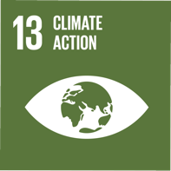

Outcomes
- Resilient system for current and future generations providing a safe, reliable, affordable and effective service.
- Risk management and risk appetite of water businesses support delivery of a resilient system.
- Water businesses leverage external expertise in resilience management.
- The resource recovery system is safe for the community and those that work with and around it.

Next Steps
- A collective understanding of what resilience means for the sewerage system that is shared by each Water Corporation and our regulators.
- A plan for meeting an agreed level of resilience that can be implemented through price review processes and integrated into our ‘business as usual’ planning and renewal processes.
- Complete the Sewerage System Resilience Project.

5.7 Environmental Discharge Limits
Melbourne generates over 320 billion litres of sewage each year that needs to be transferred and treated before it can either be reused or safely returned to the environment to protect both public health and the environment. Only a small portion of the treated water from our sewerage system is currently recycled.
Most of the sewage generated in Melbourne is transferred to one of Melbourne Water’s two sewage treatment plants - Eastern Treatment Plant in Bangholme or Western Treatment Plant in Werribee. 26 smaller treatment plants, mainly located around the fringe of the metropolitan area, service local areas across Melbourne and many of these discharge to local waterways. Figure 19 shows where each treatment plant discharges to the environment.
With population growth, the quantity of sewage generated will continue to increase, even allowing for efforts to limit the amount of water that is consumed in homes and businesses throughout the metropolitan area.
Our current approach to managing sewage involves largely a linear system that comprises collection, treatment and disposal.
If we continue this approach, receiving environments are going to reach their assimilation limit, which is the amount of treated water that they can accept before the discharges begin to have detrimental impacts, ultimately affecting our communities and ecosystems.
Limits for receiving environments are highly dependent on the local characteristics, but may include flow limits, which may be seasonal to protect waterway health, and concentration or load based limits for particular components of the treated water. A typical example is nutrient limits to protect the environment from algal blooms.
Environmental limits are normally considered to be ‘hard’ limits since they have been established so that the assimilative capacity of the receiving environment is not exceeded, ensuring protection of the beneficial uses of that receiving environment.
The State Environment Protection Policy (Waters of Victoria), sets a statutory framework for the protection of the uses and values of Victoria’s fresh and marine water environments³.
EPA Victoria recognises that environmental discharges from sewage treatment plants often need to occur as a means of managing the treated water from the system. The concept of a ‘mixing zone,’ is specified in the State Environment Protection Policy (Waters of Victoria).
Mixing zones are a tool used in licences to manage treatment plant discharges and are designed to accommodate the residual localised impact on the environment from the discharge. Mixing zones recognise the practicability aspects of treating all flow to match the background concentrations of the receiving environment. As the mixing zone describes a defined area of the environment where not all beneficial uses of the environment are not fully protected, there is an expectation that efforts will be made over time to reduce the size of this area. As flows grow with population, mixing zones will inevitably expand unless we actively work to divert treated water away through increased reuse.
Our current approach to managing environmental limits, including mixing zones, generally involves monitoring, scientific research and modelling to ensure a robust understanding of what limits the environment can carry for the constituents of the treated water. This is coupled with upgrading our treatment facilities to reduce the concentration of these constituents in the water discharged to the environment.
Long term, with our population expected to double, increasing flows and loads for treatment, this approach is unlikely to be sustainable.
To achieve the Goals of this Strategy, we need to adopt alternative ways of managing our environmental limits.

Figure 19. Map of Melbourne’s existing system – treatment plant receiving environments – text version
Figure showing the location of the 28 sewage treatment plants throughout the Melbourne region along with the discharge point to the receiving environment from each plant.
Treatment Plant | Receiving Environment
1 Altona (local) | Port Phillip Bay
2 Aurora (local) | Merri Creek (emergency only)
3 Bacchus Marsh (local) | No Outlet
4 Blind Bight (local) | Local Re-use Schemes
5 Boneo (local) | Bass Strait via SEO
6 Brushy Creek (local) | Brushy Creek
7 Craigieburn (local) | Merri Creek
6 Eastern Treatment Plant | Bass Strait
9 Gisborne (local) | Macedon River
10 Healesville (local) | Yarra River
11 Kinglake West (local) | Burtons Creek (emergency only)
12 Koo Wee Rup (local) | Emergency Only
13 Lang Lang (local) | Emergency Only
14 Lilydale (local) | Olinda Creek
15 Longwarry (local) | Local Re-use Schemes
16 Melton (local) | Werribee River (emergency only)
17 Monbulk (local) | Sassafras Creek
18 Mt Martha (local) | Bass Strait via SEO
19 Pakenham (local) | Local Re-use Schemes
20 Riddells Creek (local) | Jacksons Creek
21 Romsey (local) | No Outlet
22 Somers (local) | Mt Martha TP (#18)
23 Sunbury (local) | Jacksons Creek
24 Upper Yarra (local) | Yarra River
25 Wallan (local) | Taylors Creek
26 Western Treatment Plant | Port Phillip Bay
27 Whittlesea (local) | Plenty River (emergency only)
28 Woodend (local) | Five Mile Creek
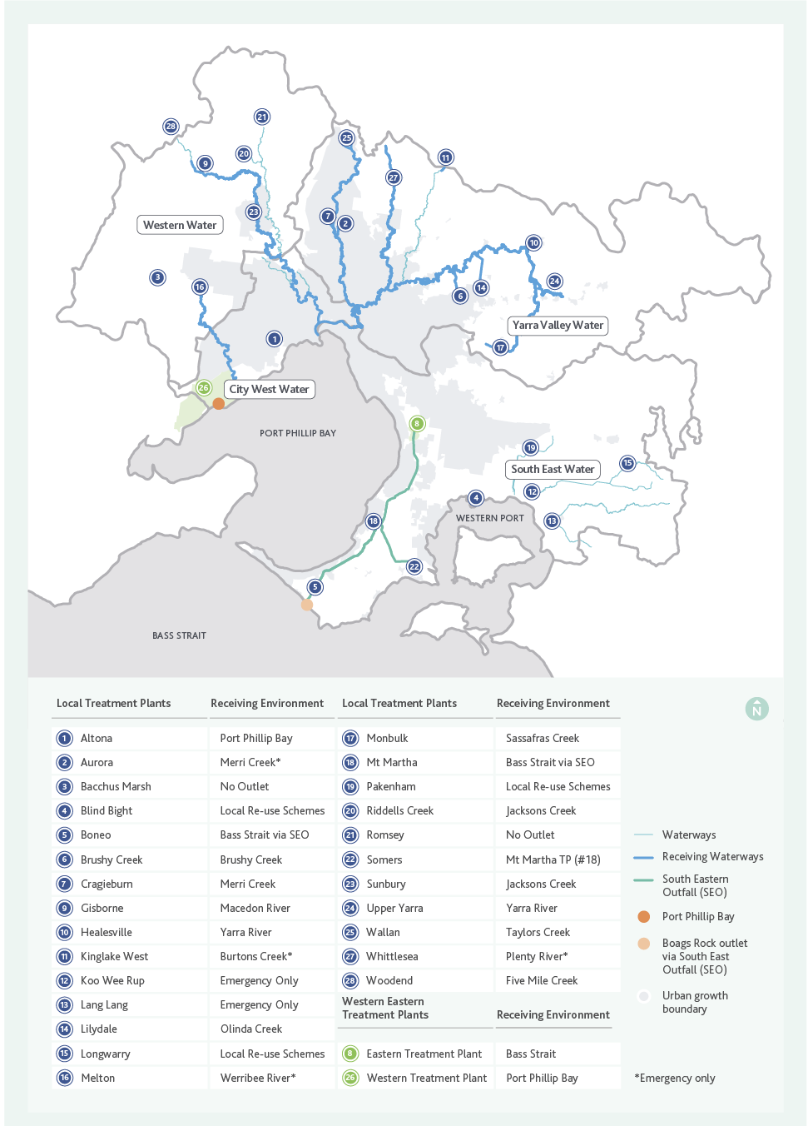

5.7.1 Discharges to Port Phillip Bay and Bass Strait
Western Treatment Plant (WTP) and Altona Treatment Plant discharge directly to Port Phillip Bay and the majority of other local treatment plants discharge to waterways that ultimately end up in the Bay. The Eastern Treatment Plant along with Somers, Mt Martha and Boneo treatment plants discharge to Bass Strait at Boags Rocks.
Over the last few decades, a large number of studies have been conducted to understand the impact of discharges from Western Treatment Plant on Port Phillip Bay and from Eastern Treatment Plant on Boags Rocks.
Port Phillip Bay studies have shown that the key element limiting productivity in the Bay is nitrogen, and that the nitrogen load to the Bay must be managed to prevent algal blooms.
The outcomes of the most recent scientific studies have been documented in the Port Phillip Bay Environmental Management Plan (2017 to 2027) and concluded that nutrients, sediment and other pollutants flowing into the Bay are the main contributors to poor water quality. A key action within the plan is Action 3.2, which states that water corporations will operate sewage treatment plants to ensure their annual nitrogen load discharges do not exceed current levels and where practicable, reduce loads of other pollutants.
For Western Treatment Plant, this means that the total nitrogen load discharged must not exceed 3,100 tonnes per year on a three-year average basis. While additional treatment will control nitrogen load discharge to a point, ultimately this cap will drive further diversion of treated water from WTP to recycling, or sewage flow growth needing to be managed at another treatment plant, or both.
The water discharged at Boags Rocks is Class A recycled water, which also meets the needs of the receiving environment. Significant environmental studies underpinned the upgrade to each of the plants over the 2010-2014 period.
Future limits on the discharge from the South Eastern Outfall may arise from the impact of population growth increasing the amount of freshwater that is being discharged into a marine environment. A recycled water scheme that used a significant volume of water, could be used to reduce the volume of water discharged (and hence the size of the mixing zone) at Boags Rocks.

5.7.2 Discharges to waterways
Our smaller, local treatment plants discharge treated water directly to waterways. The majority of these waterways ultimately end up in Port Phillip Bay. The treatment plants that discharge to these waterways will influence the success of achieving Action 3.2 of the Port Phillip Bay Environmental Management Plan (2017-2027), as discussed in Section 5.7.1.
Local treatment plants may also have constraints around the amount, quality and distribution of flow that can be discharged to local rivers or creeks. This may be driven by the need to match a natural seasonal water flow profile, or protect sensitive environmental species that could be affected by treated water discharges.
Increasing treated water quality through greater levels of treatment can provide an improvement to the receiving environment, however there are limits to what each technology can achieve.
Alternative options include increasing diversion of treated water from the water environment to a beneficial use, or managing the treated water so that it enhances a receiving environment. An example might include more highly treating, and/or providing storage of water so that it can be used for environmental flows in a beneficial manner, or diversion to agriculture to support food security and potentially reduce extractions from the local waterway.
The Melbourne Water System Strategy considers the shortfall of environmental water under the impact of climate change and has identified the following locations where there may be a deficit (See Figure 20).
These shortfalls could potentially be addressed by substituting recycled water for surface water entitlements with appropriate management of quality and flow regimes.
Challenges in being able to provide environmental water from the sewerage system to these locations include the cost of distribution infrastructure and the policy and regulatory frameworks.
Diverting treated water to an alternative location where the environment has a great capacity to assimilate discharges could also be an option. This might include diverting treated water away from a waterway to either Bass Strait or Port Phillip Bay, however this will then impact on these alternative receiving environment limits.

Figure 20. Map showing the preliminary estimates of the potential gap between the existing environmental water reserve and what would be needed to continue to deliver the periods of higher flows required to support existing environmental values under a given climate change scenario – text version
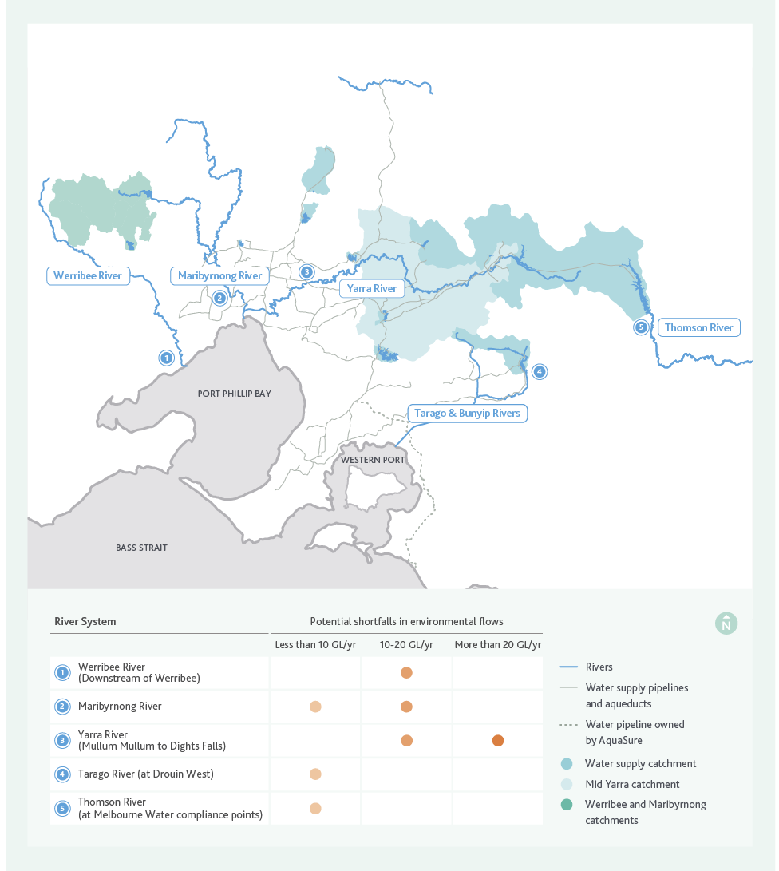
Figure shows where there may be potential shortfalls in environmental flows in the future. These potential shortfalls are;
River System | Potential shortfalls in environmental flows
Werribee River (downstream of Werribee) | 10-20 Gigalitres per year
Maribyrnong River | Less than 10 Gigalitres per year to 10-20 Gigalitres per year
Yarra River (Mullum Mullum to Dights Falls) | 10-20 Gigalitres per year to Greater than 20 Gigalitres per year
Tarago River (at Drouin West) | Less than 10 Gigalitres per year
Thomson River (at Melbourne Water compliance points) | Less than 10 Gigalitres per year

5.7.3 Emerging contaminants
As well as the nutrient limits already discussed, there are also many emerging contaminants that are either starting to appear in our sewage for the first time, or that we are only now realising can have negative impacts on our environment and public health. These include things like micro-plastics, pharmaceuticals and a range of other chemicals used for household or industrial applications. Some of these are removed at some or all of our treatment plants, but some are not.
Understanding these contaminants, their limits and effects will ensure that we are able to meet Goals 1 and 2, enhancing public health and environmental values, requiring us to have a good understanding of the contaminants in our sewage and their effects.
Current wastewater quality risks are collaboratively managed by the metropolitan water corporations through the Integrated Sewage Quality Management System (ISQMS) which is discussed further in section 5.8.5.

5.7.4 Informing environmental discharge limit decisions
Increasing population growth along with continuing a linear approach to managing sewage means we will be faced with reaching environmental limits in a number of our receiving environments over the next 10-20 years.
In the specific case of a local treatment plant reaching an environmental discharge limit, it is often suggested that the treated water or sewage is instead transferred to either Western or Eastern Treatment Plant. While this solves a local problem, it brings forward other system and environmental limits for the larger treatment plants, including the need to meet carbon pledge requirements. The carbon pledge comes into consideration depending on whether a specific treatment process at ETP or WTP consumes energy or generates energy and consideration of the emissions that might be generated.
There are many options to defer or resolve environmental discharge limits and informing the decision will require activities associated with Knowledge, Values and Rules and will be specific to each environmental limit. Options include:
- Improving understanding of receiving environments to influence limits through research and monitoring.
- Implementing innovative treatment technologies that can support greater levels of discharge to a receiving environment.
- Diverting the discharge away from the receiving environment through increasing the use of large volumes of recycled water for uses that are not seasonally influenced.
- Create new outlets, such as a new ocean outfall or a new treatment plant in new location.
Our current approach is to undertake more science to increase our knowledge of the receiving environment and better understand the potential risks posed by the discharges. This approach will only enable a limited amount of increased discharge, but is a first step to keeping pace with population growth.
While the current approach will always have a role in better defining environmental discharge limits, it is unlikely to drive the real transformative change that is needed to achieve our Vision and Goals.
This transformative change is more likely to be achieved through diverting the discharge away from the receiving environment, supporting a circular economy, requiring significant increases in recycled water use, or by creating new outlets, requiring construction of infrastructure at new locations.
As more transformative options, each would need effort across Knowledge, Values and Rules to be available to us when we reach the decision point.
Figure 21 sets out a potential pathway to work through the challenges associated with reaching an environmental limit.

Figure 21. Example of how we might address reaching our environmental outlet limits – text version
Figure shows a potential adaptive pathway solution to address reaching the assimilative capacity of a receiving environment.
The trigger to reaching the environmental limit could come through increased population growth, that is increasing the amount of nitrogen discharged to a treatment plant.
The first step to addressing the limit could be to upgrade the treatment process to remove more nitrogen.
When we reach the limit of the treatment technology to remove nitrogen we may need to consider alternative ways to distribute the flow in the receiving environment or look for alternative locations to discharge treated water to. There are potential alternative pathways for discharging treated water, which could include large scale alternative water use, or the construction of infrastructure such as outfalls to take the water to different environments.
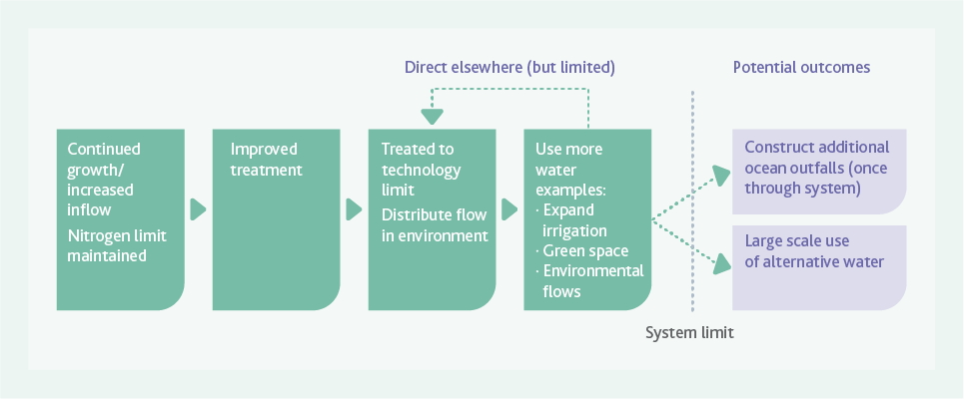

Knowledge, Values and Rules
Diverting the discharge away from the receiving environment would require significant increase in recycled water use and would support achieving Goals 1 (enhancing human health and wellbeing), 2 (enhancing our environment) and 3 (leveraging resources), as well as broader water industry goals such as integrated water management. As discussed in section 5.9, we would need to increase our knowledge of impacts and address community concerns and regulatory constraints to facilitate this.
Facilitating options such as new outlets, including an ocean outfall, or a new third large scale treatment plant, would require building our knowledge on new receiving environments to ensure understanding of potential impacts and any discharge challenges. For example, we would need to treat to a very high standard and discharge to match a natural flow profile to enhance environmental outcomes by increasing environmental flows. This knowledge would support enabling the regulatory environment to make these changes.
At this point in time, new outfall options are unlikely to be acceptable to the community.
The existing sewage treatment plants and their discharges were largely constructed many years ago and now have a social licence to operate in these locations. Proposals for new treatment plants can create significant community concerns, particularly where these are close to existing residential areas. Likewise, a new ocean outfall would raise community concerns about beach water quality and environmental impacts.
Keeping the option of new treatment plants open, whether this be a third large scale treatment plant or numerous smaller treatment plants, will require considerable effort in engaging with the community. In addition, it will require greater alignment between land use planning to identify suitable sites for these type of options along with ensuring that the receiving environment is capable of accepting discharges or that there is an acceptable outlet for the resources that are produced as a result of treating sewage.

ACTION 4
DRIVE TRANSFORMATIONAL APPROACHES TO THE ROLE THAT THE SEWERAGE SYSTEM PLAYS IN MAXIMISING THE USE OF OUR RESOURCES AND PROVIDING THE BEST ENVIRONMENTAL OUTCOMES
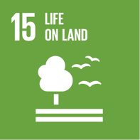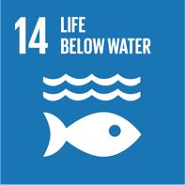

Outcomes
- A greater use of fit for purpose recycled water for the environment to support flow stressed rivers.
- Land use planning is integrated with sewerage planning as part of addressing limits identified in the adaptive pathways.

Next Steps
- Develop scientifically robust quality and hydrological regimes for flow stressed rivers that could utilise fit for purpose recycled water.
- Continue to work collaboratively with stakeholders to ensure that land use planning is an integral part of enhancing our environment and providing affordable sewerage services for our customers.
- Continue to invest in research and ensure that technological advancements remain a key part of our approach to providing services to the community.

ACTION 5
ENGAGE WITH CUSTOMERS AND STAKEHOLDERS ON AN ONGOING BASIS TO DEVELOP A GREATER APPRECIATION OF THEIR ENVIRONMENTAL VALUES

Outcomes
- Water businesses understand the environmental values of our customers which are used to inform Adaptive Pathways decisions.
- Customers understand the role of the sewerage system in the water cycle and the opportunities available for providing sustainable and affordable resource management services.

Next Steps
- Understand where there are gaps in alignment between service provision and what customers value.
- Develop a targeted and innovative strategic communication and engagement plan integrated with other engagement activities to support limits identified in the Adaptive Pathways.

5.8 Greater Melbourne Waste Limits
As Melbourne’s population grows, so does the volume of waste we produce. The sewerage system has the capability to treat organic waste that is currently sent to landfill. As pressure on landfill grows, the sewerage system is well placed to play a role in addressing the limits of the waste system. With a growing population, reduction in landfill capacity, the need to achieve net zero carbon emissions and a goal of beneficially using all our resources, the sewerage system could potentially take on a greater role in managing some components of Melbourne’s waste.
While the opportunity is evident to those in the water industry, we are yet to have alignment between the technical challenges and opportunities, the policy and regulation to enable change, and the desire of our community and stakeholders (including those in the waste industry) to see the role of the sewerage system in managing waste increase.

5.8.1 Sewage is a valuable resource
Sewage contains a number of valuable resources that are derived from waste our community generates. Water, carbon, nitrogen and phosphorous are key components of the waste materials that enter our sewerage system. Each of these components, when combined and processed, or treated at our sewerage treatment plants, can generate valuable products.
Water, for example, is a valued resource and the sewerage system has the opportunity to contribute more than it currently does to providing Melbourne with an alternative fit for purpose water resource.
Currently many of these components contribute to other limits, such as nitrogen in treated water and environmental discharge limits. Changing the way we think about sewage not as a waste, but as a resource, is critical to deferring other system limits.
Sewage contains significant quantities of carbon due to its organic content. Historically sewage treatment has focused on removing biodegradable carbon in order to protect our receiving environments from adverse impacts.
This has been a core part of most sewage treatment plants for many decades. Carbon is typically removed through aerobic treatment processes, which requires aeration, resulting in a significant consumption of electricity. Carbon can also be used to generate renewable electricity through the generation of methane-rich biogas, which is becoming more favoured with a move toward zero net carbon emissions by 2030.
There is an opportunity to divert carbon away from landfill and for the sewerage system to receive more carbon in the form of organic waste to support additional energy generation or production of carbon-based products. A key aspect of this opportunity is matching the right organic wastes with the right sewerage infrastructure option, including:
- Making use of the existing sewerage network to convey organic wastes to treatment plants, while managing the potential risk of increased odour and corrosion within the network.
- Receiving organic wastes directly at treatment plants, via truck, or directly to processes responsible for resource recovery, means energy can subsequently be recovered in the form of biogas, or from further processing of biosolids.
An alternative to converting sewage-based carbon to energy is to conserve the carbon for its value in different potential end products such as biofuels or bioplastics. This currently occurs for biosolids, which contain 38 per cent of the carbon in Melbourne’s sewage. Carbon in biosolids is beneficial for the environment where biosolids are applied to land and the carbon can improve poor soil condition.
Sewage also contains significant quantities of nitrogen which must be removed from the treated effluent stream to protect nitrogen sensitive receiving environments. Nitrogen is a valuable nutrient for agricultural applications and currently removing nitrogen from sewage is an energy intensive process.
Phosphorous is forecast to become a scarce resource in future. Sewage contains phosphorous, and this can have a detrimental impact when discharged to certain receiving environments.
Phosphorus removal currently occurs at plants that discharge to fresh water bodies, such as creeks and rivers, which are more sensitive to phosphorous than marine environments. To remove phosphorous from sewage a phosphorous-rich side stream is created, which increases the viability of recovering it as a product. Current technology allows phosphorous to be recovered in a form known as struvite, which has only limited value in Australia in today’s markets.
Historically, resources in sewage have generally been recovered if commercially viable and revenue generated exceeds the costs of recovery, or if regulatory obligations require it.
Nitrogen and phosphorous recovery have been investigated in recent years for Melbourne. These opportunities can be re-evaluated as the external drivers for recovering these nutrients changes in the future.
To realise the full potential of resource recovery from sewage and to transform our system from one of waste disposal to resource recovery, we need to overcome the current technical, social, and economic challenges to successfully deliver on our Goals of beneficially using our resources and protecting the environment.

5.8.2 Organic waste management
In metropolitan Melbourne, food and garden waste makes up approximately 28% (around 805,000 tonnes per year) of everything we send to landfill. Organic waste, and food waste in particular, has one of the lowest levels of resource recovery when compared to other waste types such as construction and demolition waste. Melbourne’s waste volume is expected to grow as our population grows. If we continue to manage waste as we have been, an estimated one million tonnes per year of extra waste will need to be disposed of to landfill by 2042. Our growing population means that we most likely cannot continue to manage waste to landfill in the way that we have in the past.
Considering the role that the sewerage system already plays in organic waste management, there is an opportunity to expand the system’s role to include other high strength organic wastes that may currently be disposed of to landfill. As part of the strategy development, consideration was given to what additional wastes could be added to the sewerage system, or how we could use land at our treatment plants to assist in managing waste for Melbourne, and contribute to reaching the strategy’s Goals.
For the strategy development, a broad definition of organic waste was adopted; ‘an organic waste is a waste substance that is derived from a natural source and, whether solid, liquid, slurry or sludge, is biodegradable under natural conditions though has not yet reached a biologically stable state.’
Within this definition, approximately 65 organic wastes have been identified as having the potential to be managed by the resource recovery system of the future. These wastes were assessed in terms of the value each waste offers in providing future resource recovery opportunities and delivering net benefits to the community.

ACTION 6
DRIVE TRANSFORMATIONAL APPROACHES TO THE ROLE OF THE SEWERAGE SYSTEM IN ORGANIC WASTE MANAGEMENT AND RESOURCE RECOVERY.
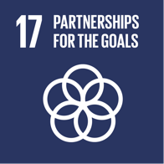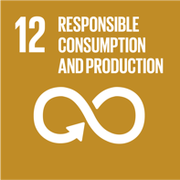

Outcomes
- A resource recovery system valued by the community for protecting public health and the environment while being equitable and affordable.
- Customers and stakeholders understand the wide range of benefits from resource recovery.
- Policy and regulation enables and encourages the use of resources through pricing frameworks and risk based approaches to integrated water and waste management.
- The role the water businesses have in managing Melbourne’s organic waste is clearly understood and agreed by all.

Next Steps
- An agreed, shared plan that the waste industry and regulators will support to deliver best for community outcomes that can support development of future business cases between the waste and water industry.
- Demonstrate and engage the community using interactive features (eg for example through pilot plants) showing that high quality resources can be produced from the sewerage system. This might include, high quality recycled water, fertilisers or innovative products such as biofuels.
Factoring in consideration of community expectations and the costs and risks of alternative pathways for managing organic waste, the sewerage system is ideally placed to play an expanded role in accepting some wastes. The framework for this assessment is shown in Figure 22.
With any expanded role in accepting a broader range of waste there will be a need to manage product quality risk, to ensure that there is not an increased risk to public health or the environment, and we do not inadvertently create a contaminated waste stream that has no resource value.

Figure 22. Organic Waste Evaluation Framework – text version
The figure shows a series of steps to undertake to evaluate organic waste. The first five steps are sequential. These are:
- Develop a long list of potential waste streams
- Confirm that the waste meets the definition of ‘Organic Waste’
- Identify individual waste stream availability within the geographic region
- Identify the proposed point of entry to the sewer system
- Assess the organic waste characteristics to determine if it is acceptable.
There are then three gateways to determine if the organic waste is acceptable, these are:
Gateway 1- Assess for Mandatory Criteria this may or may not be deemed acceptable. Unacceptable waste is that which is unsafe for the sewerage system.
Gateway 2 is a check on waste that has successfully passed Gateway 1. Waste may be deemed acceptable but fails to meet key threshold limits, in which case it likely to be of low value and high risk to the sewerage system. Alternatively it may be acceptable and meet threshold requirements. This waste passes to Gateway 3.
Gateway 3 looks at the value and risk of the waste and determines the position of the Sewerage System acceptability spectrum as either low value and high risk through to high value and low risk.
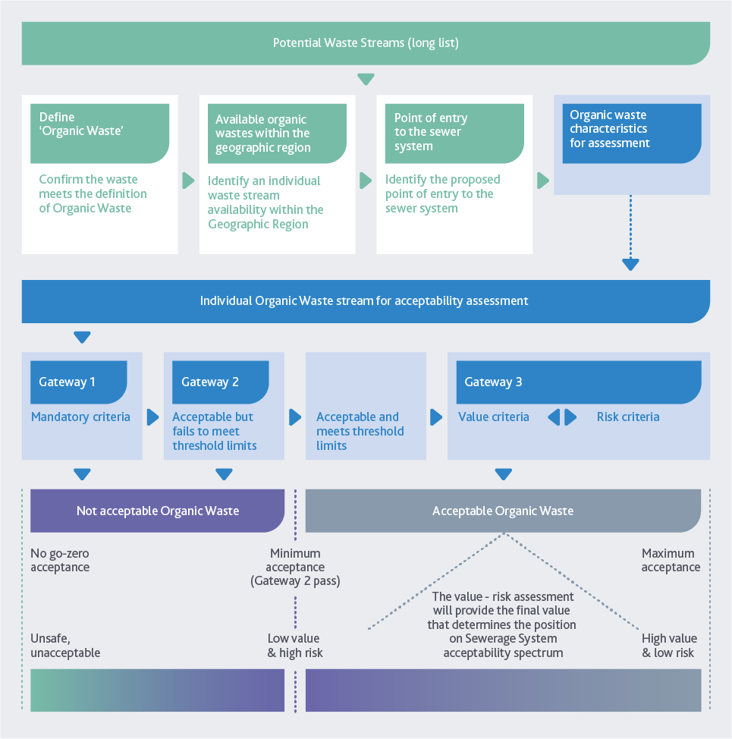

5.8.3 Interaction of responses to the waste limit with other system limits
While the capacity of the waste management system for Melbourne is one limit, any decision made to accept additional organic waste into the sewerage system will have an impact on the other key system limits. This may bring forward decision points for how best to address the environmental discharge limits and the critical network limits. Any decision to accept additional organic waste will likely see the current system reach capacity sooner than if additional organics were not added to the sewerage system.

Sewerage network limits
Hydraulic and contaminant load limits need to be considered across the network due to the additional load that could be attributed to carbon, nitrogen and suspended solids concentrations in the waste added to the sewerage system.
Treatment plant augmentation timing will need to be reviewed to ensure ongoing compliance with our customer and regulatory requirements.
Adding additional organic material may bring forward a transition to alternative treatment technologies that enable greater extraction of carbon for renewable energy generation and enable low energy removal of nitrogen components. It is likely it will increase biosolids production, adding to pressure for finding and implementing reuse of this resource. It may influence how we prioritise which resources we recover at different treatment plant sites.
Consideration of how to address emerging pollutants may also be required depending on waste acceptance criteria and the approach to trade waste management that is adopted.
Asset renewals and material selection will become a greater consideration due to the increased potential for corrosion of our network assets, particularly where the sewers are used as a conduit for transporting high strength organic waste to the treatment plants.

Supporting alternative water use
The acceptance of additional organic wastes to the sewerage system has potential to impact on the availability of fit for purpose water. The presence of emerging contaminants, metals and other contaminants that could be associated with organic waste has the potential to impact the quality of, or the production of recycled water. Sewage quality management and working with industry and the community will be essential, particularly if high value reuse of the water resource is implemented.

Environmental discharge limits
An increase in organic waste treated via the sewerage system is likely to bring forward the timing of reaching environmental discharge limits.
High strength organic wastes can contain high nitrogen concentrations or inorganic contaminants, which could lead to the need for alternative treatment processes, or recovery of nitrogen or metals in order to mitigate the impact on environmental discharge limits.
This could lead to decisions being made regarding trade-offs between capturing the additional carbon for renewable energy generation and addressing a broader waste problem for Melbourne, versus reaching an ecosystem limit in a receiving environment. The existing processes for managing sewage quality will help to inform these decisions.
There are also trade-offs that relate to where organic waste is treated. For instance, organic waste often generates odours and while using sewerage system assets to treat organic waste may shift odour issues away from landfill and other waste sites, this may increase the pressure on the sewerage system to manage the odour and amenity issues in line with community expectations.
Greater community engagement is required along with policy and regulation that is flexible and collaborative to enable these decisions to be made.

5.8.4 Informing Greater Melbourne waste limit decisions
There is a great opportunity for the sewerage system to help address Greater Melbourne’s waste limit. Not only does the sewerage system already play an important role in organic waste management in Melbourne, but with the shift to a future resource recovery system, it can support increased resource recovery levels.
The sewerage system can provide ongoing treatment capacity for organic waste rather than the finite, single-use capacity of landfills, contributing to a broader move towards a circular economy in the waste industry.
Considerable work needs to be done to arrive at an informed position as to how the sewerage system should play a greater role in waste management for Melbourne. Critical to this is ensuring that the water industry can make the transition to a resource recovery system. If we can’t, then accepting additional organic waste will only put more pressure on other system limits. Significant work is required to align the Knowledge, Values and Rules across both the water and waste industries to progress this opportunity and identify the best outcome for the community.

5.8.5 Source control
Our sewage contains waste inputs from both residential and non-residential sources such as trade waste and other organic waste that contain a range of contaminants. The water industry manages trade waste through individual trade waste agreements with non-residential customers.
Managing the inputs to the sewerage system at their source is an important first step in ensuring the quality of not only the products that are produced from the resources in the sewage, but also to ensure protection of the environment and public health.
Anything added to the sewerage system that is not able to be treated by our sewerage treatment plants ultimately ends up in some part of the environment, whether this be a landfill in the case of materials removed as part of the screening process at the treatment plants, or remains within resources- such as metals that end up in biosolids, or salt in recycled water, or microplastics and fibres that can be discharged to receiving environments.

ACTION 7
ENSURE THAT EMERGING CONTAMINANTS AND CHEMICALS OF CONCERN THAT MIGHT BE PRESENT IN SEWAGE, TREATMENT PLANT DISCHARGES AND RECOVERED RESOURCES DO NOT CAUSE HARM TO THE ENVIRONMENT OR PUBLIC HEALTH, THROUGH WHOLE OF SYSTEM MANAGEMENT


Outcomes
- There is strong policy and industry leadership regarding chemicals of concern that facilitates safe resource recovery and encompasses the management of chemicals of concern at both source and at the ‘end of pipe’.
- Robust self-reporting and tracking of off specification product events to increase learning.

Next Steps
- Ensure sewerage planning activities integrate with the ISQMS sewage quality risk assessment process.
- Development of a coordinated risk based approach between the water businesses, regulators and industry regarding the identification, management, reporting and surveillance of chemicals, pathogens and materials of emerging concern and their impact on the sewerage system, human health, the environment, and the ability to recover resources.

ACTION 8
DEVELOP AND IMPLEMENT RESOURCE RECOVERY OPPORTUNITIES
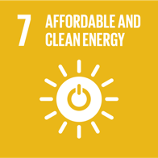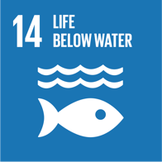

Outcomes
- Diverse markets are established for resource recovery products that could include biosolids nutrients, methane, heat, energy, and recycled water adding resilience to the sewerage system.
- Public health and the environment outcomes are protected and enhanced.

Next Steps
- 100 per cent reuse of the annual production of biosolids from WTP in accordance with EPA requirements.
- Use the environment and public health risk hierarchies and work in collaboration with the regulators to gain a greater understanding of the risk to public health and the environment associated with increased resource recovery and use.
Managing sewage quality to protect end product quality and public health and the environment needs to be balanced with acknowledging the role the sewerage system has in enabling economic development. As a community we need to determine the best place for managing different wastes to achieve ‘best for community’ outcomes, while working toward a circular economy.
As the water industry transitions towards the resource recovery system of the future, and considers accepting new forms of waste it will become even more important to protect our ability to recover resources and produce high quality products.
Our services, including trade waste services and approach to managing product quality risk will need to evolve to address emerging contaminants and other elements that impact the production of quality products to ensure that we don’t inadvertently end up with large quantities of materials that have little value as a resource.
We will need to use price signals for current and new and emerging contaminants. Combined with potentially upgrading treatment facilities and continuing to develop and implement risk management systems, this will enhance and protect public health and the environment and ensure we are able to maximise the use of our resources.

Knowledge, Values and Rules

Understanding non-prescribed activities
In Melbourne, customers are offered a single water or sewerage service provider, and government regulation exists to ensure an equitable, affordable and reliable standard of service without market mechanisms.
Currently, there is no legislation limiting water authorities from offering non-prescribed services, which are additional services beyond those prescribed in legislation or regulation. Where these make a financial return, there may be incentive to undertake them. This can offer opportunities for the water industry to help deliver on the broader policy goals of the Victorian Government, such as the sustainable management of organic waste.
The development of business opportunities that extend beyond the core, regulated functions of the water industry, as well as the potential entry of privately owned competitors increases the need for the water industry to understand the issues involved in working outside of the regulated monopoly business environment.
The water industry must carefully address competitive neutrality provisions to ensure that our sewerage customers are not cross- subsidising any activity that is in competition with a private industry.
Where the interactions between the non-prescribed services and regulated business activities are complex or significant, it may be necessary to ring-fence the non-prescribed service financially to ensure it is separate to the regulated business activities and any competitive neutrality concerns are clearly and transparently managed.

Integrated Sewage Quality Management
To ensure best practice in sewage quality management, the four metropolitan Melbourne water businesses (City West Water, Melbourne Water, South East Water and Yarra Valley Water) have established an Integrated Sewage Quality Management System (ISQMS), based on the ISO22000 standard, for sewage discharged to treatment plants connected to the sewerage network.
The purpose of the ISQMS is to:
- Provide a risk based approach to sewage quality management through the establishment of a systematic and robust process for sewage quality hazard identification, risk assessment and control implementation based on the application of the ISO22000 standard.
- Identify and achieve mutually agreed sewage quality management objectives for the four water businesses.
- Provide greater transparency and mutual understanding between the four water businesses regarding the management of sewage quality and linkages with end points within the system.
- Improve interactions between the four water businesses to deliver a truly integrated sewage quality management system across Melbourne.
The four water businesses have jointly developed protocols for improved transparency and management of sewage quality within the ISQMS framework.
The protocols describe the agreed approach to risk management across the sewerage system, as well as supporting processes relevant for a preventative risk management approach to sewage quality.
The protocols address:
- A system wide process to identify, assess and control substances, both emerging and currently present, that can adversely impact on sewage quality.
- A process to identify, assess and control risks associated with individual trade waste customers and other sources such as domestic, inflow and infiltration.
- A process for managing variations to trade waste standards.
- Verification and validation of the ISQMS and its continual improvement.

Increasing collaboration to address challenges
As part of achieving Goals 3 (leveraging resources) and 5 (enabling policy and regulatory environment), regulation and policy needs to be developed jointly between the water industry, government and the waste industry to ensure best for community outcomes are achieved.
Greater collaboration between Melbourne’s metropolitan water industry and researchers, technology developers and equipment suppliers and the community is required to actively progress opportunities and facilitate timely adoption of innovative approaches. Collaboration also enables transparent and scientifically defensible information and knowledge development, that minimises risk of failure, maximises successful implementation and supports regulatory approvals, community acceptance and investment decision making.

Understanding and developing community and market interest
While there is general interest in the products and services the sewerage system can provide, a broader understanding of these (such as recycled water and biosolids) and the associated benefits and risks could help facilitate their use, as will increased understanding of how industry interactions with the sewerage system can impact resource recovery or contribute to new opportunities.
Industry engagement suggests there is strong interest for new products and services the water industry could provide such as biofuels, heat, or an increased removal of food waste via the sewerage system. To transition to a resource recovery system, we need to enhance our understanding of industry, market and community needs to better target our products and ensure their value.
Building engagement within the community is important when taking on new roles to ensure that we have community support for any new initiatives.

Future trade-offs / opportunity costs
Strategic alignment of the water industry and key government stakeholders needs to occur as part of considering how to increase the role of the sewerage system in sustainable waste management as it leads to the need for trade-offs. Examples include:
- Conversion of sewage-based carbon and potentially new organic waste streams to energy means that the carbon will not be recovered in end products unless their value and/or associated benefits exceeds the costs to move away from investment in energy generation, or they occur once the energy needs of the sewerage system have been met.
- The sewerage system is integral to economic development and is often seen as the preferable disposal route for some contaminants in order to protect human health and the environment. This contrasts with the need to maintain product quality in a future where we are striving to realise our goal of advancing the circular economy through 100 per cent beneficial reuse of our resources.
- Recovering heat from sewers could potentially provide a heat resource and lower sewage temperatures, which may reduce sewer odour and corrosion. However, reduced sewage temperatures may adversely impact biological treatment and disinfection processes, which are generally less effective at lower temperatures.
- The acceptance of trade waste discharges that are high in salt into the sewerage system can impact on the ability to recycle water for uses that are sensitive to salt such as agricultural activities. However the discharge of salty waste streams into the sewerage system may have other benefits such as supporting industry which has benefits for the broader economy.

5.9 Availability of Fit For Purpose Water
The sewerage system has a key role to play in the supply of alternative water to meet the future needs of the Melbourne region. A water sensitive city makes efficient use of diversified water sources to build resilience and protect the environment. An Integrated Water Management approach to planning and delivery of services ensures all facets of the water cycle are considered to maximise community benefits.
Over the next 50 years, the population of Melbourne and the surrounding region is expected to continue to grow, along with the demand for water for a wide range of uses.
Victoria’s climate is changing, and will continue to change in the future, leading to an expected long-term decline in the volume of water that can be reliably supplied by the existing water supply system. Although the impacts of these and other factors are uncertain, the Melbourne Water System Strategy (MWSS) identifies that it is possible that within the next 50 years, that without intervention, the demand for water could exceed the volume of water available from the existing water supply system – potentially as early as 2028 under a scenario of high population growth and high climate change impacts.
To manage these and other challenges, the MWSS outlines a portfolio approach that can be adaptively implemented as required, recognising there is no single solution to the challenges we face that would be universally ideal under all plausible future scenarios.
How Melbourne provides water resources to meet the needs of an increasing population and a changing climate has been discussed in the MWSS and falls outside the scope of this strategy. However the sewerage system produces a significant volume of treated water that could be used to contribute to managing any water resource shortfalls as part of a broader suite of alternative water sources that include rainwater, stormwater and recycled water.
Recognising this, the MWSS has adopted a goal of working with stakeholders to deliver at least 30 billion litres each year from diverse local sources by 2065, with active investigation to enable the use of an additional 50 billion litres each year.
During 2016/17 Melbourne’s 28 sewerage treatment plants treated around 373 billion litres of water. Of this volume only around 43 billion litres was beneficially reused with the remainder discharged to our environment, including Bass Strait, Port Phillip Bay and a variety of waterways including the Yarra River, Jacksons Creek and Merri Creek.
Recycled water has been one of the main resources used from the sewerage system for many years. The Millennium Drought saw increased demand for alternative water supplies, and the introduction of a 20 per cent recycled water target. This target drove the introduction of most of the Class A recycled water schemes that Melbourne has today.
While the 20 per cent recycled water target no longer applies, most of these recycled water schemes are for the supply of agricultural water.
Agricultural uses are highly seasonal and demand for recycled water is highest when other sources of water are not available.
For recycled water to make a good contribution to overall regional water security the reuse must continue in the average and wetter years to reduce demands on the potable system and help build the drought buffer in the Thomson reservoir.
Recycled water contributes to Melbourne’s liveability through its use in watering of green open spaces, agricultural irrigation, industrial processes, toilet flushing and backyard watering and the reduction of environmental discharges.
Across Melbourne, 11 of the 28 treatment plants produce Class A recycled water. Having high quality recycled water production facilities available means we have the opportunity to reuse much of the water resource within our sewage and move away from our current approach of using this resource once.
The largest single volume of recycled water is available at the Eastern Treatment Plant, where around 120 billion litres of Class A water produced each year, with the majority of this very high quality water being discharged into Bass Strait.
In order to progress toward our goals of beneficially using 100% of our water and resources it is important that we address barriers and enhance the enablers to facilitate better use of this large and growing volume of high quality water available at various locations across the metropolitan area.

5.9.1 Increasing our use of recycled water
To increase the use of recycled water beyond what currently occurs, we need to undertake further work to understand gaps in the Knowledge, Values and Rules that are currently constraining further uptake of recycled water. When considering climate change and population growth combined with an uncertain future, we want to have the greatest number of options available and be able to explore a broad range of scenarios to ensure we provide safe and affordable water for Melbourne for the next 50 years and beyond.

Knowledge, Values and Rules

Infrastructure
Recycled water is currently considered an alternative water source, that is, water that does not come from Melbourne’s water storages and/or through Melbourne’s drinking water supply network.
Recycled water is currently only supplied to end users through purpose-built treatment plants and pipelines. It is also typically used primarily for seasonal applications, including watering of green open spaces and irrigation of agricultural land. This means that infrastructure needs to be sized to meet demands that are not there for many months of the year, which can be a less efficient investment than for an end use that is more consistent across the seasons. The infrastructure challenge is exacerbated by distance of end users from the recycled water source.
The cost of providing distribution infrastructure to seasonal and highly dispersed end users is a barrier to the uptake of recycled water.
One option to address this challenge is to locate high volume recycled water users close to sewage treatment plants (the Werribee Irrigation District, for example, is only a few kilometres from the Western Treatment Plant) to minimise the cost of infrastructure. This demonstrates the importance of integrating land use planning with water cycle planning.
Another option is to minimise the need for additional infrastructure through greater use of existing infrastructure. Better use of existing recycled water infrastructure would require development of applications with consistent, non-seasonal demands.
Some Australian states such as Western Australia and other countries, such as the USA and Singapore, not only use recycled water through dedicated recycled water infrastructure, but they also return very highly treated recycled water back into a central water distribution system. This approach uses existing water infrastructure to supply consistent, non-seasonal demand associated with residential, commercial and industrial end uses.
It takes years of work to understand both the opportunity and the risks that are posed by a such a decision. Decision makers need to not only understand the impact of emerging contaminants and other technical challenges but ensure that they understand community values about the sustainable use of resources and the need for the robust regulation and policy that would manage the use of multiple sources of water.

Investment and Pricing
Both sewerage services and recycled water services are ‘prescribed services’ under the Water Industry Regulatory Order 2014. As such, the Essential Services Commission (ESC) has powers to set the prices that water corporations may charge.
The ESC exercises these powers by way of periodic price reviews that assess both water corporations’ expenditures and prices for prescribed services. The ESC’s overarching objective for price reviews is to promote the long term interests of Victorian consumers.
Through the price review process, the ESC assesses whether water corporations’ expenditures on sewerage and recycled water services are prudent (demonstrably needed at the time the investment occurs) and efficient (at reasonable cost relative to alternative options or like investments).
Only the costs of investments deemed prudent and efficient are allowed to be recovered from consumers via water corporations’ prices. This means that while recycled water can provide greater reliability of water supply for some end uses, to increase recycled water use it must also be cost-competitive with drinking water supply and other alternative water sources such as groundwater.
Current pricing of various water sources doesn’t account for the full economic and environmental costs and benefits of each source, which if considered could mean we would make different investment decisions that provide greater value to the community overall.
Using current pricing approaches means that for recycled water schemes to be viable they need strong revenue streams. This usually requires consistent year-round large water demand at locations close to the source of the water and with long-term commitment. Currently these criteria can only be met by a small number of commercial or domestic opportunities.
The price of surface water and ground water are reflective of their lower marginal cost to supply (compared to a new recycled water scheme), due to lesser treatment requirements (for example groundwater) and in the case of surface water, the use of the centralised distribution network, which enables economies of scale.
This means businesses generally choose other, finite water sources, at a lower cost instead of recycled water, that may offer non- monetary benefits to the environment.
Changing water pricing to reflect its full value, rather than just its cost to supply, and developing an investment evaluation framework that better accounts for the non-monetary benefits would support investment in recycled water schemes, and enable alternative water sources to contribute to Melbourne’s water needs. The development of an Investment Evaluation Framework for Integrated Water Management is currently being led by DELWP and will support addressing these challenges.

Case Study

Doncaster Hill recycled water project

Overview
Yarra Valley Water (YVW) is proposing to build a Recycled Water Treatment Plant in Melbourne’s east to deliver Class A recycled water to over 5000 new homes.
Initial community consultation in 2012 found the community was opposed to the original site proposed by YVW for the Doncaster Hill Recycled Water Treatment Plant. In 2017, YVW conducted an extensive public deliberation process where an Independent Panel listened and collected feedback about five proposed sites. The process involved 10 community sessions over three weeks and heard from over 1500 people.

Drivers for change
Under Plan Melbourne 2050, Doncaster Hill is a future Principle Activity Centre, which is facing a dramatic increase in densification.
As our cities increase in densification, and in the face of an increasingly variable climate, more decisions around diversifying the water portfolio need to be made.
Doncaster Hill, provides an opportunity to implement a sustainable water solution, provide Class A recycled water for developments, maintain quality green open spaces and play a part in deferring future major augmentations to the drinking water network.

Outcome
Based on community feedback, the Independent Panel recommended Eram Park as the preferred site for the Doncaster Hill Recycled Water Treatment Plant. When built, the plant will provide recycled water to over 5000 homes for use in toilets, laundries and gardens, save 2.5 million litres of drinking water a week and provide a drought-proof water supply to keep local parks and sports grounds green.
YVW designed the extensive, public deliberation process to give the community a say in the location and type of plant that is built, and directly influence the outcome. The process enabled bottom up rather than top down decision-making, and created the conditions to take the community with them on their journey to implement a sensitive, but important infrastructure project.
End Case Study

Quality
Recycled water quality standards are specific to this water source and can be more stringent than for other water sources, which might be perceived as being from a lower risk source.
The high-quality standards specific to recycled water contribute to treatment costs, even though other sources may have similar health risks. The different rules for different water sources can be seen particularly when looking at the requirements for using stormwater compared with recycled water.
While these standards are reflective of concerns with contaminants potentially in recycled water, it could be more appropriate to adopt health standards entirely based on the risk to the end user, regardless of the source of the water. These health standards would need to be progressively updated in line with increased understanding that comes from research and technology.
The recent introduction of Health Based Targets to drinking water supplies is a step toward having a common risk based frameworks for all water supplies that guarantees public health protection regardless of the source of water. A consistent risk appetite and approach to regulating all water sources could potentially assist in facilitating a greater uptake of alternative water sources consistent with Melbourne becoming a water sensitive city.
Managing the quality of recycled water begins in the catchment. Source control is an integral part of this and is one of the greatest focus areas of research currently underway internationally to ensure protection of public health as we work toward greater reuse of our resources. Understanding the impacts of emerging contaminants and discharges is important to ensure high levels of quality control around end product quality. This was discussed in detail in section 5.8.5.

ACTION 9
Drive transformational approaches to the role of the sewerage system in Integrated Water Management

Outcomes
- Pricing and regulatory structures for recycled water include appropriate allocation of costs and benefits to the community and environment, as part of Integrated Water Management investment evaluation framework.
- An additional 50 GL/year of water from the sewerage system is beneficially reused in an economically viable way by 2040 to support MWSS goals.

Next Steps
- Review previous large scale recycled water business cases in line the IWM investment evaluation framework.
- Address the identified barriers to the implementation of previously investigated large scale recycled water schemes using the adaptive pathways concepts of ‘Knowledge, Values and Rules’.

ACTION 10
Strategic, consistent and effective engagement with government stakeholders
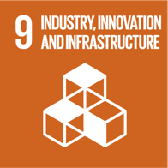

Outcomes
- Regulation supports integrated water management solutions.
- Consideration is given to the full economic benefits of making alternative water available through the use of safe, reliable and affordable recycled water.
- All water sources are regulated under a consistent framework.
Water pricing to be reflective of value and considers all benefits.
- Holistic pricing of all water sources taking into account the total environmental benefits.
- There is strong policy around chemicals of concern that enables safe reuse of resources.

Next Steps
- Support the IWM forums.
- Provide input to Recycled Water Guidance review.
- Engagement with regulators to develop plans for working together to deliver regulatory changes that will support the adaptive pathways.

Case Study

Western Irrigation Network

Overview
Western Water is leading the detailed planning phase for the Western Irrigation Network (WIN) Project. The WIN Project is a proposed network of more than 50km of pipelines to bring recycled water to agricultural precincts for irrigation.
Western Water has been working with stakeholders and potential customers to understand possible agricultural demand for recycled water in the west. The project is considering supplying Class C recycled water to agricultural land to the west of Melbourne including Parwan, Balliang and Eynesbury.

Drivers for change
Western Water already supplies recycled water, produced from treated sewage, to agricultural businesses in Sunbury, Melton, Bacchus Marsh and the Macedon Ranges. As the population of the region grows, so too does the amount of water required for our community along with the amount of recycled water produced. Recycled water is a reliable, high-quality water supply that can be used for a range of agricultural purposes.

Outcome
The project has the potential to:
- Greatly increase the use of recycled water for irrigation, reducing recycled water discharge into waterways, and improving waterway health.
- Mitigate future impacts of climate change by reducing use of drinking water for agricultural purposes and making the most of sustainable alternative water resources.
- Help existing agribusinesses to expand, and new ventures start up, with the benefit of a reliable, high quality water supply.
- Create jobs, supporting sustainable regional communities through economic growth.
Following the detailed planning phase, if it is confirmed that WIN is the best solution for managing recycled water supply in the west of Melbourne, the first stage of WIN is expected to be constructed and operational by September 2021, transforming this region into a thriving agricultural hub.
End Case Study

Case Study

Collaborating with regulators to enable innovation

Overview
Melbourne Water wanted to improve the quality of treated water from Eastern Treatment Plant to reduce the impact of discharge at Gunnamatta Beach and lift the quality of recycled water from Class C to Class A, so it could be used for a broader range of applications.
Due to water quality challenges unique to Eastern Treatment Plant, the need to address the environmental impacts on the ocean and provide Class A recycled water, Melbourne Water wanted to pursue a non-standard treatment option to achieve multiple outcomes.

Drivers for change
Approval to produce Class A recycled water is given by the EPA, but treatment processes must be endorsed by the Department of Health and Human Services (DHHS).
However, when Melbourne Water started talking with DHHS, they found there was no precedent to review the proposed treatment process and DHHS had no confidence they could approve it.
The benefits of the new approach were significant enough to encourage Melbourne Water to start talking with DHHS in 2007, with the aim of completing the $400m project by 2012.
Melbourne Water invested in the research, development and application of performance validation approaches that were consistent with the outcomes sought by DHHS.

Outcome
After five years, the non-standard water treatment approach was approved by the EPA.
The approval demonstrated the importance of investing in science to support new ways of doing things and the need to focus on shared outcomes (such as protecting the environment and public health) and strong relationships to progress change. The project also highlights the need for sustained collaboration to realise innovative outcomes with no precedents.
End Case Study

SECTION 6

Implementing the Strategy
Successful implementation of the strategy is key to being able to deliver on our Vision and Goals.
After setting the context for change, ambitious goals and identifying key decisions that will need to be made we now need to combine this with a governance framework, approach to making decisions and a series of actions to deliver the strategy.
Each component of the strategy supports the others and as such no one part can be considered in isolation.
The Vision and Goals set the direction for what we want our sewerage system to be in the future.
The Future Functions and Features provide greater clarity for decision makers as to how the system should look in order to achieve our Goals.
The Adaptive Pathways provide the framework for identifying key pieces of work to inform strategic decisions that will arise as the system reaches key limits. These limits are driven by many factors including climate change and population growth.
When system limits are identified in the Adaptive Pathways we will need to make decisions about which option to choose. The Decision Making Framework provides a transparent way to make decisions.

Figure 23. Implementing the strategy – text version
How the Sewerage Strategy components fit together to enable transformation of the current system to achieve the vision and goals.
The figure shows a circle on the left representing the current system. There is an arrow labelled Adaptive Pathways from the Current System to a nested Venn diagram representing the future system. This shows that the decisions made as part of the adaptive pathway planning process will help transform the current system to deliver a future system that achieves the vision and goals of this strategy.
The nested Venn diagram shows a circle labelled Features nested inside a circle labelled Functions, which is nested inside a circle labelled Goals, which is inside a circle labelled Vision.
There is a box labelled Decision-Making Framework underneath the Adaptive Pathways arrow connected by a double headed arrow, showing that the Decision-Making Framework will be used to support decisions as they are required by the Adaptive Pathways.
There is a dotted arrow labelled Criteria coming from the future system Venn diagram leading to the Decision-Making Framework, indicating that the Goals, Functions and Features will be used as criteria in the Decision-Making Framework.

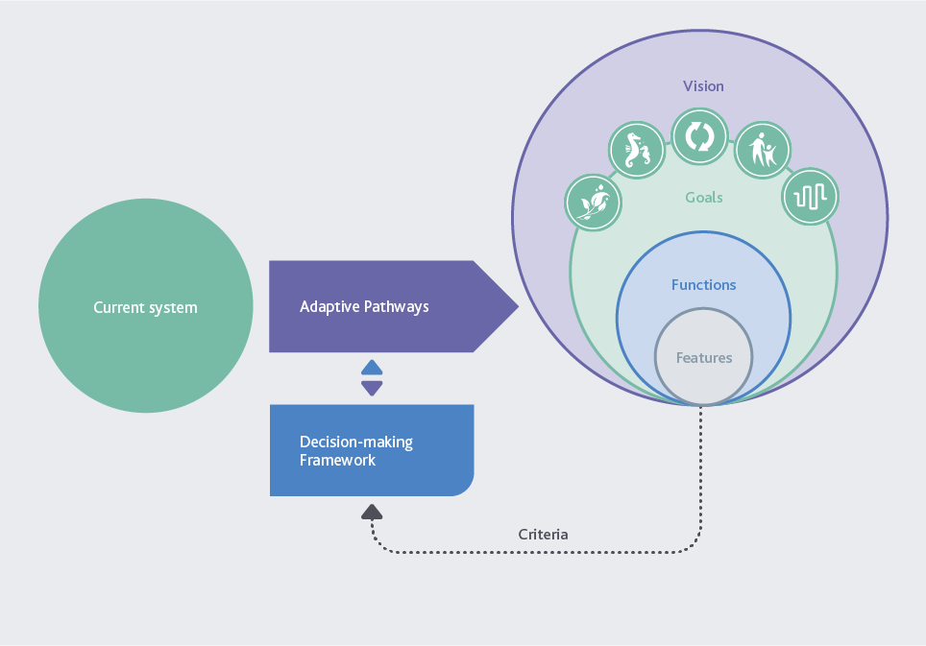

6.1 Decision Making Framework
Successful implementation of the strategy is key to being able to deliver on our Vision and Goals. The Decision Making Framework is used in the Adaptive Pathways to make a choice between different pathways, and uses the Future Functions and Features and the Sewerage Strategy Goals as criteria for making decisions.
Most importantly, the Decision Making Framework provides a process for making decisions collaboratively, and in conjunction with the Sewerage Strategy Governance.
The Decision Making Framework should be used for all decisions that relate to the sewerage system, unless there is an agreed management plan in place that has been developed according to the framework, or it can be demonstrated that no stakeholders are impacted by the decision being made. The framework is separated into three phases:
The problem phase, where the actions revolve around identifying and categorising the problem, understanding the strategic alignment, and identifying stakeholders.
The solutions phase, where options are identified and assessed against the Future Functions and Features, Goals, Vision, financial criteria and any other criteria that has been identified.
Implementation and Review, where the project that has been selected is taken to implementation and a review of both the process and the success of the project is undertaken.

6.1.1 How the Decision Making Framework works
Figure 24 illustrates the process used in the Decision Making Framework and shows how decisions are made from an individual water corporation and collaborative perspective, ensuring that problems are not lost along the way. Repeated clarification and agreement of strategic and tactical objectives is sought during the problem and solution phase to ensure we are stepping towards our Goals for the sewerage system.
A key feature of the Decision Making Framework is the agreement on project objectives and measures of success at the beginning of the collaborative process. This will facilitate best for community outcomes, achieved through optimal allocation of individual water corporation accountabilities and benefits.
While the Decision Making Framework has been designed for problems that arise through the Adaptive Pathways process, other problems may also be identified through new obligations or unmet level of service criteria and it can be used for these as well.
Further detail on the Decision Making Framework can be found in Appendix 4.

Figure 24. Decision Making Framework – text version
The figure shows The Decision Making Framework, which is an 11 step process. The right of the diagram shows a problem phase, a solution phase and a review and implementation phase as horizontal segments. The Problem phase includes:
- Problem Identification
- Strategic alignment
- Identify stakeholders
- Determination the scope
- Project setup.
The Solution phase is underneath the Problem phase and includes steps:
- Identify options
- Reasonableness test (an arrow shows that options need to pass the reasonableness test to progress to step 8, otherwise)
- Detailed options assessment
- Detailed specification of the preferred solution.
Review and Implementation is at the bottom of the diagram:
- Implementation plan
- Process review.
On the left of the diagram the steps are separated into Individual business activities and Governance arrangements guiding collaborative working.
Individual business activities include steps:
- Problem Identification
- Strategic alignment
- Identify stakeholders
- Implementation plan
- Process review
Governance arrangements guiding collaborative working includes steps:
- Determination the scope
- Project setup.
- Identify options
- Reasonableness test
- Detailed options assessment
- Detailed specification of the preferred solution.

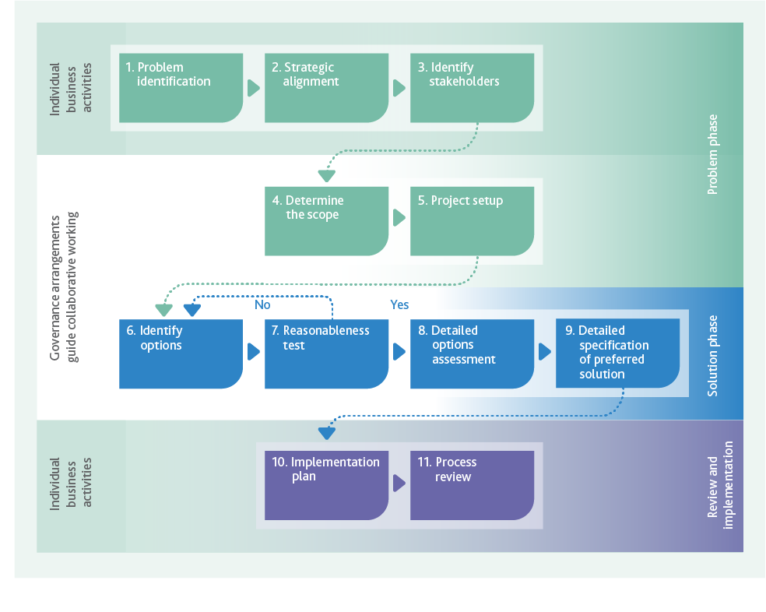

Evaluating Specific Project Benefits
Melbourne’s metropolitan water industry is working collaboratively to develop an Investment Evaluation Framework to support integrated water management. This will compare the benefits of future projects, facilitate industry collaboration and ensure sufficient financial resources are available to build the efficient, adaptable sewerage system our future requires.
The Investment Evaluation Framework, based on the principles of integrated water management, will effectively identify options suited to uncertain futures and a changing climate.
Non-monetary benefits such as the provision of green open space that improves livability or environmental outcomes will be considered in the cost evaluation of new projects through a more holistic appreciation of value.
The Investment Evaluation Framework will work in synergy with the Decision Making Framework to ensure the Goals of the sewerage strategy are met.

6.2 Collaborative Implementation
The significant uncertainty associated with a 50 year planning horizon means that definitive decisions on infrastructure development cannot all be made today. We need to keep our options open for as long as possible to ensure that we meet community needs.
By developing this strategy collaboratively we have agreed what we are striving to achieve and how we go about doing it. Collaboration also offers the best opportunity for delivering best for community outcomes for the future as community needs and expectations change, rather than preparing an infrastructure plan based on what we know today about future needs that each business then implements in isolation.
Changing the approach to understand critical system limits, the range of available options and determining the best ways of addressing them will change significantly over time.
We will work together as an industry to ensure that system limits are better understood, appropriate options are developed and decisions are made to provide the best possible outcomes for the community.

6.3 Governance for Strategy Implementation
Governance for the implementation of the strategy will play a key role in ensuring the successful delivery of the actions from the strategy and ultimately the Vision and Goals. The strategy has been developed on the understanding that the best for community outcomes will come from collaborative working relationships between the water corporations, our regulators, the community and industry experts.
Key principles for the governance of the strategy need to include:
- Clear accountability for the implementation of the strategy and for the delivery of the actions that have been identified.
- Resourcing that will ensure the strategy can be delivered. This strategy is about driving transformational change. Ensuring that we have the right resources capable of delivering this change is important. We still need input from our engineers, planners, community engagement specialists and operators, however capability to lead complex change is a critical skill for this work. In addition to resourcing there is the need for equitable funding to undertake the actions that are required.
- Collaboration by all water businesses to deliver the actions of the strategy along with the development of a process that will enable us to work closely with our regulators to ensure we can deliver our outcomes. Including appropriate expertise and oversight as we work to deliver our actions will be important and this might include independent expert review panels.
- Empowerment of team members working on delivering the strategy enabling them to deliver work for the project in accordance with agreed timeframes. Agreement on the level of empowerment that each team member has will be essential when it comes to discussing and resolving difficult and complex issues.
- Ensuring that there is sufficient engagement within each business such that all projects developed from actions become integrated into ‘Business as Usual’ planning processes.
- Coordination of all the projects arising from actions, so that all projects are working in harmony, there is no overlap of scope and resources are efficiently used to deliver the strategy Goals and Vision.
A dispute resolution process to ensure that any issues can be resolved in a timely manner. This may require a level of independence to be brought into the governance structure. Determining the ultimate governance structure for delivering the strategy along with testing and refining the tools used, will be delivered in line with Action 11.

Case Study

Why not just provide a ‘shadow price’?

Overview
A key aspect of the future of Melbourne’s sewerage system will be how it develops to service growth and how associated investment decisions will be made. This includes the choice between augmenting the centralised system and developing new decentralised treatment systems, or some combination of the two.

Drivers for change
Once the sewerage system’s critical limits are determined, a 50 year infrastructure blueprint could be developed based on augmenting the centralised system. This could be used to develop marginal or ‘shadow’ costs for evaluating alternative servicing options. A marginal cost is the additional cost for each additional unit of treatment, taking into account the cost of building new infrastructure when needed. Marginal costs for sewage treatment services incorporate high uncertainty, including uncertainties around population growth and climate change. They fail to describe the multivariable nature of sewerage service demands and require constant updating to remain relevant.
Marginal costs for sewage treatment services are only considered appropriate for high level identification of options.
The accepted best approach to sewage treatment investment decisions is to base the economic components on holistic servicing costs using net present cost analysis. This takes externalities into account in an appropriate and transparent manner.
Current planning considers shadow pricing as it is readily available and it is challenging to develop superior evaluation tools.

Outcome
Melbourne’s water corporations need to work together on joint planning, cooperation, and data transparency to enhance long term planning and associated investment decisions and progressively replace shadow pricing. The right structures need to be in place to facilitate good decision making based on robust information and collaborative planning. This includes:
- Alignment on the strategic framework for robust planning across systems and interface boundaries for longer term planning. This should be linked with Adaptive Pathway Planning.
- Agreement on sharing of mutually beneficial information to support this strategic framework and the development of guidelines for sharing.
- Ensuring that there are agreed guidelines in place to establish who should deliver any works and who would make the most efficient investment, ensuring that the allocation of benefits is linked with investments.
End Case Study

Case Study

Best for community sewerage servicing

Overview
The Casey Clyde area in the south east of Melbourne is an urban growth zone with residential zoning for 40,000 properties. The fast-growing area faces a variety of challenges including high demand for services, lower middle-income families, aspirations for sustainable water cycle and environmental outcomes and community desire for local employment opportunities.
Water corporations needed to agree on sewer servicing and recycled water approaches for this large greenfield area. The complex nature of geographical and other challenges led to cross sector collaboration. Melbourne Water, South East Water, Southern Rural Water, The Victorian Planning Authority, City of Casey, Cardinia Shire Council, developers, industry groups and community came together to develop a servicing strategy.

Drivers for change
The growth area is separated from Eastern Treatment Plant by a large ridge, so it is not naturally in the treatment plant’s catchment.
Significant infrastructure is required to link it to the central sewerage system. Melbourne Water and South East Water formed a joint project team to examine a mix of centralised and decentralised solutions.
The project team conducted extensive engagement with stakeholders and used a sophisticated triple bottom line framework (TBL) to examine a range of economic, social and environmental impacts.

Outcome
Following the results of the TBL analysis and extensive consultation, regional processing has been approved for development. The collaborative process revealed strong community and council support for the regional option, with aspirations for the scheme to support long term economic growth. It also enabled Melbourne Water to learn how their systems can interface with local systems in a mutually beneficial way.
The regional option can support a transformational agricultural recycled water scheme, augment existing sewerage services in the area, support energy recovery activities and provide a buffer for proposed industrial and residential development.
End Case Study

ACTION 11
Facilitate delivery of the strategy

Outcomes
- Melbourne’s five water businesses and key regulators (EPA,DHHS and DELWP) collaborate effectively to successfully transform the sewerage system to meet future needs.

Next Steps
- A collaborative governance structure is established to deliver the Sewerage Strategy actions.
- The Decision Making Framework is refined and developed further by testing it with a pilot project and making appropriate changes based on the learnings from the process.
- Develop an annual reporting process for measuring progress against the action plan.

6.4 Actions for Implementation
To enable us to successfully achieve the Vision and Goals of the Sewerage Strategy we have a significant amount of further work to undertake. This work has been discussed throughout the document and the related actions are consolidated in Table 2 below.
The actions are combined into themes that are aligned with the Knowledge, Values and Rules concepts from the Adaptive Pathways Planning approach. Some actions have components in more than one area and, as such, are shown more than once.

Table 2: Consolidated Implementation Actions
Strategic Action | Outcomes | Next Steps | Due Date

Actions – Deliver the Strategy
Action 11: Facilitate delivery of the strategy. | - Melbourne’s five water businesses and key regulators (EPA, DHHS and DELWP) collaborate effectively  to successfully transform the sewerage system to meet future needs. | - A collaborative governance structure is established to deliver the Sewerage Strategy actions.  - The Decision Making Framework is refined and developed further by testing it with a pilot project and making appropriate changes based on the learnings from the process.  - Develop an annual reporting process for measuring progress against the action plan. | December 2018  2019  2019
Action 2: Adopt the adaptive pathways concept to address the four identified system limits. | - Multiple pathways and options for addressing the limits have been developed, and the Knowledge, Values and Rules around each decision identified.  - Adaptive Pathways inform  the development of future infrastructure plans. | - Confirmation, quantification  and alignment of system limits identified by the Adaptive Pathways process by all five water businesses.  - An understanding of the indicators for trigger points that will initiate the requirement for a decision. This will include the requirement to understand and implement appropriate lead times to allow for planning  to occur.  - Establish a monitoring program to identify when trigger points have been reached, similar to the ‘Annual water outlook’.  - A means of testing pathways against plausible futures and vulnerabilities has been implemented.  - Develop infrastructure plans to inform future Price Submissions for Melbourne. | 2019  2019  2019  2019  Mid 2020 (to align initially with the Melbourne Water Price Submission)

Actions – Adaptive Pathways Values
Action 1: Listen, involve and engage with our customers and community to develop  a shared understanding for the future of our sewerage system | - Customers understand and value the role of the sewerage system in the water cycle, environmental protection and resource recovery and have a greater role in sewerage system planning.  - Traditional Owner cultural values are embedded into planning processes.  - Customer values and expectations are aligned with our existing service levels and any proposed future services to provide greater value to our communities. | - Understand where there are gaps in alignment between service provision and what customers value.  - Develop an innovative, targeted and strategic communication and engagement plan integrated with other engagement activities to support limits identified in the Adaptive Pathways. | 2019  2020
Action 4: Drive transformational approaches to the role that the sewerage system plays in maximising the use of our resources  and providing the best environmental outcomes | - Land use planning is integrated with sewerage planning as part of addressing limits identified in the Adaptive Pathways. | - Continue to work collaboratively with stakeholders to ensure that land use planning is an integral part of enhancing our environment and providing affordable sewerage services for our customers. | Ongoing
Action 5: Engage with customers and stakeholders on an ongoing basis to develop a greater appreciation of their environmental values | - Water businesses understand the environmental values of our customers which are used to inform adaptive pathways decisions.  - Customers understand the role of the sewerage system in the water cycle and the opportunities available for providing sustainable and affordable resource management services. | - See Action 1. | 2019  2020
Action 6: Drive transformational approaches to the role of the sewerage system in organic waste management and resource recovery | - Customers and stakeholders understand the wide range  of benefits from resource recovery.  - The role the water businesses have in managing Melbourne’s organic waste is clearly understood and agreed by all.  - A resource recovery system valued by the community for protecting public health and the environment while being equitable and affordable. | - An agreed, shared plan that the waste industry and regulators will support to deliver best for community outcomes that can support development of future business cases between the waste and water industry.  - Demonstrate and engage the community using interactive features (for example through pilot plants) showing that high quality resources can be produced from the sewerage system. This might include, high quality recycled water, fertilisers or innovative products such as biofuels. | 2021  2021

Actions – Adaptive Pathways Rules
Action 6: Drive transformational approaches to the role of the sewerage system in organic waste management and resource recovery | - Policy and regulation enables and encourages the use of resources through pricing frameworks and risk-based approaches to integrated water and waste management. |  | Ongoing
Action 7: Ensure that emerging contaminants and chemicals of concern that might be present in sewage, treatment plant discharges and recovered resources  do not cause harm to the environment or public health, through whole  of system management | - There is strong policy and industry leadership regarding chemicals of concern that facilitates safe resource recovery and encompasses the management of chemicals of concern at both source and at the ‘end of pipe’.  - Robust self-reporting and tracking of off specification product events to increase learning. | - Ensure sewerage planning activities integrate with the ISQMS sewage quality risk assessment process.  - Development of a coordinated risk based approach between the water businesses, regulators and industry regarding the identification, management, reporting and surveillance  of chemicals, pathogens and materials of emerging concern and their impact on the sewerage system, human health, the environment, and the ability to recover resources. | Ongoing  2021
Action 8: Develop and implement resource recovery opportunities | - Diverse markets are established for resource recovery products that could include biosolids nutrients, methane, heat, energy, and recycled water adding resilience to the sewerage system.  - Public health and the environment outcomes are protected and enhanced. | - 100% reuse of the annual production of biosolids from  WTP in accordance with EPA requirements.  - Use the environment and public health risk hierarchies and work in collaboration with the regulators to gain a greater understanding of the risk to public health and the environment associated with increased resource recovery and use. | In accordance with EIP  2020
Action 9: Drive transformational approaches to the role of the sewerage system in Integrated Water Management | - Pricing and regulatory structures for recycled water include appropriate allocation of costs and benefits to the community and environment, as part of Integrated Water Management investment evaluation framework. | - Address the identified barriers to the implementation of previously investigated large scale recycled water schemes using the adaptive pathways concepts of ‘Knowledge, Values and Rules’. | 2020
Action 10: Strategic, consistent and effective engagement with government stakeholders | - Regulation supports integrated water management solutions.  - Consideration is given to the full economic benefits of making alternative water available through the use of safe, reliable and affordable recycled water.  - All water sources are regulated under a consistent framework.  - Water pricing to be reflective of value and considers all benefits.  - Holistic pricing of all water sources taking into account the total environmental benefits.  - There is strong policy around chemicals of concern that enables safe reuse of resources. | - Support the Integrated Water Management forums.  - Provide input to Recycled Water Guidance review.  - Engagement with regulators to develop plans for working together to deliver regulatory changes that will support the Adaptive Pathways. | 2018/19  2019  2019

Actions – Adaptive Pathways Knowledge
Action 3: Develop a plan to ensure the resilience of the system is capable to meet Melbourne’s future needs | - Resilient system for current and future generations providing a safe, reliable, affordable and effective service.  - Risk management and risk appetite of water businesses support delivery of a resilient system.  - Water businesses leverage external expertise in resilience management.  - The resource recovery system is safe for the community and those that work with and around it. | - A collective understanding  of what resilience means for the sewerage system that  is shared by each Water Corporation and our regulators.  - A plan for meeting an agreed level of resilience that can be implemented through price review processes and integrated into our ‘business as usual’ planning and renewal processes.  - Complete the Sewerage System Resilience Project. | 2019  2020  2019
Action 4: Drive transformational approaches to the role that the sewerage system plays in maximising the use of our resources and providing the best environmental outcomes | - A greater use of fit for purpose recycled water for the environment to support flow stressed rivers. | - Develop scientifically robust quality and hydrological regimes for flow stressed rivers that could utilise fit for purpose recycled water.  - Continue to invest in research and ensure that technological advancements remain a key part of our approach to providing services to the community. | 2021  Ongoing
Action 9: Drive transformational approaches to the role of the sewerage system in Integrated Water Management | - An additional 50 GL/year of water from the sewerage system is beneficially reused in an economically viable way by 2040 to support MWSS goals. | - Review previous large scale recycled water business cases in line with the IWM investment evaluation framework.  - Address the identified barriers to the implementation of previously investigated large scale recycled water schemes using the adaptive pathways concepts of ‘Knowledge, Values and Rules’. | 2019  2021

APPENDIX 1

Melbourne’s journey towards a water sensitive city
The Traditional Owners who originally inhabited the area surrounding the Yarra River and Port Phillip Bay that is now Melbourne managed the water and land sustainably for thousands of generations.
The discovery of gold in 1851 made Melbourne one of the richest cities on earth. A population of around 500,000 people by the 1880s made Melbourne Australia’s largest city and these people required drinking water, which came from Yan Yean Reservoir and Watts River (near Healesville). The city had a major pollution problem, and was described by British journalists as ‘Marvellous Smellbourne’ because of unsanitary waste disposal methods.
Most of the waste from homes was emptied into open drains that flowed into street channels, rivers and creeks.
Waste from industry also flowed into these channels and turned Melbourne’s rivers and creeks into open sewers. Concerned about the spread of disease, the authorities carried out a Royal Commission in 1888 to develop a solution to Melbourne’s waste problems.
The answer was the construction of a sewerage system – a system of pipes, pumps and sewers– built underground to carry sewage from homes and factories to a sewage treatment farm. This was the beginning of Melbourne’s transition towards a Sewered and Drained City.
In 1889, an English engineer, Mr James Mansergh, was employed to draw up plans for Melbourne’s sewerage system to protect public health and the environment. In 1891, the Melbourne and Metropolitan Board of Works (MMBW) was formed to take responsibility for both water supply and the treatment of sewage.
Mansergh’s plans were modified by the MMBW’s first engineer-in-chief, Mr William Thwaites, and in May 1892, construction began on Melbourne’s sewerage system. A pumping station was built at Spotswood (now the site of the Scienceworks Museum) to send the city’s waste to a treatment farm built at Werribee. The first Melbourne homes were connected to the sewerage system in 1897. Factories were also connected to the system to convey trade waste to the treatment farm.
Post the Second World War, significant expansion of the sewerage system took place to service Melbourne’s growth, including the upgrade of Western Treatment Plant and establishment of the Eastern Treatment Plant. The foresight of our forebears means that Melbourne’s sewerage system remains a predominately gravity system, which makes it a lower cost system to operate than a system solely reliant on pumping.
The integration of environmental benefits into sewage treatment planning characterises our progression towards a Waterway City, including off-site reuse of recycled water supply, which started in the 1980s.
The Western Treatment Plant at Werribee contains a network of lagoons, wetlands, inter-tidal and shoreline areas that provide a haven for thousands of birds, including thousands of migratory waders that fly 12,000 kilometres from Siberia to avoid the harsh northern winter.
The Western Treatment Plant and areas of the surrounding bay and peninsula were declared a sanctuary for native animals in 1921, and in 1983, the plant became a Ramsar-listed wetland, internationally recognised for supporting waterfowl.
In 2004, Melbourne Water completed a $160 million treatment upgrade of the plant to reduce nitrogen loads to the bay. This work stemmed from a CSIRO study that found Port Phillip Bay could be damaged if nitrogen loads entering its waters continued to increase.
Affordability continues to be a consideration in sewerage planning. At only one-tenth the land size of the Western Treatment Plant, the newer Eastern Treatment Plant in Bangholme treats nearly half of Melbourne’s sewage using a biological and mechanical process that requires significantly less land, however this is more costly to operate.

Figure 25. Melbourne’s Index Benchmarking Results – text version
Results from Melbourne’s benchmarking as a water sensitive city. Melbourne achieved 100% for a water supply, sewered and drained city, scored 97% for a waterway city, scored 50% for a water cycle city and scored 10% for a water sensitive city.
The left of the figure shows concentric circles for each indicator. For each indicator the percentage of the circle that is coloured corresponds to the benchmark value.
The right of the figure shows a spider plot of different indicators. These are (clockwise from top left):
- Promote adaptive infrastructure
- Ensure good water sensitive governance
- Increase community capital
- Achieve equity of essential services
- Improve productivity and resource efficiency
- Improve ecological health
- Ensure quality urban space
The spider diagram shows that Melbourne has achieved a score of at least 2.5 in all of these.

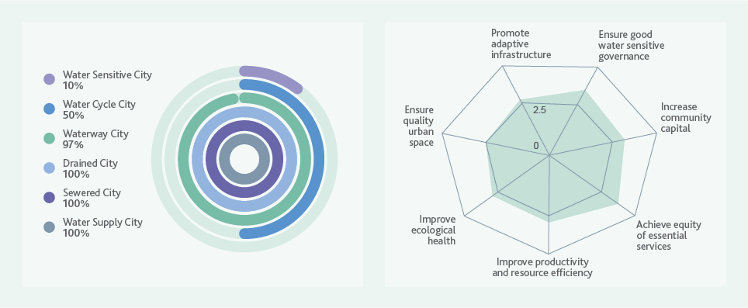
Melbourne’s sewerage system has continued to expand as Melbourne has grown, and technology advancements have allowed for system improvements and efficiencies to improve capacity and resilience towards a Water Cycle City.
Today, Melbourne has been benchmarked on its performance as a water sensitive city and is considered well serviced by water supply, sewerage, and drainage systems. Everyone has access to safe and secure drinking water, safe and reliable sanitation and the city is fairly well protected against floods. In the categories of Water Supply City, Sewered City and Drained City, the Greater Melbourne Region is rated at 100 per cent.
There are opportunities to move toward a water sensitive city through working with the community to increase their understanding of the water system and improving delivery of Integrated Water Management.

APPENDIX 2

Melbourne sewerage system overview
Melbourne’s existing sewerage system includes wholesale and retail sewerage assets managed by Melbourne Water, City West Water, South East Water, Yarra Valley Water and Western Water. This, not only encompasses network assets, such as pipes and treatment plants, but also includes the resources within and recovered from sewage, the receiving environments to which treated water is discharged, the land on which assets are built and the air to which gases are released from the system.
Melbourne’s sewage is transferred via a network of pipes and pumping stations to one of Melbourne’s 28 treatment plants. These treatment plants process sewage so it can be safely reused or discharged to its receiving environment. The system consists of over 25,000 km of pipes, including small reticulation assets to service residential streets through to large bulk assets to convey Melbourne’s sewage to our treatment plants.
The summary of Melbourne’s sewerage system provided below only includes bulk sewerage assets. This refers to all sewers 300 mm in diameter or greater and their associated assets, such as pump stations. Sewers with diameters less than 300 mm were excluded as these are considered reticulation assets.

A2.1 Pipe Age and Material
Figure 18 (in Section 5.6.1) and ERS below show the construction date of Melbourne’s sewers. This shows that the system expanded significantly (over 85 per cent) since the 1950s (post World War II). Sewers in Melbourne’s CBD were mostly built in the late 1800s to early 1900s when Melbourne’s sewerage system was first established. New sewers are mostly located on the fringe of the system, to support Melbourne’s historical growth outwards.
Figure 27 below shows the different material types sewers are constructed from in Melbourne’s sewerage system. Pipe material is closely correlated to pipe age, with older sewers in Melbourne’s CBD largely made of brick or concrete. Brick sewers have a higher potential to collapse due to displacement of bricks. Concrete is more susceptible to structural failure from reduced pipe strength from corrosion. Technology has allowed us to learn more about the behaviour of different materials so over time, the materials have changed. For example, we now know that gases, such as hydrogen sulphide, released when sewage interacts with bacteria living in wet sewer walls, causes sewers to corrode. Sewage age and time within the system also contribute to corrosion and odour. This means, where possible, we now use non-corrosive materials to build new sewers. However, it does still present a challenge for maintaining and renewing existing brick and concrete sewers.
We use pipe age and material along with other forms of technology, such as CCTV footage, to understand where and when pipe failure may occur.
These factors are used by Melbourne’s water industry to assign a risk rating to each sewer in Melbourne’s sewerage system from low risk to extreme risk of failure. We then focus our efforts on fixing the extreme risk sewers, to make sure the sewerage system continues to operate.

A2.2 Pumping Stations
While Melbourne’s sewerage system is largely serviced via gravity, the system does contain a number of pumping stations. The majority of these are required to service low lying areas where gravity flow is not possible or areas where there are ground condition or topographic constraints. Melbourne’s three largest pumping stations are operated by Melbourne Water, of which two are located on the Western Trunk Sewer operating as lift pumping stations to transfer sewage to Western Treatment Plant. The third being the inlet pumping station to Eastern Treatment Plant. The Eastern Treatment Plant also has a significant outlet pumping station that transfers treated water to the South Eastern Outfall which runs 56 km from Eastern Treatment Plant to the ocean outfall at Boags Rocks on the southern Mornington Peninsula.

Figure 26. Pie graph of Melbourne’s existing system – text version
Construction date | Percentage of network by length
Pre 1950’s | 13%
1950’s | 3%
1960’s | 11%
1970’s | 20%
1980’s | 16%
1990’s | 11%
2000’s | 15%
2010’s | 11%
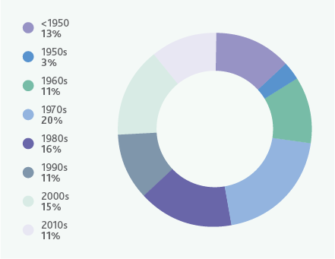

Figure 27. Pie graph of Melbourne’s existing system – text version
Material type | Percentage of network by length
Brick Sewers | 3%
Concrete | 14%
Concrete reinforced | 14%
Non corrosive | 30%
Vitrified clay | 34%
Other | 5%

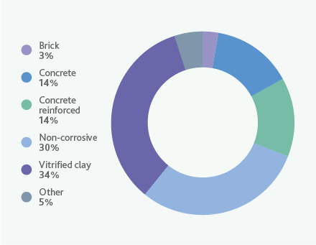

A2.3 Emergency Relief Structures
Emergency Relief Structures (ERS) provide a controlled point of discharge for excess flows from the sewerage system to a receiving environment, such as waterways. Approximately half of Melbourne’s ERSs are associated with pumping stations. These ERSs will only operate in the event of pump failure and therefore are less likely to release sewage flows to their receiving environment than ERSs located on trunk sewers.
ERSs are designed to not operate during normal operation and are subject to EPA compliance and the 1 in 5 year Average Recurrence Interval (ARI) containment standard. This wet weather capacity standard is set by the EPA and is the containment standard that the sewerage system must meet in order to comply with the State Environment Protection Policy (Waters of Victoria).
This standard states that sewers must contain flows associated with a 1 in 5 ARI rainfall event, which is roughly an event that happens once every five years. The purpose of this standard is to protect public and environmental health from sewage spills.

A2.4 Sewage Treatment Plants
Most of the sewage generated in Melbourne is transferred to one of Melbourne Water’s two sewage treatment plants: Eastern Treatment Plant in Bangholme or Western Treatment Plant in Werribee. These two treatment plants are the largest in Australia, and process approximately 87 per cent of Melbourne’s sewage, which can then be supplied as recycled water or safely released into Port Phillip Bay (Western Treatment Plant) or Bass Strait (Eastern Treatment Plant). The system also contains 26 local treatment plants, which treat the remaining 13 per cent of Melbourne’s sewage. These local treatment plants are mostly located on the fringes of Melbourne and are operated by the urban water corporations.
Figure 4 (in Section 1.6) shows the location of sewage treatment plants across Melbourne.

Western Treatment Plant
Western Treatment Plant (WTP) treats more than half of Melbourne’s sewage at a 10,500 hectare site in Werribee, southwest of Melbourne. The treatment process has evolved over the last 100 years with advances in technology from land filtration to lagoon systems to activated sludge. Today, the treatment process takes place within five lagoon systems.
Sewage is initially transferred to the anaerobic (no oxygen) lagoons. These lagoons have large plastic covers that are designed to keep oxygen out.
The anaerobic environment allows certain bacteria to thrive and begin the biological treatment process. As the bacteria breakdown the organic material in sewage, odour and methane gas is produced. These gases are captured under the plastic covers, which reduces greenhouse gas emissions and air pollution from the odours.
Once captured, the gas is sent to an onsite power station where it is used to create renewable energy.
The partially treated sewage is then transferred to aerobic lagoons. These lagoons are uncovered, which allows oxygen from the atmosphere to support additional biological treatment using a different type of naturally occurring bacteria. Natural oxygen transfer is assisted by mechanical equipment which pumps more oxygen into this sewage to intensify the treatment process. These bacteria help remove nutrients which can be damaging to the receiving environment of Port Philip Bay, such as carbon and nitrogen. In doing so, the bacteria clump together, making it easy for these clumps to be removed from the water by settling. These solids, known as biosolids are then dried and either reused or stored in large stockpiles on site.
Some of the water is treated using more engineered and controlled treatment systems, called activated sludge plants, to make it suitable for reuse or it is released to Port Phillip Bay in accordance with EPA licence requirements. Treated water is either reused as Class C recycled water or released to Port Philip Bay, while some undergoes additional disinfection to produce Class A recycled water.
The existing treatment process at Western Treatment Plant uses very little energy and takes around 35 days. While this process has low operating cost, the use of lagoons is land intensive and this process means there is seasonal variability in the quality of water produced.
Western Treatment Plant is unique, in that it is not only a sewage treatment plant, but also an internationally recognised wetland site (under the Ramsar Convention) primarily due to it being home to various native flora and fauna and migratory birds. Melbourne Water has obligations under both State and Commonwealth legislation, principally the Environment Protection Act 1970 and the Environment Protection and Biodiversity Conservation Act 1999, for management and operation of the site.
The unique and invaluable biodiversity of the site has come about through the historical sewage management practices, and requires the carbon and nitrogen present in semi-treated sewage to continue to thrive. This tension between maintaining biodiversity values and continuously reducing other environmental impacts is a key feature of managing the Western Treatment Plant.

Eastern Treatment Plant
Eastern Treatment Plant, located in Bangholme southeast of Melbourne, is Melbourne’s second major treatment plant, treating nearly half of Melbourne’s sewage. At only one-tenth the land size of the Western Treatment Plant, the Eastern Treatment Plant uses a three stage biological and mechanical process that requires significantly less land, however this is more costly to operate. The time to treat sewage is significantly less than Western Treatment Plant, taking about 24 hours compared to 35 days.
The first stage is preliminary treatment, which removes gross pollutants from the sewage. This process involves the use of screens to remove large items, such as rags, wipes, rubbish, sticks and rocks to prevent damage and clogging of downstream equipment. This is then followed by primary sedimentation where grit (like sand), and fine organic particles sink to the bottom of tanks and are removed. The material removed by the screens as well as the grit are cleaned and generally sent to landfill. The organic sludge is pumped to large tanks, called digesters.
Digesting sludge produces methane-rich biogas which is used to produce renewable electricity by an onsite power station. The digested solids are dried and either reused, or stored in large stockpiles on site.
The second stage of the process is secondary treatment using biological processes that require aeration to provide oxygen to the bacteria.
Similarly to Western Treatment Plant, this treatment process breaks down organic material and removes nutrients. In contrast to Western Treatment Plant, the Eastern Treatment Plant only employs the high rate and intensive activated sludge treatment process and does not have lagoon treatment.
Commissioned in 2012, the final stage of treatment at Eastern Treatment Plant is advanced tertiary treatment. This includes ozone treatment and biological media filtration followed by ultraviolet light (UV) and chlorine treatment. These steps reduce solids and particles, colour, and odour along with pathogens to produce a high quality water, suitable for discharge to the receiving marine environment or reuse as Class A recycled water. All treated water is pumped offsite to the South Eastern Outfall where recycled water is either supplied to customers or released to Bass Strait at Boags Rocks on the southern Mornington Peninsula.

Local treatment plants
Melbourne’s sewerage system also has 26 smaller treatment plants that service local areas across Melbourne. These plants are mainly located around the fringe of the metropolitan area. Each treatment plant needs to comply with licence requirements set by the EPA.
Licence objectives require that all relevant provisions of all relevant State Environment Protection Policies (SEPPs) are met, including protection of beneficial uses of the environment. As a whole, our compliance with these licence requirements is very good across Melbourne.
Each treatment plant uses different combinations of treatment technologies, depending on the receiving environment which they discharge to, plant size and available land, and the resources that they recover from sewage. For Melbourne’s local treatment plants this ranges from more natural and low rate lagoon-based treatment through to higher rate primary, secondary and tertiary treatment.

A2.5 Our Receiving Environments
When treated water generated at our treatment plants cannot be reused, it is safely released to receiving environments such as rivers, creeks, Port Phillip Bay and Bass Strait. Section 5.7 shows the receiving environment for each of Melbourne’s treatment plants. Some of our treatment plants practice 100 per cent reuse and therefore do not discharge treated water to a receiving environment.
The Environment Protection Act 1970 sets the framework for Victoria’s licensing and permitting system, under which EPA issues a licence to each treatment plant, outlining the rules that allow treated water to be safely released to its receiving environment. These rules protect the health and safety of the community and waterway health.
Licence objectives require treatment plants to meet relevant provisions of all State Environment Protection Polices (SEPPs) and Industrial Waste Management Policies. The State Environmental Protection Policy (Waters of Victoria) sets a statutory framework for the protection of the uses and values of Victoria’s fresh and marine water environments.

A2.6 Resource Recovery
The three main resource recovery products produced from Melbourne’s sewerage system are recycled water, biosolids and biogas.

Recycled water
In Melbourne, we currently use recycled water for toilet flushing, garden watering (but only in some residential areas where there is access to Class A recycled water), agriculture, commercial and industrial uses and conservation flows for waterways. We currently use about 31 billion litres, which represents 10 per cent of the treated water currently produced by Melbourne’s sewerage system.
Across Melbourne, eleven of the twenty-eight treatment plants produce Class A recycled water. Of these, Melbourne Water’s Western Treatment Plant and Eastern Treatment Plant, as well as South East Water’s Boneo Treatment Plant, supply the most Class A recycled water. This water is mostly used for agricultural purposes in the Werribee Irrigation District, Eastern Irrigation Scheme and the agricultural area around the Boneo Treatment Plant.
Since the millennium drought, the Melbourne water industry has invested in Class A ‘third pipe’ recycled water schemes to reduce drinking water demands of greenfield residential and commercial developments. However, these schemes are dispersed across Melbourne in association with the location of recycled water resources at the respective treatment plants. Some commercial developments have building scale Class A recycled water treatment plants.

Biosolids
Biosolids are the solid organic material remaining after sewage treatment. Once dry, this material has similar properties to soil and contains varying degrees of carbon, nitrogen, phosphorous, metals and other contaminants. Sewage treatment by-products are considered a biosolid if they can be managed to sustainably use their nutrient, soil, energy and other values. EPA regulates how biosolids may be stored and reused, while protecting the environment and public health.
Biosolids produced at Eastern and Western Treatment Plants that were historically stockpiled are now being reused as opportunities present themselves. Biosolids are also reused at a number of local treatment plants across Melbourne. For the remainder of the local treatment plants, sludge is discharged to Melbourne’s centralised sewerage system, where it is transferred to either Western or Eastern Treatment Plants for treatment and reuse.
Biosolids have been reused in land application for agricultural purposes on a relatively routine basis as cost effective opportunities have presented themselves for example as construction fill material, and landfill capping. Disposal via landfill is cost prohibitive and is not aligned with the Environment Protection Act 1970, EPA guidelines or government waste policies.

Biogas (renewable energy)
As part of the biological treatment process, methane-rich biogas are generated. At both Western Treatment Plant and Eastern Treatment Plant, biogas from the treatment process is captured and transferred to onsite power stations where it is combusted into renewable energy (electricity). The Western Treatment Plant can produce about 10 megawatts of renewable electricity, which accounts for all of the plant’s power requirements.
The Eastern Treatment Plant currently produces about 5 megawatts of renewable electricity, which accounts for about one third of the plant’s power requirements. Any excess electricity can be fed back into the Victorian electricity grid.
Biogas is generated at treatment plants that employ anaerobic processes to treat sewage. Therefore the opportunity to produce renewable electricity is only present at some of our treatment plants.
Production of renewable energy from our treatment plants has the following benefits:
- Less reliance on the grid for electricity, which reduces treatment costs to customers.
- Odour Reduction. The biogas produced through treatment processes is highly odourous. Collection of the biogas and combustion (either by flare or power generation) is a key part of managing odour risk, at Western and Eastern Treatment Plants which is regulated by Melbourne Water’s EPA licence.
- Biogas is methane rich and therefore has very high associated Scope 1 greenhouse gas emissions. Reuse of this biogas reduces these emissions and subsequent impacts on climate change.
The following reuse practices are employed at two of the 26 local treatment plants across Melbourne:
- Mt Martha Treatment Plant – Excess biogas produced from the sludge digestion process is captured and used to heat the digestion process.
- Aurora Treatment Plant – Has a waste to energy facility next to the plant, which processes commercial food waste into clean, renewable energy. The facility uses anaerobic digestion to produce biogas that is combusted into renewable electricity. The facility produces enough energy to power itself and the Aurora Treatment Plant. Any excess energy is fed back into Melbourne’s electricity grid.

APPENDIX 3

Adaptive Pathways Case Studies

Case Study 1

The availability of fit for purpose water for Melbourne

What is the limit?
The sewerage system has a key role to play as a source of recycled water that can be used to reduce the demand on the existing water supply system in Melbourne and the surrounding region as part of Integrated Water Management and progressing toward a water sensitive city.
Over the next 50 years, the population of Melbourne and the surrounding region is expected to continue to grow, so the demand for water is also expected to continue to grow.
Victoria’s climate is changing, and will continue to change in the future, leading to an expected long-term decline in the volume of water that can be reliably supplied by the existing water supply system.
Although the impacts of these and other factors are uncertain, the Melbourne Water System Strategy identifies that, without intervention, it is possible within the next 50 years, the demand for water could exceed the volume of water available from the existing water supply system – potentially as early as 2028 under a scenario of high population growth and high climate change impacts.
To manage these challenges and others, the Melbourne Water System Strategy outlines a portfolio approach that can be adaptively implemented as required, recognising that there is no single solution to the challenges we face that would be universally ideal under all plausible future scenarios. We need to keep as many options open as possible to ensure that affordable options are available for our customers.

How does the limit impact on the sewerage system?
Melbourne’s sewerage system treated around 373 billion litres of water during 2016/17. Of this volume, around 43 billion litres of water was beneficially reused, with the remainder safely discharged to our environment, including Port Phillip Bay, Bass Strait and a variety of waterways. Recognising the large volume of recycled water this represents, it is a key element of the portfolio approach described in the Melbourne Water System Strategy along with other alternative sources of water including rainwater and stormwater.
Continuing to discharge increasing volumes of treated water to our environment by continuing to use our water resources once only, will see environmental limits being reached sooner than if we find alternative uses for the treated water. Environmental guidelines set specific limits for a variety of parameters including the amount of solids, nutrients and volume of water that we can discharge to the environment after treatment at our sewerage plants. As our population grows, so will the level of ‘contaminants’ we have to treat and the harder it will become for us to manage sewerage discharge within environmental limits. Reaching our environmental limits will drive the need to find alternative ways to dispose of treated water to ensure ongoing protection of our environment.

What are some of the options to manage the limit?
The portfolio approach described in the Melbourne Water System Strategy to manage the challenges associated with population growth, climate change, and other factors includes four key elements:
- Making the most of the water supply system.
- Using water efficiently.
- Using diverse sources of water (such as rainwater, stormwater and recycled water).
- Optimising the water grid and market.
At least three of these elements have the potential to interact strongly with the sewerage system:
- Using water efficiently, through the use of water efficient appliances, programs such as Target 155, and other initiatives. By reducing the volume of water used across Melbourne and the surrounding region, using water efficiently can also reduce the volume of water that is discharged to the sewerage system. This may be of benefit to receiving environments in managing the amount of water that needs to be discharged.
However, reducing the volume of water that is discharged to the sewerage system does not reduce the amount of nutrients and other contaminants that need to be treated before discharge, so it does not affect other system limits related to treatment plant and receiving environment capacity.
- Using diverse sources of water by increasing the use of recycled water for non-drinking purposes could reduce the volume of treated water that needs to be discharged to Port Phillip Bay, Bass Strait, and various inland waterways. In the community, the majority of people currently favour using these sources of water for non-drinking purposes5. Increased use of recycled water does not reduce the volume of sewage that needs to be treated, so although it can assist with managing discharge limits, it does not necessarily affect other system limits related to sewage transfer and treatment plant capacity.
- Optimising the water grid and market, including through initiatives outlined in Water for Victoria, will ensure water can be transferred across Melbourne and into the surrounding region to wherever it is needed most. The water grid and market could also help to create stronger incentives to invest in making the most of the water supply system, using water efficiently, and diverse sources of water. This enables the benefits of these initiatives to be shared across the region.
It remains possible that with this approach we may not be able to keep pace with the rate at which water resource shortfalls could develop under some scenarios of high population growth and high climate change impacts.
In this case, the water grid and market could also enable the benefits of any necessary future investments in major water supply augmentations to be shared across Melbourne and the surrounding region. For the sewerage system, this could have the consequence of continuing our current approach of using our water resources once, and then treating and disposing the used water to the environment which will place greater pressure on our environmental and system and network limits.
The implementation of all four elements of the portfolio approach described in the Melbourne Water System Strategy will be adaptively managed, to ensure any solutions implemented in the future reflect factors such as observed climate change, demand growth, community expectations, technological developments, and any other relevant considerations.
End Case Study

Case Study 2

Environmental discharge limit – nitrogen to Port Phillip Bay

What is the limit?
The Western Treatment Plant (WTP) is the largest of Melbourne’s 28 treatment plants, and treats over 50 per cent of Melbourne’s sewage. The plant discharges treated water into Port Phillip Bay as well as providing recycled water for use both onsite and offsite.
Nitrogen is one of the key influencers to the health of the bay and discharge from the plant contributes to the nitrogen load to Port Phillip Bay.
The Port Phillip Bay Environmental Management Plan (2017–2027) requires water corporations’ wastewater treatment plant annual nitrogen load discharges to not exceed current levels (refer to Action 3.2). In the case of WTP this means that the nitrogen discharged to the bay must not exceed 3,100 tonnes per year as a three-year rolling average.

How does the limit impact on the sewerage system?
With Melbourne’s population predicted to more than double over the next 50 years, this will increase the amount of nitrogen that is to be treated at the plant. Similarly the sewerage system is well positioned to play a larger role in Melbourne’s waste management and this could potentially increase nitrogen loads received at WTP. Both of these future changes will require decisions to be made as to how best manage sewage to ensure the Port Phillip Bay nitrogen limit is not exceeded.
The current approach to managing environmental limits includes undertaking research to understand environmental carrying capacity of pollutants and their impacts, incrementally upgrading treatment plant capacity and diverting treated water to a variety of non-drinking uses, essentially diverting the water away from Port Phillip Bay.
In the long term, the current approach is unlikely to be sustainable. We need to ensure that our actions do not impact on the health of the bay and continue to provide the community with affordable solutions for managing sewage. At some point in the next 50 years we will reach the point where we can no longer continue to discharge an increasing volume of treated water into Port Phillip Bay due to the amount of nitrogen that it contains.

What are some of the options to manage the limit?
Based on current approaches there are a series of options that are available to address the limit along with options that are currently not available for implementation.
The options that are available to address the limit include:
- Continuing to undertake research to:
  - Demonstrate the nitrogen loads into the Bay can be sustained at the current levels.
  - Prove and implement technology that can achieve greater levels of nitrogen removal via the sewage treatment process.
  - Prove market viability and the ability to reliably produce products containing nitrogen that would enable the nitrogen to be diverted away from the bay.
- Investing in offsets or other methods that improve the health of the bay that are less expensive than treatment plant upgrades and would defer more costly investment at WTP.
- Increasing reuse of recycled water from WTP for current accepted uses such as third pipe, irrigation of parks and gardens, agriculture, environmental flows etc. Delivering water from WTP to where it can be used, along with finding seasonally independent water uses that can utilise large volumes of water is likely to become harder, particularly with urban development and the increased housing development surrounding the treatment plant.
- Treatment Plant Augmentation to increase the amount of nitrogen removed, ensuring that the discharge remains within the 3100 tonne per annum limit.

Options that are currently not available to address the environmental discharge limit
As our population continues to grow and with an ongoing approach of using our resources once and then disposing of them to the environment, the options above may no longer be adequate for managing the nitrogen discharges to the bay.
There are a series of options that are currently not available due to gaps in the Knowledge, Values and Rules.
Significant work would be needed to better understand these options and determine their feasibility. These additional options are currently unavailable to decision makers, but with further work could become available to reduce nitrogen to the bay. They include:
- Continue to use the centralised sewerage system and send sewage to Western Treatment Plant. Nitrogen in excess of that able to be received by the bay could be diverted to a new outlet such as an ocean outfall.
- A new resource recovery plant (or plants) could be constructed at other locations throughout Melbourne, increasing the amount of decentralised treatment plants that enable the use of resources locally.
Issues to be overcome include locating plants to fit with broader land-use planning and finding appropriate outlets for treated water and other resources.
- Increase existing recycled water uses by finding large volume uses that aren’t subject to seasonal demand. This might include large industrial or other non-drinking uses.
- Capping the inputs to WTP which would mean we need to find alternative ways to manage sewage.
- New technology to increase nitrogen removal efficiency cheaply.
- A combination of options that might include the production of very high quality water using technology that is affordable, along with the opening up of potential new large volume uses that are not subject to seasonal demands.
The work required to make these options available to decision makers of the future is likely to be time intensive and complex. By starting work on investigating the feasibility of these type of options we reduce the risk to future generations of delivering options that are unaffordable, create inequality amongst the community, that are not valued by the community, or run the risk of becoming stranded assets in the long term.
End Case Study

APPENDIX 4

Decision Making Framework
The Decision Making Framework involves a process to foster collaboration between stakeholders and continuous improvement in decision making. There are a number of steps in the framework, which are broadly explained here. The steps are also shown in Figure 24.

Problem Identification
The initial step of the decision making framework is identification of the problem. This may come up through the adaptive pathways, or could arise through other obligations, or level of service criteria.

Strategic Alignment and Measures of Success
To understand the context of the problem and ensure that it is being addressed appropriately, the strategic alignment of the problem needs to be understood.
Strategic Objectives are high level, long term, system objectives and include the Sewerage Strategy goals.
For example: Melbourne’s sewerage system leads the world in protecting and enhancing natural assets including waterways, green spaces, biodiversity and marine environments.
Tactical Objectives are medium term (5-10 years), quantitative objectives. Tactical objectives should be linked to addressing one or more strategic objectives.
For example, containment of 1 in 5 year storm events within the sewer network, without generating releases to waterways through Emergency Relief Structures.
Measures of Success are quantitative measures that identify whether strategic or tactical objectives are being met and can be used to quantify the success of a particular solution. For each strategic or tactical objective there may be many measures of success.
For example, containment of 1 in 5 year storm events could be monitored to determine success of the example tactical objective above. Alternatively, other measures of waterway health could be used to assess the achievement of the strategic objective.

Identify Stakeholders
During stakeholder identification, stakeholders are identified as either direct stakeholders, such as water corporations, who may have accountabilities and are likely to be financially impacted, or indirect stakeholders, such as community groups, who have a strong interest in the aspects of the system that will be impacted. Direct stakeholders will form part of the project team, while indirect stakeholders will be involved in options identification and assessment. Indirect stakeholders could also be involved in determining the measures of success, depending on the strategic alignment of the project.

Scope
In the scoping stage of the framework, stakeholders work together to come to agreement on:
- Problems and drivers.
- Goals and strategic objectives.
- Tactical objectives.
- Measures of success.
Stakeholders also need to identify a first cut of options for assessment, determine the data and information requirements and allocate accountabilities for the various components of the project, for example leadership of work packages. Determining the Measures of Success early on in the project ensures that all stakeholders are working towards the same outcomes, and that projects are selected with outcomes that benefit the whole community.

Project Set-Up
During project set-up guidance documentation is developed that outlines how benefits are evaluated, how different risk appetites are considered and how best for community outcomes will be determined. The guidance document should also include details of:
- Problems and drivers.
- Goals and strategic objectives.
- Tactical objectives.
- Measures of success.
- Any limits from the adaptive pathways being addressed.
- Benefits information and assessment.
- Cost information.
- Risk assessment and allocation.
The Triple Bottom Line assessment and the Economic Evaluation Framework that has been jointly developed by the water corporations are recommended for use in assessing the benefits and cost information.

Identify Options
Once scoping and set-up has been completed, a suite of options for assessment is developed. These options should first be taken from existing Adaptive Pathways. Additional options can be included as required. At this stage it is important to engage with customers and community stakeholders, who may not have direct involvement in the project. Each option needs to undergo the Reasonableness Test to be considered for detailed options assessment and analysis. The Reasonableness Test includes confirmation that the option is consistent with the Sewerage Strategy Vision, Goals and Future Functions and Features, as well as ensuring that it will deliver the tactical objectives and close any current performance gaps. Overarching obligations are also considered in this test including customer focus, contribution to liveability and supporting sustainable economic development.

Assessment and Analysis
Using the information gathered in the project set up and scoping steps of the framework, the stakeholders come to agreement on the method and form of analysis to be used to identify that objectives have been met. This includes any models or specific tools. The stakeholders should use these tools to assess each response option and quantify how it performs against the Measures of Success identified in Scoping, the benefits that it will deliver, the costs of delivery and the allocation of risks for relevant stakeholders.
The solution selected for detailed specification should be the one that simultaneously best meets the Measures of Success and performs best in the Economic Evaluation agreed to in the project set up. In the case of a trade-off between individual measures of success and economic evaluation, stakeholders will need to come to an agreement on the best solution for the community. Once again the Decision Making Framework requires confirmation that the selected solution is in alignment with the Sewerage Strategy Vision, Goals and Future Functions and Features.

Implementation and Review
In implementation, all stakeholders must confirm formal adoption of the proposed solution, including the appropriate business and regulatory approvals. The final step of the framework is review of the process and the experience of using the framework, capturing the overall learnings and modifying the Decision Making Framework accordingly. This will ensure that the Decision Making Framework remains a living document, and continues to evolve and adapt along with the sewerage system and water corporations.

Glossary
Adaptive management | Systematic process of continually improving management policies and practices, taking account of new data and emerging technologies.
Adaptive Pathways Planning | A planning methodology designed to consider many different options, high future uncertainty and multiple plausible futures.
Alternative Water | Source of water that is not from a traditional drinking water catchment. Includes rainwater, stormwater, recycled water.
Amenity | The pleasantness of a place to visitors and the ability of a place to provide a restorative escape from the urban landscape.
Anaerobic treatment | A treatment process that occurs without oxygen present.
Asset | Natural or constructed features that are of value including natural assets such as waterways or constructed assets such as sewers, pump stations and treatment plants.
Assimilative capacity | The ability of a receiving environment to accept a level of pollutants without creating a detrimental impact on ecosystems
Average Recurrence Interval (ARI) | The average or expected value of the periods between exceedances of a given rainfall total accumulated over a given duration. It is implicit in this definition that the periods between exceedances are generally random.
Best Practice | The best combination of techniques, processes or technology used in an industry or activity that minimise the environmental impact of that industry or activity.
Biodiversity | A measure of the number and variety of plants, animals and other living things (including microorganisms) across our land, waterways and seas. It includes the diversity of their genetic information, the habitats and ecosystems within which they live, and their connections with other life forms and the natural world. Reduced biodiversity is considered a negative influence on the health of an ecosystem.
Bulk entitlement | The legal right to water held by water corporations and specified entities defined in the Water Act 1989. Bulk entitlements define the amount of water that an authority is entitled to from a river, water storage or aquifer, and may also specify the rate at which it may be taken and the reliability of the entitlement.
Catchment | An area of land where runoff from rainfall flows into one river system. Water supply catchments are an area of land where runoff from rainfall flows to a point where water is extracted for water supply purposes.
Circular Economy | A regenerative system in which resource inputs, waste, emissions, and energy loss are minimised.
Class A recycled water | Class A recycled water is highly treated non potable water suitable for high-exposure end uses, including:  - Residential developments (for example, for use in ‘residential dual pipe’ systems for firefighting toilet flushing, laundry and garden use).  - Irrigation where public access is unrestricted.  - Irrigation of food crops intended for raw or unprocessed consumption.
Class C recycled water | Class C recycled water is non potable treated water that may be used for the following purposes:  - Urban: (non-potable) with controlled public access – ie. irrigation of parks at night.  - Agricultural: e.g. human food crops that will be cooked/processed before consumption, grazing/fodder for livestock.  - Industrial: systems with no potential worker exposure.
Climate change | A long-term shift in regional and global weather patterns, in particular the shift evident from the mid-20th century above and beyond natural variability and attributed to human activities.
Climate variability | The variation in climate conditions from season to season and year to year around the average climate state. Climate change interacts with climate variability, shifting not only average climate conditions but also increasing the range over which the climate varies.
Closed loop system | A system where end products are recycled through the system.
Community | The people who live, work or visit Melbourne and the surrounding region.
Customer | Any individual or group who receives services from Melbourne’s water corporations, including local government, land developers, industry and households across the greater Melbourne region.
Desalination | A process that removes salt from water. This process can be used to convert seawater into freshwater suitable for drinking and other purposes.
Diverse sources of water | A term used in this strategy to refer to rainwater, stormwater and recycled water.
Emergency Relief Structure (ERS) | A controlled point for excess flows from the sewerage system to be released to the environment.
Environmental values | The ecological and amenity values of an asset. With respect to waterways, key environmental values include amenity, birds, fish, frogs, macroinvertebrates, platypus and vegetation.
Environmental water | Water used to maintain the environmental values of regulated waterways.
Environmental Water Reserve | The share of water resources set aside by the Victorian Government to maintain the environmental values of regulated waterways, even though water is being diverted from a waterway to support urban centres and agricultural activities.
Flow regime | The typical, predictable pattern of flows experienced by a waterway over many seasons and years.
Gigalitre (GL) | 1 billion (1,000,000,000) litres. This is the equivalent of around 400 Olympic swimming pools of water.
Greenfield development | Development on previously undeveloped land.
Groundwater | All subsurface water, filling the porous spaces in geological formations. Some waterways lose water into groundwater, while others gain water from groundwater, depending on the geology and hydrology of the area.
Hazard Analysis and Critical Control Points (HACCP) | Hazard Analysis and Critical Control Point - is a systematic preventative approach most commonly used for food and safety to address physical, chemical, and biological hazards as a means of prevention, rather than purely inspection of the finished product. In relation to this document recycled water production is managed by the HACCP process.
Habitat | The natural home or environment of an animal, plant, or other organism.
Hydraulic model | A mathematical model of a pipe network that assesses flows and pressures through the system.
Hydrology | The scientific study of water and its movement, distribution and quality.
Impervious surface | Any surface that covered by materials such as asphalt, concrete, stone, brick, metal, etc, through which water cannot penetrate. In the urban environment, roads, footpaths, roofs, carparks, and other constructed assets often create impervious surfaces.
Inflows | Water flowing into a storage or waterway. Sometimes this term is used interchangeably with streamflow measured at a particular location.
Inflow and Infiltration | Rainwater that enters the sewer during a storm event, either through leaking pipes or improper connections.
Integrated water management | Integrated water management brings together consideration of all facets of the water cycle to maximise social, environmental and economic benefits. By considering the whole water cycle when planning and delivering services, as well as key interfaces with urban development and broader land and resource management processes, integrated water management takes advantage of links between different elements and develop solutions that have broader benefits over a long period of time.
Integrated Sewage Quality Management System (ISQMS) | Cross industry system to assist with the day to day management of sewage quality and identify and manage any strategic risks.
Kilolitre (kL) | 1 thousand (1,000) litres.
Liveability | The wellbeing of a community comprising the many characteristics that make a location a place where people want to live now and in the future.
Long Run Marginal Cost (LRMC) | The additional cost of an additional unit of treatment or conveyance, taking into account the cost of building additional assets as necessary.
Megalitre (ML) | 1 million (1,000,000) litres.
Metropolitan water corporation | City West Water, Yarra Valley Water or South East Water.
Microplastics | Pieces of plastic with a diameter less than 5 millimetres. Sources of microplastics include granules (microbeads) used in cosmetic and personal care products, nurdles (plastic pre-production pellets), plastic packaging that has disintegrated, and fibres from washing water used to clean synthetic clothes. Microplastics are of a size that allows them to be ingested by animals.
Millennium Drought | The drought in Melbourne and the surrounding region that started in 1997 and ended in 2009.
Mixing Zone | An area contiguous to a licensed waste discharge point and specified in that licence, where the receiving environmental quality objectives otherwise applicable under the State Environment Protection Policy (Waters of Victoria) do not apply to certain indicators as specified in the licence. This means that some or all beneficial uses of a given segment of the environment may not be protected in the mixing zone.
Non potable water | Water that is not suitable for drinking.
Non-prescribed service | A water corporation service that is not prescribed by regulation or legislation.
Organic waste | A waste substance that is derived from a natural source and, whether solid, liquid, slurry or sludge, is biodegradable under natural conditions though has not yet reached a biologically stable state.
Pathogens | Disease-causing microorganisms, such as bacteria, protozoa, and viruses.
Peri-urban | The area of land immediately adjoining an urban area; between the suburbs and the countryside.
Pervious surface | Any surface covered by materials through which water can penetrate into the soil.
Prescribed service | A water corporation service that is prescribed in legislation or regulation.
Primary Treatment | A sewage treatment process that settles out large particles.
Rainwater | Water that runs off roofs when it rains.
Ramsar wetland | Wetlands listed as internationally significant under the Convention on Wetlands held in Ramsar, Iran in 1971.
Receiving environment | The environment to which treated water is discharged. Usually a waterway, bay or ocean.
Recreational benefits | The direct and indirect benefits derived from social interaction, physical activity and relaxation linked to water-related recreational activities such as sporting events, fishing, water skiing, rowing, camping, walking and gathering with friends and family.
Recycled water | Water derived from the sewerage system that has been treated for the purposes of re-use.
Reservoir | A natural or artificial lake or tank used to store water.
Residential water use | Water used by households for purposes such as showering, flushing toilets, washing clothes, washing dishes, watering gardens, etc.
Retail water corporation | Any of the three retail water corporations connected to the Melbourne water supply system: City West Water, South East Water, Yarra Valley Water.
Reticulation assets sewer | A network of smaller sewer pipes, connecting residential properties to larger branch sewers.
Ring-fence | Financially separating a subset of a company’s assets, while still operating the company as a single commercial entity.
River | This term refers to rivers, creeks and streams and their tributaries, and includes the bed, banks and streamside land.
Secondary Treatment | Sewage treatment process that removes dissolved parameters such as nutrients and remaining solids through bacterial decomposition.
Septicity | A condition of sewage where it is observed as having black colour, high sulfides and odour. Sewage with high septicity has high hydrogen sulphide levels, is very corrosive and has a strong odour.
SEPP | State Environment Protection Policy.
Sewage | Wastewater produced as a result of residential and non-residential uses of water that needs to be collected for treatment before further use or discharge to the environment.
Sewer mining | Extracting sewage from a sewer pipe to remove resources (for example water or energy) for use locally. The unwanted remainder of the sewage such as the solids are returned to the sewer for management at one of the major treatment plants.
Sewerage | The pipelines, pump stations, treatment plants, and other infrastructure used to collect, remove, treat and dispose of sewage.
Shadow Cost | Similar to the LRMC, a price used to identify the savings that would need to be generated to justify an alternative method of treatment or conveyance.
Shared benefits | Shared benefits are achieved when water is managed primarily to meet the needs of the entitlement holder, but also to deliver other types of benefits through planning that deliberately targets other compatible outcomes.
Stakeholder | An agency, organisation, group or individual with a direct or indirect interest in a project or program, or who positively or negatively affects or is affected by the implementation and outcome of it.
Statement of Obligations | Statements made under section 41 of the Water Industry Act 1994 that specify the obligations of Victoria’s water corporations in relation to the performance of their functions and the exercise of their powers.
Stormwater | Water that runs off impervious surfaces like roads and footpaths when it rains, that would have seeped into the ground and been taken up by vegetation before urban development occurred; unless rainwater is captured, it also contributes to stormwater.
Streamflow | Water that flows in a river or creek.
Sustainable water strategies | Long term planning documents legislated under the Water Act 1989, to address threats to, and identify opportunities to improve water security and river health outcomes for each region of Victoria.
Tertiary Treatment | Removal of pathogens from treated sewage through filtration and disinfection. A key step in producing high quality recycled water.
Trade waste | Liquid waste discharged to sewer from a property (generally a commercial or industrial business) that may contain a range of contaminants at higher concentrations than normal household sewage.
Traditional Owners | People who, through membership of a descent group or clan, are responsible for caring for Country. Aboriginal people with knowledge about traditions, observances, customs or beliefs associated with a particular area. A Traditional Owner is authorised to speak for Country and its heritage.
Triple Bottom Line | An assessment method incorporating social, economic and environmental benefits.
Trunk sewer | A large diameter sewer pipe that conveys sewage from the reticulation sewers to a treatment plant.
Urban | Areas that are built up with human dwellings or buildings.
Urban water corporation | Victorian Water Corporations servicing urban areas, as listed in the Statement of Obligations. Used in this strategy to refer to City West Water, Yarra Valley Water, South East Water and Western Water.
Urban water strategies | Strategies prepared by the urban water corporations, which establish how water supplies and water demands will be balanced over the long term for their customers.
Victorian Environmental Water Holder | An independent statutory body responsible for holding and managing Victoria’s environmental water entitlements.
Water consumption | The volume of water used for a particular purpose, which could include for residential, non-residential, non-revenue, irrigation, and other purposes.
Water demand | The volume of water needed for a particular purpose, which could include for residential, non-residential, non-revenue, irrigation, and other purposes.
Water entitlement | A legal right to water, used as a general term for various specific legal instruments, such as bulk entitlements.
Water grid | Many water supply systems across Victoria are linked by built infrastructure and natural river systems. The water grid is the term used to refer to the linkages between water supply systems.
Water quality | The physical, chemical and biological characteristics of water in relation to a set of standards.
Water sector | Any entities with a stake or role in water management. For example water corporations, catchment management authorities, local government and environmental water holders.
Water industry | A term used in this strategy to refer to Melbourne Water and the urban water corporations.
Water sensitive city | A city that uses its water resources sustainably incorporating the principles of Integrated Water Management.
Water storages | A hydrological feature in which water is stored. Surface water storages include natural and artificial ponds, lakes, reservoirs and lagoons, also the bodies of water held behind weirs and dams.
Water supply system | The water supply system is the network of reservoirs, water treatment plants, pipelines, pump stations, and other infrastructure used to supply water to Melbourne and the surrounding region.
Waterways | Rivers and streams, their associated estuaries and floodplains (including floodplain wetlands) and non-riverine wetlands.
Waterway condition/waterway health | Waterway condition (or waterway health) is an umbrella term for the overall state of key features and processes that underpin functioning waterway ecosystems (such as species and communities, habitat, connectivity, water quality, riparian vegetation, physical form, and ecosystem processes such as nutrient cycling and carbon storage).
Waterway Manager | The agency or authority responsible for the environmental management of catchments and waterways. Melbourne Water plans and delivers services to manage waterways across the Port Phillip and Westernport region as the appointed waterway manager under S188(A) of the Water Act (1989).
Wetlands | Wetlands are areas, whether natural, modified or artificial, subject to permanent or temporary inundation, that hold static or very slow moving water and develop, or have the potential to develop, biota adapted to inundation and the aquatic environment. They may be fresh or saline.

References
Bosomworth K, Leith P, Harwood A & Wallis PJ, 2017, ‘What’s the problem in adaptation pathways planning? The potential of a diagnostic problem-structuring approach’ in Environmental Science and Policy Vol 76, pp. 23-28
City West Water, South East Water, Melbourne Water & Yarra Valley Water, 2016, Melbourne’s Urban Water Strategies, Customer and Stakeholder Research Report, City West Water, South East Water, Melbourne Water and Yarra Valley Water, Melbourne
Department of Environment, Land, Water and Planning, 2017, Integrated Water Management Framework for Victoria, DELWP, Melbourne
Department of Environment, Land, Water and Planning, 2017, Port Phillip Bay Environmental Management Plan, DELWP, Melbourne
Department of Environment, Land, Water and Planning, 2016, Victoria in Future 2016 Population and household projections to 2051, DELWP, Melbourne
Environment Protection Agency, Victoria, 2006, State Environment Protection Policy (Waters for Victoria), EPA Victoria, Melbourne
Goddard R, Colloff MJ, Wise RM, Ware D & Dunlop M, 2016, ‘Values, rules and knowledge: Adaptation as change in the decision context’ in Environmental Science and Policy Vol 57, pp. 60-69
Haasnoot M, Kwakkel JH, Walker WE & ter Maat J, 2012, ‘Dynamic adaptive policy pathways: A method for crafting robust decisions for a deeply uncertain world’, in Global Environmental Change, Elsevier Ltd.
Melbourne Water, 2017, Melbourne Water System Strategy, Melbourne Water, Docklands Melbourne Water, 2016, Water Issues Tracking
Metropolitan Waste and Resource Recovery Group, 2016, Metropolitan Waste and Resource Recovery Implementation Plan 2016, Metropolitan Waste and Resource Recovery Group, Melbourne
Sustainability Victoria, 2015, Victorian Organics Resource Recovery Strategy, Sustainability Victoria, Melbourne Sustainability Victoria, 2018, Statewide Waste and Resource Recovery Infrastructure Plan, Sustainability Victoria, Melbourne

ENDNOTES
¹ Based on T. Wong and R. R. Brown (2009). The Water Sensitive City: Principles for Practise. Water Science and Technology 60(3):673-682
² Department of Environment, Land, Water and Planning (2016) Victoria in Future 2016 Population and household projections to 2051, DELWP
³ Environment Protection Agency, Victoria (2006) State Environment Protection Policy (Waters for Victoria)
⁴ Melbourne Water (2017) Melbourne Water System Strategy Figure 18
⁵ City West Water, South East Water, Melbourne Water, Yarra Valley Water (2016) Melbourne’s Urban Water Strategies, Customer and Stakeholder Research Report

Melbourne Water
www.melbournewater.com.au
Yarra Valley Water
www.yvw.com.au
City West Water
www.citywestwater.com.au
South East Water
www.southeastwater.com.au
Western Water
www.westernwater.com.au

